# 9. Assessment of the flathead sole-Bering flounder stock complex in the Bering Sea and Aleutian Islands

Cole C. Monnahan1 and Rebecca Haehn2

1Resource Ecology and Fisheries Management Division

2Resource Assessment and Conservation Engineering Division

Alaska Fisheries Science Center

National Marine Fisheries Service

National Oceanic and Atmospheric Administration

7600 Sand Point Way NE, Seattle, WA 98115-6349

# Executive Summary

## Summary of Changes in Assessment Inputs

1. Final 2018 and 2019 catch biomasses and 2020 catch biomass through October 26, 2020 were added to the model
2. 2018-2019 fishery age composition data were added
3. 2020 fishery length composition data were added to the model.
4. 2019 Eastern Bering Sea shelf survey biomass was added to the linear regression used to determine estimates of AI survey biomass in years when no AI survey occurred; this updated survey biomass index was added to the assessment model for 1982-2019.
5. 1999 and 2018-2019 survey age composition data were added to the model.
6. 2019 survey length composition data were added to the model
7. Survey ages 1-2 were added to the model, and survey ages for Bering flounder were removed, both of which were mistakes in the previous assessment.

## Summary of Changes in Assessment Methodology

No new models were considered this year. The previously accepted model 18.2c was updated with new data and is referred to as 18.2c (2020).

## Summary of Results

The key results of the assessment, based on the author’s preferred model (Model 18.2c), are compared to the key results of the accepted 2019 update assessment (McGilliard et al. 2019) in the table below.

|  |  |  |  |  |
| --- | --- | --- | --- | --- |
| **Quantity** | As estimated or | | As estimated or | |
| *specified last* year for: | | *recommended this* year for: | |
| 2020 | 2021 | 2021* | 2022* |
|
| *M* (natural mortality rate) | 0.2 | 0.2 | 0.2 | 0.2 |
| Tier | 3a | 3a | 3a | 3a |
| Projected total (3+) biomass (t) | 684,768 | 692,915 | 602,497 | 608,576 |
| Projected Female spawning biomass (t) | 154,195 | 160,864 | 150,433 | 154,906 |
| *B100%* | 212,060 | 212,060 | 203,658 | 203,658 |
| *B40%* | 84,824 | 84,824 | 81,463 | 81,463 |
| *B35%* | 74,221 | 74,221 | 71,280 | 71,280 |
| *FOFL* | 0.47 | 0.47 | 0.46 | 0.46 |
| *maxFABC* | 0.38 | 0.38 | 0.37 | 0.37 |
| *FABC* | 0.38 | 0.38 | 0.37 | 0.37 |
| OFL (t) | 82,810 | 86,432 | 75,863 | 77,763 |
| maxABC (t) | 68,134 | 71,079 | 62,567 | 64,119 |
| ABC (t) | 68,134 | 71,079 | 62,567 | 64,119 |
| **Status** | As determined *last* year for: | | As determined *this* year for: | |
| 2018 | 2019 | 2019 | 2020 |
| Overfishing | no | n/a | no | n/a |
| Overfished | n/a | no | n/a | no |
| Approaching overfished | n/a | no | n/a | no |

* Projections are based on estimated catches of 8,669 t used in place of maximum permissible ABC for 2020 and 11,519 t used in place of maximum permissible ABC for 2021 and 2022. The final catch for 2020 was estimated by taking the average tons caught between October 26 and December 31 over the previous 5 years (2015-2019) and adding this average amount to the catch-to-date as of October 26, 2020. The 2021 and 2022 catch was estimated as the average of the total catch in each of the last 5 years (2015-2019).

## Responses to SSC and Plan Team Comments on Assessments in General

Note:  Given the time constraints posed by this year's meeting schedule, the SSC co-chairs have suggested that authors not feel obligated to respond to all of last year's SSC and Team comments in this year's assessments.

***From the October 2019 SSC minutes: “****The SSC recommends the authors complete the risk table and note important concerns or issues associated with completing the table”.*

The risk table was added to this assessment for the first time this year, as 2019 was a partial assessment. No important concerns or issues were identified, so no reduction from maxABC is recommended.

***From the September 2019 Joint and BSAI Plan Team minutes***: “*The Teams recommend that each author have discretion to use the proposed systematization presented here as a tool to assist them in filling out the risk table.”*

The authors filled out the required risk table, but did not use the proposed systematization.

## Responses to SSC and Plan Team Comments on Assessments specific to This Assessment

**From the December 2018 SSC minutes:** *The author notes that average summer bottom temperature may not be adequate to describe the relationship among the environmental drivers of flathead sole stock distribution and behavior. The SSC recommends that this continue to be explored.*

No exploration of environmental drivers were done this year.

*The SSC recommends the author investigate Northern Bering Sea survey data for Bering flounder, in particular.*

Use of the Northern Bering Sea survey data was not investigated this year.

# Introduction

"Flathead sole" as currently managed by the North Pacific Fishery Management Council (NPFMC) in the Bering Sea and Aleutian Islands (BSAI) represents a two-species complex consisting of true flathead sole (*Hippoglossoides elassodon*) and its morphologically-similar congener Bering flounder (*H. robustus*). "Flathead sole" was formerly a constituent of the "other flatfish" SAFE chapter. Based on changes in the directed fishing standards to allow increased retention of flatfish, in June 1994 the Council requested the BSAI Plan Team to assign a separate Acceptable Biological Catch (ABC) and Overfishing Limit (OFL) to "flathead sole" in the BSAI, rather than combining them into the "other flatfish" recommendations as in previous assessments. Subsequent to this request, stock assessments for "flathead sole" have been generated annually to provide updated recommendations for ABC and OFL.

Flathead sole are distributed from northern California off Point Reyes northward along the west coast of North America and throughout Alaska (Hart 1973). In the northern part of its range, this species overlaps with its congener, Bering flounder, whose range extends north to the Chukchi Sea and into the western Bering Sea. Bering flounder typically represent less than 3% of the combined biomass of the two species in annual groundfish surveys conducted by the Alaska Fisheries Science Center (AFSC) in the eastern Bering Sea (EBS). The two species are very similar morphologically, but differ in demographic characteristics and spatial distribution. Differences between the two species in the EBS have been described by Walters and Wilderbuer (1997) and Stark (2011). Bering flounder exhibit slower growth and acquire energy more slowly when compared with flathead sole. Individual fish of the same size and sex can be 10 years apart for the two species, while fish of the same age can differ by almost 10 cm in size. These differences are most pronounced for intermediate-aged fish (5-25 years old) because asymptotic sizes, by sex, are similar for the two species. Thus, whereas age at 50% maturity is similar for both species (8.7 years for Bering flounder, 9.7 years for flathead sole), size at 50% maturity is substantially smaller for Bering flounder than for flathead sole (23.8 cm vs. 32.0 cm, respectively; Stark, 2004 and Stark, 2011). Stark (2011) hypothesized that the difference in growth rates between the two species might be linked to temperature, because Bering flounder generally occupy colder water than flathead sole and growth rates are typically positively correlated with temperature.

Walters and Wilderbuer (1997) illustrated the possible ramifications of combining demographic information from the two species. Although Bering flounder typically represent less than 3% of the combined survey biomass for the two species, lumping the two species increases the uncertainties associated with estimates of life-history and population parameters. Accurate identification of the two species occurs in the annual EBS trawl survey. The fisheries observer program also provides information on Bering flounder in haul and port sampling for fishery catch composition. Biological, fishery, and survey information for Bering flounder was discussed in Appendix C in Stockhausen et al., 2010.

For the purposes of this report, Bering flounder and flathead sole are combined under the heading “*Hippoglossoides* spp.” and, where necessary, flathead sole (*H. elassodon*) is used as an indicator species for the complex. Where the fishery is discussed, the term "flathead sole" will generally refer to the two-species complex rather than to the individual species.

# Fishery

Catches of flathead sole (*Hippoglossoides* spp.) were reported by foreign fleets beginning in 1964 and were the sole source of the catch time series until 1977, when observers began collecting biological information on some vessels. Bering flounder began to be identified by observers as a separate species in 1978 (however note that geneticists have not concluded that Bering flounder and flathead sole are truly separate species, pers. comm. Spies). Foreign reported catches prior to 1977 fluctuated and were as low as 3,449 t in 1965 and as high as 26,108 t in 1971. Catches during the period of joint venture fisheries from 1978-87 averaged 7,195 t and generally decreased from 1981-1987. From 1988-2007, when the flatfish fishery was a domestic fishery and the BSAI had not yet been rationalized, annual catches averaged 16,179 t (Table 9.2, Figure 9.1). The catch in 2008 (24,539 t) was the highest since 1998. The average catch from 2010-2019 (13,652 t), after the implementation of Amendment 80, was substantially smaller than that from the 1988-2007 period. The catch in 2019 was 15,858 t and the catch-to-date in 2020 (as of October 26, 2020) was 8,556 t. On average, approximately 0.60% of the catch in each year (1992-2020) was identified as Bering flounder. A maximum in the proportion of the catch that was found to be Bering flounder was 6.7% occurring in 1980 (Table 9.1).

The majority of the catch was taken by non-pelagic trawl gear (78% on average from 1992-2020) and pelagic trawl gear (20% on average from 1992-2020; Table 9.3). In addition, almost all of the catch was taken from NMFS statistical areas 509, 513, 517, and 521 in each year; 13%, 23%, 9%, and 45% of the catch was taken in each of these four reporting areas, respectively, in 2020 (as of October 26, 2020; Table 9.4).

Although the flathead sole and Bering flounder complex receive a separate ABC and TAC from other flatfish species, until 2008 it was managed in the same Prohibited Species Catch (PSC) classification as rock sole and "other flatfish" and it received the same apportionments and seasonal allowances of incidental catch of prohibited species as these other stocks. In July, 2007, however, the NPFMC adopted Amendment 80 to the BSAI Fishery Management Plan (FMP). The purpose of this amendment was, among other things, to: 1) improve retention and utilization of fishery resources by the non-American Fisheries Act (non-AFA) trawl catcher/processor fleet by extending the AFA’s Groundfish Retention Standards to all vessels and 2) establish a limited access privilege program for the non-AFA trawl catcher/processors and authorize the allocation of groundfish species to cooperatives to encourage lower discard rates and increased value of harvested fish while lowering costs. In addition, Amendment 80 also mandated additional monitoring requirements which include observer coverage on all hauls, motion-compensating scales for weighing samples, flow scales to obtain accurate catch weight estimates for the entire catch, no mixing of hauls and no on-deck sorting. Amendment 80 applies to catcher/processors and creates three designations for flatfish trawlers: Amendment 80 cooperatives, Amendment 80 limited access, and BSAI limited access (i.e., all others not covered by Amendment 80). Under Amendment 80, allocations of target species and PSC are based on individual fishing history. Vessels may form cooperatives, with each cooperative being assigned cooperative-level allocations of target species and PSC. Catcher/processors that do not participate in a cooperative fall under the Amendment 80 limited access designation. Target species and PSC allocations are made to the limited access sub-sector, not to individual vessels within it. Thus, vessels within the Amendment 80 limited access sub-sector function as in a traditional TAC-based fishery (i.e., they compete amongst each other for limited harvests). Additionally, PSC in the Amendment 80 limited access sector is managed in the same manner as it was managed prior to 2008: the Amendment 80 limited access flathead sole fishery is managed in the same PSC classification as Amendment 80 limited access fisheries for rock sole and “other flatfish” and it receives the same apportionments and seasonal allocation as these fisheries. Once TAC and PSC have been allocated to the two Amendment 80 sectors, any remaining allocations of target species and PSC are made to the (non-Amendment 80) BSAI limited access sector.

Prior to the implementation of Amendment 80 in 2008, the flathead sole directed fishery was often suspended or closed seasonally prior to attainment of the TAC for exceeding halibut bycatch limits after the opening of the fishery on January 20th of each year; no such closures have occurred since 2007 (Table 9.5).

Substantial amounts of flathead sole have been discarded in various eastern Bering Sea target fisheries, although retention standards have improved since the implementation of Amendment 80 in 2008 (Table 9.6). Based on data from the NMFS Regional Office Catch Accounting System, about 30% of the *Hippoglossoides spp.* catch was discarded prior to 2008. Subsequent to Amendment 80 implementation, at least 85% of *Hippoglossoides* species caught have been retained in each year since 2008 (Table 9.6).

# Data

The following data were used in the assessment:

|  |  |  |  |  |  |  |
| --- | --- | --- | --- | --- | --- | --- |
| **Source** |  | **Data** |  | **Species Included** |  | **Years** |
| NMFS Aleutian Islands Groundfish Trawl Survey |  | Survey biomass (linear regression used to combine BS shelf survey estimates with AI survey estimates for a single survey biomass index) |  | Flathead only; no Bering flounder were caught in the Aleutian Islands |  | 1983, 1986, 1991-2000 (triennial), 2002-2006 (biennial), 2010-2018 (biennial) |
| NMFS Bering Sea Shelf Groundfish Survey (standard survey area only1) |  | Survey biomass (linear regression used to combine BS shelf survey estimates with AI survey estimates for a single survey biomass index) |  | Flathead sole and Bering flounder combined |  | 1982-2019 |
|  |  |  |  |  |  |
|  | Age composition, included as conditional age at length |  | Flathead sole only |  | 1982, 1985, 1992-1995, 1999-2019 |
|  | Length composition |  | Flathead sole only |  | 1982-2019 |
| U.S. trawl fisheries |  | Catch (Bering Sea and Aleutian Islands; pelagic and non-pelagic trawl2) |  | Flathead sole and Bering flounder combined |  | 1977-2020 |
|  |  |  |  |  |  |
|  | Age composition (Bering Sea only; non-pelagic trawl only) |  | Flathead sole only |  | 2000, 2001, 2004-2007, 2009-2019 |
|  |  |  |  |  |  |
|  | Length composition (Bering Sea only; non-pelagic trawl only) |  | Flathead sole only |  | 1977-1999, 2002-2003, 2008, 2020 |
| Foreign trawl fisheries in the BSAI |  | Catch (Bering Sea and Aleutian Islands; trawl) |  | Flathead sole and Bering Flounder combined |  | 1964-1987 |

1. Excludes survey strata 70, 81, 82, 90, 140, 150, and 160
2. A very small amount of catch is taken with hook and line and is included in the total catch biomass

## Fishery:

This assessment used fishery catches for flathead sole and Bering flounder combined (*Hippoglossoides spp.*) from 1964 through October 26, 2020 (Table 9.1, Figure 9.1). Fishery age and length composition data were used for flathead sole caught in the Bering Sea by non-pelagic trawl (and excluding Bering flounder catches, pelagic trawl catches, and Aleutian Islands catches). Fishery age compositions for 2000, 2001, 2004-2007 and 2009-2019 were included in the assessment model (Figure 9.2 and Table 9.7; <http://www.afsc.noaa.gov/REFM/docs/2016/BSAIflathead_Age_and_Length_Composition.xlsx>). The number of hauls from which age compositions originate were small for years 1994, 1995, and 1998 (Table 9.7 and Table 9.8) and they were excluded from the assessment model. Size compositions were available for 1977-2018 (Table 9.7 and Figure 9.2, <http://www.afsc.noaa.gov/REFM/docs/2016/BSAIflathead_Age_and_Length_Composition.xlsx>). To avoid double-counting data used to estimate parameters in the assessment model, the size composition data were excluded in the model optimization when the age composition data from the same year were included. Thus, only the flathead sole fishery size compositions for 1977-1999, 2002-2003, 2008 and 2020 were included in the assessment model.

## Survey:

Groundfish surveys are conducted annually by the Resource Assessment and Conservation Engineering (RACE) Division of the AFSC on the continental shelf in the EBS using bottom trawl gear. These surveys are conducted using a fixed grid of stations and have used the same standardized research trawl gear since 1982. The "standard" survey area has been sampled annually since 1982, while the "northwest extension" has been sampled since 1987 (Figure 9.3). In 2010, 2017, and 2019, RACE extended the groundfish survey into the northern Bering Sea (Figure 9.3) and conducted standardized bottom trawls at 142 new stations. The data generated by this survey extension are discussed further in the Ecosystem Considerations section of this assessment and may have important implications for the future management of Bering flounder (Stockhausen et al. 2012), but was not included in the current stock assessment models. RACE also conducts bottom trawl surveys in the Aleutian Islands (AI) on a triennial basis from 1980 to 2000 and on a biennial basis since 2002 (although no survey was conducted in 2008). Bering flounder are caught in small amounts on the EBS shelf (0-6% of *Hippoglossoides spp.* survey biomass; Table 9.9), but have not been recorded in any year of the AI survey.

Survey-based estimates of total biomass use an “area-swept” approach and implicitly assume a catchability of 1. Following Spencer et al. (2004), EBS surveys conducted prior to 1982 were not included in the assessment because the survey gear changed after 1981. To maintain consistent spatial coverage across time, only survey strata that have been consistently sampled since 1982 (i.e., those comprising the "standard" area) are included in the EBS biomass estimates.

This assessment used a single survey index of "total" *Hippoglossoides spp.* biomass that included the EBS “standard” survey areas and AI survey areas for the years 1982-2018 (Table 9.9). Figure 9.4 shows that survey biomass for *Hippoglossoides spp*. in the Aleutian Islands is very small as compared to that from the EBS shelf survey, and survey biomass for Bering flounder is very small as compared to that of flathead sole. A linear regression is used to estimate a relationship between EBS shelf *Hippoglossoides spp.* survey biomass estimates and AI survey biomass estimates; this relationship is used to estimate AI survey biomass in years when no AI survey occurred (by using the linear equation to find an AI biomass estimate in a particular year based on the EBS biomass estimate for that year). Based on these surveys, *Hippoglossoides* *spp*. biomass approximately quadrupled from the early 1980s to a maximum in 1997 (795,463 t). Estimated biomass then declined to 401,723 t in 2000 before increasing to a recent high of 644,948 t in 2006. The 2019 estimate was 604,445 t.

Although survey-based estimates of total biomass assume a catchability (and size-independent selectivity) of 1, previous assessments for flathead sole and other BSAI flatfish had identified a relationship between bottom temperature and survey catchability (e.g., Wilderbuer et al. 2002; Spencer et al., 2004; Stockhausen et al., 2011). A plot of mean bottom temperatures from the EBS shelf survey and the *Hippoglossoides spp* survey biomass index are shown in Figure 9.5. Bottom temperatures are hypothesized to affect survey catchability by affecting the stock distribution and/or the activity level of flatfish. The spatial distribution of flathead sole has been shown to shift location in conjunction with shifts in the location of the cold pool on the EBS shelf. This relationship was investigated in previous assessments for flathead sole (Spencer et al., 2004) by using annual temperature anomalies from data collected at all survey stations as a covariate of survey catchability. Model results from that assessment indicated the utility of this approach and was used in several subsequent assessments (e.g., Stockhausen et al., 2012, McGilliard et al. 2014, and McGilliard et al. 2016). However, in the 2014 and 2016 assessments and in preliminary 2018 model runs the model estimated close to no relationship between temperature and catchability and this relationship was removed from the 2018 assessment, and is not included here either. Figure 9.5 shows that the trend in mean bottom temperature has been different from the trend in the survey biomass index since 2015. It is possible that a relationship exists between the cold pool, other factors, and flathead sole distribution, but that average summer bottom temperature is too coarse a variable to represent the environmental drivers of flathead distribution and catchability. Notably, 2018 was the first year in history of the EBS shelf survey that no temperatures below 2℃ were observed (no cold pool was observed; the cold pool is defined by the summer EBS trawl survey as a pool of water with temperatures below 2℃).

Sex-specific survey age, conditional age-at-length and size composition data for flathead sole only from the EBS shelf survey only (“standard” survey areas) were included in the assessment. Survey ages for 1982, 1985, 1992-1995, and 2000-2019 were used. Survey size composition data were available for 1982-2018, and used in all years because the conditional age-at-length approach prevents double counting the data. A maximum age (plus group) of 20, and lengths were binned using 2 cm size bins, from 6 cm to 58 cm. Figures 9.6 and 9.7 show length-at-age data for flathead sole by sex, cohort, and year from the EBS shelf survey.

# Analytical approach

## General Model Structure

Beginning in 2018 models were conducted using the SS3 and r4ss frameworks (Methot and Wetzel 2013, Taylor et al. 2018, R Core Team 2020); the SS3 framework is coded in AD Model Builder (Fournier et al. 2012). SS3 is a flexible, sex- and age-structured integrated modeling platform that allows for rapid exploration of alternative model structures.

Extensive model exploration and new data sources were added in the 2018 assessment, and we refer the reader to that SAFE for more details (McGilliard *et al*. 2018). Briefly, foreign reported catches (1964-1987) were added and catch prior to 1964 was set to the average of the catches from 1964-1977. Based on CIE review feedback about uncertainty in initial age structure, an early period of recruitment deviations for age-0 recruits was estimated separately for the years 1963-1972, in addition to the main period of age 0 recruitment deviations from 1973 onward, each subject to a sum-to-zero constraint. Recruitment in 2017-2020 was fixed to the mean recruitment for the main period because too few age 0-4 individuals were observed to estimate these recruitment deviations reliably.

Survey selectivity is age-based and sex-specific, using a double-normal selectivity curve configured to approximate a logistic curve. Fishery selectivity is logistic, length-based and sex-specific because previous assessments showed a persistent pattern in residuals for males. A separate fishery selectivity curves is estimated for the period 1964-1987 when management of the BSAI flatfish fishery shifted significantly.

Sex-specific growth is estimated internally via the von-Bertalanffy growth curve and the CVs in length-at-age defining the age-length transition matrix using data on age within each length bin (a conditional age-at-length approach; e.g., Lee et al*.* 2019). Estimating growth within the model using this approach allows for uncertainty in growth estimates to propagate through the model and allows for the effects of selectivity on the length and age samples to be taken into account. It also allows the use of the survey marginal length compositions in years with ages.

The number of hauls were used as the initial input sample size for each year of length and age composition data (rather than setting the input sample size to 200 for each year). Several studies have found that more information on a fish population can be obtained by conducting many small hauls rather than fewer large hauls because fish with correlated characteristics (for example, fish of similar ages) tend to be found together within a haul. Therefore, the number of hauls is likely a better indicator of effective sample size each year than assuming equal sample sizes across all years when the number of hauls sometimes varied greatly among years (Pennington and Volstad 1994). The composition data were then weighted with the Francis (2011) method, as a way to account for the effects on effective sample size of potential time-varying processes that were not explicitly taken into account in the model structure.

## Description of Alternative Models

There were no alternative models considered in 2020. The 2018 accepted model, 18.2c, was run with updated data through 2020 and labeled 18.2c (2020).

## Parameters estimated outside the assessment model

The survey catchability, time- and age-invariant natural mortality for females and males, variability of recruitment ($σ_{R}$), the maturity ogive, the ageing error matrix, sex-specific length-at-age transition matrices, and the weight-length relationship were estimated outside the assessment model. The survey catchability parameter was fixed at 1.0. The natural mortality rates were fixed at 0.2 for both sexes, and $σ_{R}$ was equal to 0.5, consistent with previous assessments. The maturity ogive for flathead sole followed an age-based logistic curve where age at 50% maturity was 9.7 and age at 95% maturity was 12.8. The ageing error matrix was taken directly from the Stock Synthesis model used in assessments prior to 2004 (Spencer et al., 2004). A length–weight relationship of the form *W* = *a Lb* was fit to survey data from 1982-2016 for males and females combined, with parameter estimates *a* = 0.00298 and *b* = 3.327 (weight in g, length in cm).

## Parameters estimated inside the assessment model

### Recruitment

The log of unfished recruitment (*R0*), log-scale recruitment deviations for an early period (1963-1972) and a main period (1973-2016) were estimated. A 1:1 sex ratio is assumed.

### Growth

Sex-specific growth parameters (*Lamax=21+, Lamin=3, k*, *CV* of length-at-age at age 3, *CV* of length-at-age at age 21+) were estimated inside the assessment model.

### Selectivity and fishing mortality

Survey selectivity parameters were estimated using age-based, sex-specific, asymptotic curves that were time-invariant and are listed in the table below. The double-normal curve was used to easily allow previous and future explorations of alternative survey selectivity forms. Here the double-normal curve is constrained to mimic a logistic shape because there was no evidence for dome-shaped survey selectivity.

|  |  |
| --- | --- |
| **Double-normal selectivity parameters** | **Survey** |
| Peak: beginning age for the plateau | Estimated |
| Width: width of plateau | 12 |
| Ascending width (log space) | Estimated |
| Descending width (log space) | 3 |
| Initial: selectivity at smallest age bin | 0 |
| Final: selectivity at largest age bin | Follows shape of descending limb |
| Male Peak Offset | Estimated |
| Male ascending width offset (log space) | Estimated |
| Male descending width offset (log space) | 0 |
| Male "Final" offset (transformation required) | 0 |
| Male apical selectivity | 1 |

Fishery selectivity parameters for logistic, length-based, sex-specific curves were estimated (the parameters for each curve were the length at 50% selectivity to the fishery and slope of the selectivity curve). Separate fishery selectivity curves were estimated for 2 distinct time periods (1964-1987 and 1988-present). Finally, annual fishing mortality rates were estimated (1964-2020).

### Objective Function

Parameter estimates were obtained by minimizing the overall sum of a weighted set of negative log-likelihood components derived from fits to the model data described above and a set of penalty functions used to improve model convergence and impose various constraints (Methot and Wetzel 2013). Fits to observed annual fishery size and age compositions, as well as survey biomass estimates and size and age compositions were included among the set of likelihood components. A likelihood component based on recruitment deviations from the mean was also included. Penalties were imposed to achieve good fits to annual fishery catches (biomass) and the assumed historical fishery catch. The functions used are described in more detail in Methot and Wetzel (2013) and in Appendix B of McGilliard et al*.* (2018).

# Results

## Model Evaluation

### Model Comparison of updates from 2018

Figures 9.8-9.12 shows that Models 18.2c and 18.2c (2020) have very similar spawning biomass, survey biomass, recruitment, fishing mortality, and stock status. Estimated growth curves were also very similar (Table 9.13; Figure 9.13, 9.14). The results are similar in expectation and uncertainty, corroborating the stable nature of the model to data and configurations found previously (McGilliard et al*.* 2018).

### Results for the recommended model: Model 18.2c (2020)

Individual parameter estimates for Models 18.2c and 18.2c (2020) are shown in Table 9.13-Table 9.17.

#### Biomass trend

Figure 9.9b shows that fits to the survey biomass index for Model 18.c (2020) fit the data well from 1982-1996. Starting in 1997 there were fluctuations in survey biomass that were not fully captured by the model. Previous assessments modeled a linkage between survey catchability and average bottom temperature (e.g. Stockhausen et al. 2012) and visually the trends look related, but the 2014 and 2016 model estimates of the parameter linking temperature to catchability were close to 0, suggesting that a relationship does not exist (McGilliard et al. 2014, McGilliard et al. 2016), and a model run in 2018 including a linkage between temperature and catchability also showed no meaningful relationship (Figure 9.23). Flathead sole are thought to move in response to the cold pool, avoiding colder water and this was thought to affect catchability. It is possible that the size of the cold pool affects survey catchability, but that a different environmental indicator is needed that more precisely measures the size of the cold pool relative to the range of flathead sole and Bering flounder.

Spawning biomass was at a low in 1983 of 81,882 t, reached a peak in 1998 of 225,332 t, and decreased to a current spawning biomass of 148,077 t in 2020 (Table 9.18). A period of high recruitments occurred from 1980-1990, and a period low recruitments occurred from 2004-2010. The age-0 recruitment was fixed to equal mean recruitment for the most recent four years because too few flathead sole are observed at ages 0-3 to estimate recruitment reliably (Table 9.16 and Table 9.19).

#### Fishing mortality and SPR

Historical apical fishing mortality was between 0.007 and 0.07 for the historical period of foreign fleets and the joint venture fishery. The estimates of uncertainty in fishing mortality during this period are artificially small. If future assessments include models with a stock-recruit relationship, the influence of uncertainty in early catches and fishing mortality should be evaluated. Fishing mortality reached a peak in 1990 at 0.115, and remained between 0.06 and 0.09 in the 1990s and early 2000’s. Fishing mortality reached another peak of approximately 0.121 in in 2008 year and has generally declined in recent years since 2008 (Table 9.17). In contrast, the plot of 1-SPR shows that overall fishing intensity was highest during the period of foreign fishing, peaking in 1972 of approximately 0.5. 1-SPR fell to between 0.1 and 0.2 in 1987-1989 and stabilized around or just above 0.2 thereafter. The estimated SPRs over the modeled time period were all well below the management target of 1-SPR = 0.6.

Figure 9.24 shows expected numbers-at-age and expected mean age in each year for Model 18.2c. A similar pattern was estimated for males and females with a period of high recruitment in the early 1980s and again from 2010 onwards (but note that recruitment is set to its mean value from 2014-present).

#### Selectivity

Figure 9.15 and Figure 9.16 show the estimated length-based fishery selectivity curves and Figure 9.17 shows the estimated age-based survey selectivity curves for Model 18.2c. The fishery selectivity curves suggest that males were caught at smaller lengths than females. Likewise, the survey selectivity curves are age-based and males and females were caught at similar ages, which means that males were caught at smaller lengths than females because males grow more slowly and not as large as females. This could occur if similar ages of flathead sole (male and female) tend to be caught together. Another reason why this could occur is if there was a consistent bias in sexing the fish, such that smaller fish caught within a haul are more likely to be sexed as male. However, conversations with the survey sampling group indicate that flathead sole are relatively easy to sex as compared to other species. Allowing male selectivity to be different from female selectivity was new in the 2018 model and largely resolved a residual pattern in yearly fits to fishery and survey length composition data that occurred across almost every year modeled and in all of the historical BSAI flathead sole assessments that reported yearly fits to fishery and survey length composition data (Stockhausen et al. 2012, McGilliard et al. 2014, McGilliard et al. 2016).

The survey sampling group reported finding similar ages of flathead sole within hauls, and this could be explored further in the future by looking at the survey and observer age data at the haul level. Model 18.2c (2020) estimated male and female fishery selectivity curves for the period 1964-1987 that selected fish at substantially smaller lengths than for the current period beginning in 1988. In the early period there were only catch data from 1964-1976, and only length composition and catch data from 1977-1982. The model could estimate a substantially different fishery selectivity curve if length-at-age were different during this early period. However, survey length-at-age data exist beginning in 1982, during this early period, and show no substantial changes in length-at-age over time (Figure 9.6-Figure 9.7). Additionally, the model could estimate a different fishery selectivity curve for the early period if length-at-age were different for fishery data than for survey data. If this were occurring it would likely show up in ghost fits to fishery length composition data in years where fishery age composition data were included in the likelihood instead of fishery length composition data. Fishery age composition data were used in many years from 2000 onward (Figure 9.37), and ghost fits to fishery length composition data in those years were quite good (Figure 9.36), suggesting that for these years, length-at-age in the fishery was similar to length-at-age in the survey (only the survey data was used to inform growth parameters and variability in growth in the model). There were no fishery ages available prior to 2000 to further test this hypothesis, but there was also no indication that length-at-age changed meaningfully over time.

#### Growth

Figure 9.28-Figure 9.31 show observed and expected mean age-at-length for females and males combined with 90% intervals about observed age-at-length and observed and expected standard deviation in age-at-length for Model 18.2c. Mean age-at-length estimates fit fairly well in 1982-1995. In some years (2001-2003, 2005-2006, 2009-2011, and 2013-2014), the model appears to slightly underestimate mean age-at-length for the oldest ages (ages 15+). This may occur because there were not many observations of ages 15+ relative to younger ages, which was reflected in the plots of expected and observed standard deviations in age-at-length where expected standard deviation at larger lengths is high, while observed standard deviation is very low, or sometimes zero. This difference in standard deviation will occur when sample sizes are low because the standard deviation calculated from only one sample is zero and the standard deviation calculated from only a few samples is likely to be low and not reflective of the true standard deviation in age-at-length for the population. Figure 9.32-Figure 9.34 shows Pearson residuals in fits to conditional age-at-length data, which show no concerning patterns.

#### Fits to survey length-composition data

Fits to survey length composition data are shown in Figure 9.20 and Figure 9.25. Residuals were relatively small, but there was a persistent pattern throughout the time series showing that the model estimated more 20-30cm fish than were observed and fewer 30-40cm fish than were observed. This pattern existed in previous BSAI flathead assessments (McGilliard et al. 2016, McGilliard et al. 2014, and Stockhausen et al. 2012). Several hypotheses were explored through additional model runs about why this residual pattern occurred (McGilliard et al*.* 2018). Briefly, the previous authors tested more flexible selectivity patterns, a four-parameter growth curve, more complexity in CV in length at age, alternative and data weighting schemes, but none of these tests improved the residual patterns found here.

One last, untested hypothesis is that the data do not fully characterize the variability in length at age for this stock. That is, the distribution of lengths for the fish with otoliths collected does not match the length distribution of all fish sampled. This hypothesis was not explored here but could be in future assessments.

We note that in the 2018 assessment some compositions for Bering flounder were included by accident. We removed them here but this did not improve this particular issue fitting to the length compositions.

#### Fits to fishery age- and length-composition data

Overall fits to fishery age composition data were reasonable, but not perfect (Figure 9.18 and Figure 9.37). The yearly distributions of ages varied from year to year, suggesting that perhaps a larger sample of ages from the fishery each year would improve our knowledge of the distribution of ages caught by the fishery. One very large residual occurred in fits to fishery length-composition data in 1983 and in some years the fishery caught more 45-60cm males than were expected (Figure 9.20 and Figure 9.35).

## Time series results

Time series of estimated total biomass, spawning biomass, and recruitment are shown in Table 9.18, and Table 9.19, and in Figures 9.22 and 9.23. Estimated fishing mortality is plotted against spawning stock biomass relative to the harvest control rule in Figure 9.38. The stock was below its estimated *F35%* level and above its *B35%* level for all years for which data exist. The stock is currently well above its *B35%* level and is being fished well below its *F35%* level.

### Retrospective Analysis

Retrospective analyses were conducted by running this year’s assessment model iteratively, each time removing one additional year of data, starting with the most recent year of data. Previous assessments had moderate retrospective patterns, but they were largely eliminated in the 2018 assessment (McGilliard et al. 2018).

The retrospective model estimates for Model 18.2c (2020), including spawning biomass, recruitment, and apical fishing mortality are shown in Figure 9.39. Estimates of spawning biomass and fishing mortality for the retrospective runs were very similar to one another, while recruitment in recent years differed among models, but a consistent retrospective pattern was not clear. A lack of information about young and small flathead sole in the assessment may have contributed to variation in estimates of recruitment in the most recent years of the model. In addition, the model is configured to fix recruitment for the most recent four years to mean recruitment, complicating the interpretation of the retrospective pattern for recruitment. The Mohn’s ** for Model 18.2c (2020) were:

|  |  |  |
| --- | --- | --- |
| Spawning Biomass | Recruitment | Fishing Mortality |
| -0.046 | -0.283 | 0.068 |

Hurtado-Ferro et al. (2015) developed some rules of thumb for ranges of Mohn’s ** values that may arise without the influence of model mis-specification. They found that values between -0.15 and 0.20 for longer-lived species and values between -0.22 and 0.30 for shorter-lived species could arise without the influence of model mis-specification based on a simulation-estimation study. The values for Mohn’s ** for this year’s BSAI flathead assessment are within these bounds for spawning biomass and fishing mortality, but outside them for recruitment. However, the Mohn’s ** value for recruitment was not very meaningful, as estimates from the current assessment were being compared to recruitment estimates fixed at the mean value for recruitment in many of the retrospective runs.

## Harvest Recommendations

### Amendment 56 Reference Points

This stock complex is managed as a Tier 3a stock. The following table shows the reference points calculated for the 2020 assessment.

|  |  |
| --- | --- |
| SSB 2021 | 150,433 |
| *B40%* | 81,463 |
| *F40%* | 0.37 |
| max*Fabc* | 0.37 |
| *B35%* | 71,280 |
| *F35%* | 0.46 |
| *FOFL* | 0.46 |

### Specification of OFL and Maximum Permissible ABC

The reference fishing mortality rate for the flathead sole/Bering flounder complex was determined by the amount of reliable population information available (Amendment 56 of the Fishery Management Plan for the groundfish fishery of the Bering Sea/Aleutian Islands). Estimates of F40%, F35%, and SPR40% were obtained from a spawner-per recruit analysis. Assuming that the average age-3 recruitment from the 1980-2019 year classes estimated in this assessment represented a reliable estimate of equilibrium recruitment, an estimate of B40% was calculated as the product of SPR40% times the equilibrium number of recruits. Since reliable estimates of the current spawning biomass (B), B40%, F40%, and F35% exist and B>B40%, the flathead sole/Bering flounder reference fishing mortality is defined in Tier 3a. For this tier, FABC is constrained to be ≤ F40%, and FOFL is defined to be F35%.

A standard set of projections is required for each stock managed under Tiers 1, 2, or 3 of Amendment 56. This set of projections encompasses seven harvest scenarios designed to satisfy the requirements of Amendment 56, the National Environmental Policy Act, and the Magnuson-Stevens Fishery Conservation and Management Act (MSFCMA). For each scenario, the projections begin with the vector of current numbers at age estimated in the assessment. This vector is then projected forward to the beginning of next year using the schedules of natural mortality and selectivity described in the assessment and the best available estimate of total (year-end) catch for the current year. In each subsequent year, the fishing mortality rate is prescribed on the basis of the spawning biomass in that year and the respective harvest scenario. In each year, recruitment is drawn from an inverse Gaussian distribution whose parameters consist of maximum likelihood estimates determined from recruitments estimated in the assessment. Spawning biomass is computed in each year based on the time of peak spawning and the maturity and weight schedules described in the assessment.

Total catch estimates used in the projections are 8,669 t in 2020 and 11,519 t for 2021 and 2022 used in place of maximum permissible ABC. The final catch for 2020 was estimated by taking the average tons caught between October 26 and December 31 over the previous 5 years (2015-2019) and adding this average amount to the catch-to-date as of October 26, 2020, and the catch for 2021 and 2022 was taken as the average catch over the last 5 years (2015-2019). Total catch for all subsequent years was assumed equal to the catch associated with the respective harvest scenario. The projection was run 1000 times to obtain distributions of possible future stock sizes, fishing mortality rates, and catches.

Five of the seven standard scenarios will be used in an Environmental Assessment prepared in conjunction with the final SAFE. These five scenarios, which are designed to provide a range of harvest alternatives that are likely to bracket the final TAC for 2021, are as follows (“*max F*ABC” refers to the maximum permissible value of *F*ABC under Amendment 56):

*Scenario 1*: In all future years, *F* is set equal to *max FABC*. (Rationale: Historically, TAC has been constrained by ABC, so this scenario provides a likely upper limit on future TACs.)

*Scenario 2*: In all future years, *F* is set equal to a constant fraction of *max FABC*, where this fraction is equal to the ratio of the *FABC* value for 2021 recommended in the assessment to the *maxFABC* for 2021. (Rationale: When *FABC* is set at a value below *max FABC*, it is often set at the value recommended in the stock assessment.)

*Scenario 3*: In all future years, *F* is set equal to 50% of max *FABC*. (Rationale: This scenario provides a likely lower bound on *FABC* that still allows future harvest rates to be adjusted downward when stocks fall below reference levels.)

*Scenario 4*: In all future years, *F* is set equal to the 2016-2020 average *F*. (Rationale: For some stocks, TAC can be well below ABC, and recent average *F* may provide a better indicator of *FTAC* than *FABC*.)

*Scenario 5*: In all future years, *F* is set equal to zero. (Rationale: In extreme cases, TAC may be set at a level close to zero.)

The 12-year projections of the mean spawning stock biomass, fishing mortality, and catches for the five scenarios are shown in Table 9.20-Table 9.22.

Two other scenarios are needed to satisfy the MSFCMA’s requirement to determine whether the flathead sole stock is currently in an overfished condition or is approaching an overfished condition. These two scenarios are as follows (for Tier 3 stocks, the MSY level is defined as *B35%*):

*Scenario 6*: In all future years, *F* is set equal to *FOFL*. (Rationale: This scenario determines whether a stock is overfished. If the stock is expected to be above its MSY level in the current year, then the stock is not overfished.)

*Scenario 7*: In the current year and next year, *F* is set equal to *max FABC*, and in all subsequent years, *F* is set equal to *FOFL*. (Rationale: This scenario determines whether a stock is approaching an overfished condition. If the stock is expected to be above its MSY level in 2033 under this scenario, then the stock is not approaching an overfished condition.)

Results of these projections are given in Tables 9.20-9.22.

### Risk Table and ABC Recommendation

#### Overview

The following template is used to complete the risk table:

|  |  |  |  |  |
| --- | --- | --- | --- | --- |
|  | *Assessment-related considerations* | *Population dynamics considerations* | *Environmental/ecosystem considerations* | *Fishery Performance* |
| Level 1: Normal | Typical to moderately increased uncertainty/minor unresolved issues in assessment. | Stock trends are typical for the stock; recent recruitment is within normal range. | No apparent environmental/ecosystem concerns | No apparent fishery/resource-use performance and/or behavior concerns |
| Level 2: Substantially increased concerns | Substantially increased assessment uncertainty/ unresolved issues. | Stock trends are unusual; abundance increasing or decreasing faster than has been seen recently, or recruitment pattern is atypical. | Some indicators showing adverse signals relevant to the stock but the pattern is not consistent across all indicators. | Some indicators showing adverse signals but the pattern is not consistent across all indicators |
| Level 3: Major Concern | Major problems with the stock assessment; very poor fits to data; high level of uncertainty; strong retrospective bias. | Stock trends are highly unusual; very rapid changes in stock abundance, or highly atypical recruitment patterns. | Multiple indicators showing consistent adverse signals a) across the same trophic level as the stock, and/or b) up or down trophic levels (i.e., predators and prey of the stock) | Multiple indicators showing consistent adverse signals a) across different sectors, and/or b) different gear types |
| Level 4: Extreme concern | Severe problems with the stock assessment; severe retrospective bias. Assessment considered unreliable. | Stock trends are unprecedented; More rapid changes in stock abundance than have ever been seen previously, or a very long stretch of poor recruitment compared to previous patterns. | Extreme anomalies in multiple ecosystem indicators that are highly likely to impact the stock; Potential for cascading effects on other ecosystem components | Extreme anomalies in multiple performance indicators that are highly likely to impact the stock |

The table is applied by evaluating the severity of four types of considerations that could be used to support a scientific recommendation to reduce the ABC from the maximum permissible. These considerations are stock assessment considerations, population dynamics considerations, environmental/ecosystem considerations, and fishery performance. Examples of the types of concerns that might be relevant include the following:

1. Assessment considerations—data-inputs: biased ages, skipped surveys, lack of fishery-independent trend data; model fits: poor fits to fits to fishery or survey data, inability to simultaneously fit multiple data inputs; model performance: poor model convergence, multiple minima in the likelihood surface, parameters hitting bounds; estimation uncertainty: poorly-estimated but influential year classes; retrospective bias in biomass estimates.
2. Population dynamics considerations—decreasing biomass trend, poor recent recruitment, inability of the stock to rebuild, abrupt increase or decrease in stock abundance.
3. Environmental/ecosystem considerations—adverse trends in environmental/ecosystem indicators, ecosystem model results, decreases in ecosystem productivity, decreases in prey abundance or availability, increases or increases in predator abundance or productivity.
4. Fishery performance—fishery CPUE is showing a contrasting pattern from the stock biomass trend, unusual spatial pattern of fishing, changes in the percent of TAC taken, changes in the duration of fishery openings.

#### Assessment considerations

Overall, the model fits all the data sets very well. Both the survey index, and survey and fishery composition data show no concerning patterns. All parameters were well estimated, without any convergence issues. Adding the new data had a minimal impact on estimated parameters and management quantities, corroborating the general stability of the model found in previous assessments. There was also no meaningful retrospective pattern. We therefore conclude there are no increased concerns and set this consideration at level 1.

#### Population dynamics considerations

The spawning stock biomass has been above target for the entire time period for which there are data. It is projected to increase into the near future (based on Scenario 4 projection above) as there have been larger than average cohorts over the past 5 years that will mature. This is already born out in the estimated age 3+ biomass and index, both of which show a general increase since 2015. Since we have no increased concerns we set the concern level to 1.

#### Environmental/Ecosystem considerations

**Environmental processes:** Following two years of physical oceanographic perturbations, the eastern Bering Sea experienced a return to near-normal climatic conditions in 2020. Summer bottom temperatures and spatial extent of the cold pool were average based on the ROMS hindcast model and observations from the 2020 Dyson cruise. However, summer sea surface temperatures through August were above average in the southern and northern Bering Sea, similar to those observed in 2019 (Siddon, 2020).

Based on the OSCURS model, the 2020 springtime drift pattern was mixed, with an early period of favorable winds consistent with eastward drift followed by a period of unfavorable winds consistent with westward drift (Cooper and Wilderbuer, 2020). This drift pattern appears consistent with years when below-average recruitment occurred for flathead sole (FHS).

**Prey:** The 2020 springtime drift pattern likely retained FHS larvae over the southern middle domain (Cooper and Widerbuer, 2020). In that region, the 2020 spring bloom timing occurred about a week earlier than the long-term mean while production was below the long-term mean (Nielsen et al., 2020). Depending on the spatial and temporal overlap between larvae and available primary production, this can result in a match or mismatch with favorable feeding conditions. Prey resources for adult FHS and Bering flounder include brittle stars (echinoderms), polychaetes, and crustaceans as well as juvenile walleye pollock. Trends in the abundance of motile epifauna remained above the long-term mean in 2019, although decreased 10% from 2018 (Whitehouse, 2019). This indicates sufficient prey availability for adult FHS over the southern Bering Sea shelf. Recent years of pollock recruitment were low, but the 2018 year class appears strong (as age-1 in 2019 assessment; Ianelli et al., 2019), therefore juvenile pollock may have been an available prey resource for FHS and Bering flounder.

In 2019, FHS condition (as measured by weighted length-weight residuals) was near the historical average over the SEBS shelf with positive residuals over the southern portion of the bottom trawl survey area (strata 10, 30, and 50) and negative residuals over the northwest region (strata 40 and 40) (Rohan and Laman, 2020).

**Predators:** Predators of FHS include Pacific Cod, pollock, arrowtooth flounder, Greenland turbot, and halibut. In terms of predation pressure on FHS, we focus on biomass trends over the southern Bering Sea shelf. The biomass within the apex predator guild (including Pacific cod, arrowtooth flounder, Greenland turbot, and halibut) increased slightly (2%) from 2018 to 2019 and remains at the long term mean (Whitehouse, 2019). Pacific cod and arrowtooth flounder are the biomass-dominant components of the guild. Pacific cod biomass has decreased since 2015 and is below its long term mean. In 2019, the biomass of Pacific cod in the standard bottom trawl survey area increased slightly (2%) while the abundance increased dramatically (112%) from 2018. This indicates strong recruitment of age-1 fish. Depending on the eventual year class strength of the 2018 Pacific cod cohort, this could present increased predation risk to FHS in the future. arrowtooth flounder biomass increased 13% from 2018 to 2019.

The biomass of pelagic foragers, dominated by pollock, increased from 2018 to 2019, but remains below the long term mean (Whitehouse, 2019). However, the biomass of pollock increased 75% from 2018 and indicates movement of adult pollock into the region that could present predation risk to FHS (Ianelli et al., 2019).

**Competitors** for FHS prey resources include other benthic foragers, like northern rock sole and yellowfin sole. The trend in biomass of the benthic foragers guild has been declining since approximately 2010 and remained below the long term mean in 2019 (Whitehouse, 2019), suggesting a reduction in prey competition that is supported by the positive length-weight residuals over the southern shelf (strata 10, 30, and 50).

Together, the most recent data available suggest there are no apparent ecosystem concerns, although predation pressure may be rising – level 1.

#### Fishery performance

There is no ESP for this stock complex, but we note that the fishery has consistently caught only a small fraction of the ABC (average 16% over last 5 years). We did not examine CPUE trends nor spatial patterns of fishing. There are no changes in the duration of fishing openings. Altogether, we see no cause for concern and give this consideration a level 1 as well.

#### Summary and ABC recommendation

|  |  |  |  |
| --- | --- | --- | --- |
| *Assessment-related considerations* | *Population dynamics considerations* | *Environmental/*  *ecosystem considerations* | *Fishery Performance considerations* |
| Level 1: no increased concerns | Level 1: no increased concerns | Level 1: no increased concerns | Level 1: no increased concerns |

Since we rated all four considerations at level 1, we do not believe a reduction from maxABC is warranted.

### Status Determination

The stock is not being subjected to overfishing, because the catch in 2019 (15,858 t) is less than the 2019 OFL (80,918 t). The results of scenarios 6 and 7 above indicate that the stock is not overfished and is not approaching an overfished condition. With regard to assessing the current stock level, the expected stock size in the current year of scenario 6 is 146,307 t, which is higher than *B35%* (71,280 t), so the stock is not currently overfished. The expected spawning stock size in the year 2033 of scenario 7 (76,046 t) is greater than *B35%*; thus, the stock is not approaching an overfished condition. The *F* that would have produced a catch for last year equal to last year’s OFL was *F=*0.495.

# Ecosystem Considerations

## Ecosystem effects on the stock

### Prey availability/abundance trends

Results from an Ecopath-like model (Aydin et al., 2007) based on stomach content data collected in the early 1990’s indicate that flathead sole occupy an intermediate trophic level in the eastern Bering Sea ecosystem (Figure 9.40). They feed upon a variety of species, including juvenile walleye pollock and other miscellaneous fish, brittlestars, polychaetes, and crustaceans (Figure 9.41). The proportion of the diet composed of fish appears to increase with flathead sole size (Lang et al., 2003). The 2017 pollock assessment estimated high recruitment in 2014 and 2015 (Ianelli et al. 2017). Information about the abundance trends of the benthic infauna of the Bering Sea shelf is sparse, although some benthic infauna are caught in the EBS groundfish trawl survey. The original description of infaunal distribution and abundance by Haflinger (1981) resulted from sampling conducted in 1975 and 1976 and has not been re-sampled since.

McConnaughy and Smith (2000) compared the diet between areas with high survey CPUE to that in areas with low survey CPUE for a variety of flatfish species. For flathead sole, the diet in high CPUE areas consisted largely of echinoderms (59% by weight; mostly ophiuroids), whereas 60% of the diet in the low CPUE areas consisted of fish, mostly pollock. These areas also differed in sediment types, with the high CPUE areas consisting of relatively more mud than the low CPUE areas. McConnaughy and Smith (2000) hypothesized that the substrate-mediated food habits of flathead sole were influenced by energetic foraging costs.

### Predator population trends

The dominant predators of adult flathead sole are Pacific cod and walleye pollock (Figure 9.42). Pacific cod, along with skates, also account for most of the predation upon flathead sole less than 5 cm (Lang et al. 2003). Arrowtooth flounder, Greenland turbot, walleye pollock, and Pacific halibut comprised other predators. Flathead sole contributed a relatively minor portion of the diet of skates from 1993-1996, on average less than 2% by weight, although flatfish in general comprised a more substantial portion of skates greater than 40 cm. A similar pattern was seen with Pacific cod, where flathead sole generally contribute less than 1% of the cod diet by weight, although flatfish in general comprised up to 5% of the diet of cod greater than 60 cm. In 2017 the survey biomass for EBS Pacific cod declined by 46%, the largest decline of Pacific cod in the history of the survey (Thompson et al. 2017). A survey extension to the Northern Bering Sea (NBS) showed a substantial increase in NBS Pacific cod in 2017 from the previous NBS survey in 2010. The NBS survey was completed again in 2018 and showed a high level of Pacific cod in the region. Recent genetics work (pers. comm. Spies) showed that the cod found in the EBS shelf and NBS surveys cannot be distinguished genetically. See the EBS Pacific cod assessment within this SAFE report for more information. Survey biomass of skates in the Bering Sea has been increasing since 2011 (Ormseth 2016, Ormseth 2017). There is a large amount of uncertainty concerning predation on flathead sole; almost 80% of the mortality that flathead sole experience is from unexplained sources (Figure 9.42).

There is some evidence of cannibalism for flathead sole. Stomach content data collected from 1990 indicate that flathead sole were the most dominant predator, and cannibalism was also noted in 1988 (Livingston et al. 1993).

### Changes in habitat quality

The habitats occupied by flathead sole are thought to be influenced by temperature or the extent of sea ice, which has shown considerable variation in the eastern Bering Sea in recent years. For example, the timing of spawning and advection to nursery areas are expected to be affected by environmental variation. Flathead sole spawn in deeper waters near the margin of the continental shelf in late winter/early spring and migrate to their summer distribution of the mid and outer shelf in April/May. The distribution of flathead sole, as inferred by summer trawl survey data, has been variable. In 1999, one of the coldest years in the eastern Bering Sea, the distribution was shifted further to the southeast than it was during 1998-2002. Bottom temperatures during the 2006-2010 and 2012-2013 summertime EBS Trawl Surveys were colder than average. 2018 was the warmest year recorded in the EBS shelf trawl survey and the only year in the history of the survey in which no cold pool was observed (i.e. no temperatures below 2 deg C were recorded at any survey station). Further exploration of flathead sole behavior in relation to the cold pool is needed. If flathead sole move to avoid the cold pool, there may be an increase in flathead sole habitat with loss of sea ice.

In the 2010 NBS survey, no flathead sole were found in the northern Bering Sea area, but a substantial abundance of Bering flounder was found. Bering flounder biomass in the northern Bering Sea area was estimated at 12,761 t, larger than that in the standard survey area (12,360 t). This is consistent with the view that Bering flounder in the BSAI fishery are a marginal stock on the edge of their species range in the eastern Bering Sea. Potential management implications of the northern Bering Sea survey for Bering flounder based on the 2010 NBS survey were discussed in more detail in Appendix C of the 2010 SAFE document (Stockhausen et al., 2010).

Survey biomass of flathead sole in the 2017 and 2018 NBS was 83 t and 510 t, respectively, and Bering flounder survey biomass was 20,712 t and 30,025 t. No genetics work has been done to date to determine if the flathead sole in the NBS are genetically the same as the flathead sole in the EBS, or if Bering flounder and flathead sole found in these areas are actually different species. Future assessments may need to incorporate the data from the NBS.

## Fishery Effects on the Ecosystem

Table 9.23-Table 9.26 show the contribution of fishing targeting flathead sole on non-target species and prohibited species catch. In 2020, the flathead sole fishery in the BSAI contributed 0-12% of the catch of any nontarget species. Table 9.25 shows the contribution of the directed flathead sole fishery to prohibited species catch estimates as a proportion of all prohibited species catch for each species. The flathead sole fishery caught 21% of *Opilio* tanner (snow) crab and 24% of *Bairdi* tanner crab in 2020.

Table 9.26 shows that the proportion of BSAI halibut mortality as PSC that occurred in the directed flathead sole fishery was at 8% in 2019 and 2.5% in 2020 of the halibut mortality as PSC from all fisheries in the BSAI.

# Data Gaps and Research Priorities

The relationship between survey average bottom temperature and catchability that was previously included in this assessment was removed because it was estimated to be almost non-existent. However, flathead sole are thought to move in relation to the cold pool. It may be that average summer bottom temperature was not a sufficient measure of flathead sole behavior with respect to the cold pool. Other variables could be explored, and the data could be explored further to see if the temperature measured at the haul level is correlated with the magnitude of survey catches for flathead sole. The VAST software package (Thorson and Barnett 2017) is a promising avenue because it provides sophisticated capabilities to explore such relationships, and has already been used to explore the effect of the cold pool on the distribution of EBS species (Thorson 2019).

In addition, it is thought that some mis-identification of Bering flounder and flathead sole occur, but also Bering flounder are thought to be found in colder, more northern areas. The length-at-age data could be explored with respect to temperature at the time of each survey haul to see if a more effective way to separate the morphologically similar congeners is by area or haul, rather than by species identification. It is not actually known that Bering flounder are a different species than flathead sole (pers. comm. Ingrid Spies).

Estimation of natural mortality and mean catchability, perhaps with development of a prior for each of these two parameters could be explored in future assessments to better represent uncertainty in biomass and management quantities. Uncertainty bounds are small in the current and likely overstate our knowledge of stock status.

The detail with which fishery data are included in the assessment could be explored further. Up to 30% of the catch was taken by pelagic trawls in some years; future assessments could model the pelagic trawl fishery as a separate fleet, which may have different selectivity than non-pelagic trawls. In addition, discards are not modeled separately for this stock and this could be investigated.

EBS slope data, the Northwest region of the EBS shelf survey, and the Northern Bering Sea survey could be investigated for potential incorporation into the assessment. Although flathead sole tend to prefer the shelf, data on flathead sole exist in the slope survey and should be explored further. The upcoming stock structure analysis for BSAI flathead sole will include slope data. Aleutian Islands data could be used as a second survey, although there are relatively few flathead sole found in the Aleutian Islands. Alternatively, a survey averaging approach could be used instead of the linear regression to interpolate AI survey biomass in years without an AI survey. Advantages would be improved estimates of uncertainty about interpolated AI survey biomass estimates, and the assumption that interpolated biomass estimates are more closely related to survey biomass in the AI in surrounding years (rather than related to survey biomass in the EBS in those years). However, the contribution of AI biomass to the survey biomass index is a very small fraction of the total biomass and therefore alternative methods for including AI data may not have a large influence on results.

An exploration of the use of stock-recruitment relationships (Ricker, Beverton-Holt) has been considered in the past and could be considered for this new modeling framework, in response to previous GPT and SSC comments from several years ago. Likewise, a new ageing error matrix could be estimated using updated data and methods described in Punt et al. (2008).

# Literature Cited

Aydin, K., S. Gaichas, I. Ortiz, D. Kinzey, and N. Friday. 2007. A comparison of the Bering Sea, Gulf of Alaska, and Aleutian Islands large marine ecosystems through food web modeling. NOAA Tech. Memo. NMFS-AFSC-178. 298 p.

Cooper, D. and Wilderbuer, T. (2020). Update on Eastern Bering Sea Winter Spawning Flatfish Recruitment and Wind Forcing. In: E.C. Siddon, 2020. Ecosystem Status Report 2020: Eastern Bering Sea, Stock Assessment and Fishery Evaluation Report, North Pacific Fishery Management Council, 1007 West Third, Suite 400, Anchorage, Alaska 99501

Fournier, D.A., Skaug, H.J., Ancheta, J., Ianelli, J., Magnusson, A., Maunder, M.N., Nielsen, A., and Sibert, J. 2012. AD Model Builder: using automatic differentiation for statistical inference of highly parameterized complex nonlinear models. Optim. Methods Softw. 27:233-249.

Francis, R. I. C. C. (2011). Data weighting in statistical fisheries stock assessment models. Canadian Journal of Fisheries and Aquatic Sciences, 68, 1124-1138.

Haflinger, K. 1981. A survey of benthic infaunal communities of the southeastern Bering Sea shelf. In D.W Hood and J.A. Calder (eds), The eastern Bering Sea shelf: oceanography and resources. Univ. of Wash. Press, Seattle, pp 1091-1104.

Hart, J.L. 1973. Pacific fishes of Canada. Canadian Government Publishing Centre, Supply and Services Canada, Ottawa, Canada KIA OS9.

Ianelli, J., Kotwicki, S., Honkalehto, T., Holsman, K., and Fissel, B. 2017. 1. Assessment of the Walleye Pollock Stock in the Eastern Bering Sea. In Stock Assessment and Fishery Evaluation Report for the Groundfish Resources of the Bering Sea/Aleutian Islands Region, p. 55-184. North Pacific Fishery Management Council, P.O. Box 103136, Anchorage, Alaska 99510.

Ianelli, J., B. Fissel, K. Holsman, T. Honkalehto, S. Kotwicki, C. Monnahan, E. Siddon, S. Stienessen, and J. Thorson (2019). Assessment of the Walleye Pollock Stock in the Eastern Bering Sea. In: Stock Assessment and Fishery Evaluation Report for the Groundfish Resources of the Bering Sea/Aleutian Islands Regions. Report, North Pacific Fishery Management Council.

Lee, H., K.R. Piner, I.G. Taylor, T. Kitakado (2019). On the use of conditional age at length data as a likelihood component in integrated population dynamics models. Fisheries Research. 216: 204-211. https://doi.org/10.1016/j.fishres.2019.04.007

Livingston, P.A., A. Ward, G.M. Lang, and M-S. Yang. 1993. Groundfish food habits and predation on commercially important prey species in the eastern Bering Sea from 1987 to 1989. U.S. Dep. Commer. NOAA Tech. Memo. NMFS-AFSC-11. 192 pp.

McConnaughy, R.A. and K.R. Smith. 2000. Associations between flatfish abundance and surficial sediments in the eastern Bering Sea. Can J. Fish. Aquat. Sci. 2410-2419.

McGilliard, C.R., D. Nichol, and L. Britt. 2019. 9. Assessment of the Flathead Sole-Bering flounder Stock in the Bering Sea and Aleutian Islands. In Stock Assessment and Fishery Evaluation Report for the Groundfish Resources of the Bering Sea/Aleutian Islands Region, p. 855-860. North Pacific Fishery Management Council, P.O. Box 103136, Anchorage, Alaska 99510.

McGilliard, C.R., Nichol, D., and Palsson, W. 2018. 9. Assessment of the Flathead Sole-Bering flounder Stock in the Bering Sea and Aleutian Islands. In Stock Assessment and Fishery Evaluation Report for the Groundfish Resources of the Bering Sea/Aleutian Islands Region, p. 1229-1318. North Pacific Fishery Management Council, P.O. Box 103136, Anchorage, Alaska 99510.

McGilliard, C.R., Stockhausen, W., Nichol, D., and Palsson, W. 2016. 9. Assessment of the Flathead Sole-Bering flounder Stock in the Bering Sea and Aleutian Islands. In Stock Assessment and Fishery Evaluation Report for the Groundfish Resources of the Bering Sea/Aleutian Islands Region, p. 1229-1318. North Pacific Fishery Management Council, P.O. Box 103136, Anchorage, Alaska 99510.

McGilliard, C.R., Nichol, D., and Palsson, W., Stockhausen, W. 2014. 9. Assessment of the Flathead Sole-Bering flounder Stock in the Bering Sea and Aleutian Islands. In Stock Assessment and Fishery Evaluation Report for the Groundfish Resources of the Bering Sea/Aleutian Islands Region, p. 1151-1258. North Pacific Fishery Management Council, P.O. Box 103136, Anchorage, Alaska 99510.

Methot. R.D. and Wetzel, C. 2013. Stock Synthesis: a biological and statistical framework for fish stock assessment. Fisheries Research. 142: 86-99.

Nielsen, J.M., Eisner, L., Watson, J., Gann, J.C., Mordy, C.W., Bell, S.W., Harpold, C., Crouser, D., and Stabeno, P. (2020). Spring satellite chlorophyll-a concentrations in the Eastern Bering Sea. In: E.C. Siddon, 2020. Ecosystem Status Report 2020: Eastern Bering Sea, Stock Assessment and Fishery Evaluation Report, North Pacific Fishery Management Council, 1007 West Third, Suite 400, Anchorage, Alaska 99501

Ormseth, O.A. 2017. Assessment of the skate stock complex in the Eastern Bering Sea and Aleutian Islands Area. In Plan Team for Groundfish Fisheries of the Bering Sea/Aleutian Islands (compiler), Stock assessment and fishery evaluation report for the groundfish resources of the Bering Sea/Aleutian Islands regions, p. 1045-1054. North Pacific Fishery Management Council, 605 W. 4th Avenue Suite 306, Anchorage, AK 99501.

Ormseth, O.A. 2016. Assessment of the skate stock complex in the Eastern Bering Sea and Aleutian Islands Area. In Plan Team for Groundfish Fisheries of the Bering Sea/Aleutian Islands (compiler), Stock assessment and fishery evaluation report for the groundfish resources of the Bering Sea/Aleutian Islands regions, p. 1769-1868. North Pacific Fishery Management Council, 605 W. 4th Avenue Suite 306, Anchorage, AK 99501.

Pennington, M., and Volstad, J.H. 1994. Assessing the effect of intra-haul correlation and variable density on estimates of population characteristics from marine surveys. Biometrics. 50: 725-732.

Punt, A.E., Smith, D.C., Krusic-Golub, K., Robertson, S. 2008. Quantifying age-reading error for use in fisheries stock assessments, with application to species in Australia’s southern and eastern scalefish and shark fishery. Can. J. Fish. Aquat. Sci. 65(9): 1991-2005.

R Core Team (2020). R: A language and environment for statistical computing. R Foundation for Statistical Computing, Vienna, Austria. URL <https://www.R-project.org/>.

Rohan, S., and Laman, N., 2020. Eastern and Northern Bering Sea Groundfish Condition. In Siddon, E.C., 2020. Ecosystem Status Report 2020: Eastern Bering Sea, Stock Assessment and Fishery Evaluation Report, North Pacific Fishery Management Council, 1007 West Third, Suite 400, Anchorage, Alaska 99501

Siddon, E.C., 2020. Ecosystem Status Report 2020: Eastern Bering Sea, Stock Assessment and Fishery Evaluation Report, North Pacific Fishery Management Council, 1007 West Third, Suite 400, Anchorage, Alaska 99501

Spencer, P.D., Walters, G. E., and T. K. Wilderbuer. 2004. Flathead sole. In Stock Assessment and Fishery Evaluation Document for Groundfish Resources in the Bering Sea/Aleutian Islands Region as Projected for 2005, p.515-616. North Pacific Fishery Management Council, P.O. Box 103136, Anchorage, Alaska 99510.

Stark, J.W. 2004. A comparison of the maturation and growth of female flathead sole in the central Gulf of Alaska and south-eastern Bering Sea. J. Fish. Biol. 64:876-889.

Stark, J. W. 2011. Contrasting the maturation, growth, spatial distribution and vulnerability to environmental warming of Hippoglossoides robustus (Bering flounder) with H. elassodon (flathead sole) in the eastern Bering Sea. Marine Biology Research. 7:778-785.

Stockhausen, W.T., D. Nichol, R. Lauth and M. Wilkins. 2010. Assessment of the Flathead sole Stock in the Bering Sea and Aleutian Islands. In Stock Assessment and Fishery Evaluation Report for the Groundfish Resources of the Bering Sea/Aleutian Islands Region. North Pacific Fishery Management Council, P.O. Box 103136, Anchorage, Alaska 99510.

Stockhausen, W.T., and D. Nichol. 2011. Assessment of the Flathead sole Stock in the Bering Sea and Aleutian Islands. In Stock Assessment and Fishery Evaluation Report for the Groundfish Resources of the Bering Sea/Aleutian Islands Region. North Pacific Fishery Management Council, P.O. Box 103136, Anchorage, Alaska 99510.

Stockhausen, W.T., and D. Nichol. 2012. Assessment of the Flathead sole Stock in the Bering Sea and Aleutian Islands. In Stock Assessment and Fishery Evaluation Report for the Groundfish Resources of the Bering Sea/Aleutian Islands Region. North Pacific Fishery Management Council, P.O. Box 103136, Anchorage, Alaska 99510.

Taylor, I.G., Ian J. Stewart, Allan C. Hicks, Tommy M. Garrison, Andre E. Punt, John R. Wallace, Chantel R. Wetzel, James T. Thorson,Yukio Takeuchi, Kotaro Ono, Cole C. Monnahan, Christine C. Stawitz, Z. Teresa A'mar, Athol R. Whitten, Kelli F. Johnson, Robbie L. Emmet, Sean C. Anderson, Gwladys I. Lambert, Megan M. Stachura, Andrew B. Cooper, Andi Stephens, Neil L. Klaer and Carey R. McGilliard (2018). r4ss: R Code for Stock Synthesis. R package version 1.32.1. https://github.com/r4ss

Thompson, G. G., and R. R. Lauth. 2017. Assessment of the Pacific cod stock in the Eastern Bering Sea and Aleutian Islands Area. In Stock Assessment and Fishery Evaluation Report for the Groundfish Resources of the Bering Sea/Aleutian Islands Region. North Pacific Fishery Management Council, P.O. Box 103136, Anchorage, Alaska 99510.

Thorson, J.T. 2019. Measuring the impact of oceanographic indices on species distribution shifts: The spatially varying effect of cold‐pool extent in the eastern Bering Sea. Limnology and Oceanography, 64(6), pp.2632-2645.

Thorson, J.T. and Barnett, L.A., 2017. Comparing estimates of abundance trends and distribution shifts using single-and multispecies models of fishes and biogenic habitat. ICES Journal of Marine Science, 74(5), pp.1311-1321.

Walters, G.E., and T.K. Wilderbuer. 1997. Flathead sole. In Stock Assessment and Fishery Evaluation Document for Groundfish Resources in the Bering Sea/Aleutian Islands Region as Projected for 1998, p.271-295. North Pacific Fishery Management Council, P.O. Box 103136, Anchorage, Alaska 99510.

Wilderbuer, T.K., A.B. Hollowed, W.J. Ingraham, Jr., P.D. Spencer, M.E. Conners, N.A. Bond and G.E. Walters. 2002. Flatfish recruitment response to decadal climatic variability and ocean conditions in the eastern Bering Sea. Progress in Oceanography. 55:235-247.

Whitehouse, G.A. (2019). 2019 Report Card. In Siddon, E., and Zador, S., 2019. Ecosystem Status Report 2019: Eastern Bering Sea, Stock Assessment and Fishery Evaluation Report, North Pacific Fishery Management Council, 605 W 4th Ave, Suite 306, Anchorage, AK 99501.

# Tables

Table 9.1. Catch (in tons) of flathead sole and Bering flounder combined (*Hippoglossoides* spp.), flathead sole only, and Bering flounder only in the BSAI as of October 26, 2020. Observer data on species-specific extrapolated weight in each haul was summed over hauls within each year and used to calculate the proportion of the total *Hippoglossoides* spp. catch that was flathead sole or Bering flounder. Proportions were multiplied by the total *Hippoglossoides* spp. (flathead sole and Bering flounder combined) catches reported by AKFIN to obtain total catch of flathead sole separately from that of Bering flounder.

|  |  |  |  |  |  |  |  |  |
| --- | --- | --- | --- | --- | --- | --- | --- | --- |
| **Year** | **Total *(Hippo. spp)*** | **Flathead sole** | **Bering Flounder** |  | **Year** | **Total *(Hippo. spp)*** | **Flathead sole** | **Bering Flounder** |
| 1964 | 12,315 |  |  |  | 1999 | 18,573 | 18,553 | 20 |
| 1965 | 3,449 |  |  |  | 2000 | 20,441 | 20,408 | 33 |
| 1966 | 5,086 |  |  |  | 2001 | 17,811 | 17,795 | 16 |
| 1967 | 11,218 |  |  |  | 2002 | 15,575 | 15,550 | 25 |
| 1968 | 12,606 |  |  |  | 2003 | 13,785 | 13,767 | 18 |
| 1969 | 9,610 |  |  |  | 2004 | 17,398 | 17,374 | 24 |
| 1970 | 21,050 |  |  |  | 2005 | 16,108 | 16,077 | 31 |
| 1971 | 26,108 |  |  |  | 2006 | 17,981 | 17,975 | 6 |
| 1972 | 10,380 |  |  |  | 2007 | 18,958 | 18,952 | 6 |
| 1973 | 17,715 |  |  |  | 2008 | 24,540 | 24,526 | 14 |
| 1974 | 13,198 |  |  |  | 2009 | 19,558 | 19,530 | 28 |
| 1975 | 5,011 |  |  |  | 2010 | 20,127 | 20,101 | 26 |
| 1976 | 7,565 |  |  |  | 2011 | 13,558 | 13,538 | 20 |
| 1977 | 7,909 |  |  |  | 2012 | 11,368 | 11,362 | 6 |
| 1978 | 13,864 | 13,734 | 130 |  | 2013 | 17,355 | 17,275 | 80 |
| 1979 | 6,042 | 6,042 | 0 |  | 2014 | 16,512 | 16,479 | 33 |
| 1980 | 8,600 | 8,026 | 574 |  | 2015 | 11,308 | 11,274 | 33 |
| 1981 | 10,609 | 10,599 | 10 |  | 2016 | 10,313 | 10,301 | 12 |
| 1982 | 8,417 | 8,397 | 20 |  | 2017 | 9,111 | 9,108 | 3 |
| 1983 | 5,518 | 5,509 | 9 |  | 2018 | 11,007 | 11,001 | 5 |
| 1984 | 4,458 | 4,395 | 63 |  | 2019 | 15,858 | 15,857 | 1 |
| 1985 | 5,636 | 5,626 | 10 |  | 2020* | 8,556 | 8,554 | 2 |
| 1986 | 5,208 | 5,146 | 62 |  |  |  |  |  |
| 1987 | 3,595 | 3,479 | 116 |  |  |  |  |  |
| 1988 | 6,783 | 6,697 | 86 |  |  |  |  |  |
| 1989 | 3,604 | 3,594 | 10 |  |  |  |  |  |
| 1990 | 20,245 | 19,264 | 981 |  |  |  |  |  |
| 1991 | 14,197 | 14,176 | 21 |  |  |  |  |  |
| 1992 | 14,407 | 14,347 | 60 |  |  |  |  |  |
| 1993 | 13,574 | 13,463 | 111 |  |  |  |  |  |
| 1994 | 17,006 | 16,987 | 19 |  |  |  |  |  |
| 1995 | 14,715 | 14,710 | 4 |  |  |  |  |  |
| 1996 | 17,346 | 17,341 | 5 |  |  |  |  |  |
| 1997 | 20,683 | 20,678 | 5 |  |  |  |  |  |
| 1998 | 24,387 | 24,381 | 7 |  |  |  |  |  |

*2020 catches are current as of October 26, 2020

Table 9.2. Combined catch (t) of flathead sole and Bering flounder (Hippoglossoides spp.) in the Bering Sea and Aleutian Islands as of October 26 2020.

|  |  |  |  |  |
| --- | --- | --- | --- | --- |
| **Year** | **Total** | **non-CDQ** | **CDQ** | **Proportion CDQ** |
| 1995 | 14,715 | 112 | 14,603 | 0.01 |
| 1996 | 17,346 | 126 | 17,220 | 0.01 |
| 1997 | 20,683 | 34 | 20,649 | 0.00 |
| 1998 | 24,387 | 0 | 24,387 | 0.00 |
| 1999 | 18,573 | 729 | 17,844 | 0.04 |
| 2000 | 20,441 | 457 | 19,984 | 0.02 |
| 2001 | 17,811 | 223 | 17,588 | 0.01 |
| 2002 | 15,575 | 464 | 15,111 | 0.03 |
| 2003 | 13,785 | 0 | 13,785 | 0.00 |
| 2004 | 17,398 | 545 | 16,853 | 0.03 |
| 2005 | 16,108 | 891 | 15,217 | 0.06 |
| 2006 | 17,981 | 405 | 17,576 | 0.02 |
| 2007 | 18,958 | 1,071 | 17,887 | 0.06 |
| 2008 | 24,540 | 500 | 24,040 | 0.02 |
| 2009 | 19,558 | 508 | 19,050 | 0.03 |
| 2010 | 20,127 | 943 | 19,184 | 0.05 |
| 2011 | 13,558 | 674 | 12,884 | 0.05 |
| 2012 | 11,368 | 507 | 10,861 | 0.04 |
| 2013 | 17,355 | 697 | 16,657 | 0.04 |
| 2014 | 16,512 | 726 | 15,786 | 0.04 |
| 2015 | 11,308 | 596 | 10,712 | 0.05 |
| 2016 | 10,313 | 594 | 9,719 | 0.06 |
| 2017 | 9,111 | 582 | 8,529 | 0.06 |
| 2018 | 11,007 | 999 | 10,007 | 0.09 |
| 2019 | 15,858 | 680 | 15,178 | 0.04 |
| 2020 | 8,556 | 438 | 8,117 | 0.05 |

Table 9.3. Proportion of combined catch of flathead sole and Bering flounder (Hippoglossoides spp.) by gear type in recent years, as calculated from observer data. Proportions are shown on a scale of white to dark gray, with the lowest proportions in white and the highest proportions in dark grey. Proportions for 2020 are current as of October 26, 2020.

|  |  |  |  |  |  |  |
| --- | --- | --- | --- | --- | --- | --- |
| **Year** | **Non-Pelagic Trawl** | **Pelagic Trawl** | **Pair Trawl** | **Shrimp Trawl** | **Pot or Trap** | **Longline** |
| 1992 | 0.52 | 0.45 | 0.00 | 0.00 | 0.00 | 0.03 |
| 1993 | 0.85 | 0.14 | 0.00 | 0.00 | 0.00 | 0.02 |
| 1994 | 0.89 | 0.09 | 0.00 | 0.00 | 0.00 | 0.02 |
| 1995 | 0.85 | 0.13 | 0.00 | 0.00 | 0.00 | 0.02 |
| 1996 | 0.79 | 0.19 | 0.00 | 0.00 | 0.00 | 0.02 |
| 1997 | 0.81 | 0.16 | 0.00 | 0.00 | 0.00 | 0.03 |
| 1998 | 0.86 | 0.12 | 0.00 | 0.00 | 0.00 | 0.02 |
| 1999 | 0.76 | 0.21 | 0.00 | 0.00 | 0.00 | 0.02 |
| 2000 | 0.77 | 0.21 | 0.00 | 0.00 | 0.00 | 0.02 |
| 2001 | 0.74 | 0.23 | 0.00 | 0.00 | 0.00 | 0.02 |
| 2002 | 0.73 | 0.24 | 0.00 | 0.00 | 0.00 | 0.03 |
| 2003 | 0.75 | 0.21 | 0.00 | 0.00 | 0.00 | 0.04 |
| 2004 | 0.76 | 0.20 | 0.00 | 0.00 | 0.00 | 0.04 |
| 2005 | 0.74 | 0.22 | 0.00 | 0.00 | 0.00 | 0.05 |
| 2006 | 0.73 | 0.24 | 0.00 | 0.00 | 0.00 | 0.03 |
| 2007 | 0.67 | 0.31 | 0.00 | 0.00 | 0.00 | 0.02 |
| 2008 | 0.83 | 0.16 | 0.00 | 0.00 | 0.00 | 0.01 |
| 2009 | 0.80 | 0.19 | 0.00 | 0.00 | 0.00 | 0.01 |
| 2010 | 0.79 | 0.20 | 0.01 | 0.00 | 0.00 | 0.01 |
| 2011 | 0.63 | 0.35 | 0.00 | 0.00 | 0.00 | 0.02 |
| 2012 | 0.64 | 0.34 | 0.00 | 0.00 | 0.00 | 0.02 |
| 2013 | 0.82 | 0.17 | 0.00 | 0.00 | 0.00 | 0.01 |
| 2014 | 0.83 | 0.14 | 0.00 | 0.00 | 0.00 | 0.02 |
| 2015 | 0.78 | 0.20 | 0.00 | 0.00 | 0.00 | 0.03 |
| 2016 | 0.83 | 0.15 | 0.00 | 0.00 | 0.00 | 0.03 |
| 2017 | 0.86 | 0.10 | 0.00 | 0.00 | 0.00 | 0.04 |
| 2018 | 0.89 | 0.08 | 0.00 | 0.00 | 0.00 | 0.02 |
| 2019 | 0.92 | 0.06 | 0.00 | 0.00 | 0.00 | 0.02 |
| 2020 | 0.74 | 0.22 | 0.00 | 0.00 | 0.00 | 0.04 |

Table 9.4. Combined proportions of catch of flathead sole and Bering flounder (Hippoglossoides spp.) by NMFS reporting area in recent years. Proportions are shown on a scale of white to dark green, with the lowest proportions in white and the highest proportions in dark green. Catches in 2020 are through 10/26/2020.

|  |  |  |  |  |  |  |  |  |  |  |  |  |  |  |  |
| --- | --- | --- | --- | --- | --- | --- | --- | --- | --- | --- | --- | --- | --- | --- | --- |
| **Year** | **508** | **509** | **512** | **513** | **514** | **516** | **517** | **518** | **519** | **521** | **523** | **524** | **541** | **542** | **543** |
| 1992 | 0.00 | 0.14 | 0.00 | 0.19 | 0.05 | 0.01 | 0.16 | 0.00 | 0.02 | 0.40 | 0.02 | 0.01 | 0.00 | 0.00 | 0.00 |
| 1993 | 0.00 | 0.19 | 0.00 | 0.39 | 0.02 | 0.01 | 0.12 | 0.00 | 0.00 | 0.24 | 0.01 | 0.01 | 0.00 | 0.00 | 0.00 |
| 1994 | 0.00 | 0.14 | 0.00 | 0.37 | 0.00 | 0.03 | 0.25 | 0.00 | 0.01 | 0.18 | 0.00 | 0.01 | 0.00 | 0.00 | 0.00 |
| 1995 | 0.00 | 0.19 | 0.00 | 0.40 | 0.01 | 0.01 | 0.27 | 0.00 | 0.01 | 0.12 | 0.00 | 0.00 | 0.00 | 0.00 | 0.00 |
| 1996 | 0.00 | 0.32 | 0.00 | 0.34 | 0.00 | 0.01 | 0.25 | 0.00 | 0.01 | 0.06 | 0.00 | 0.01 | 0.00 | 0.00 | 0.00 |
| 1997 | 0.00 | 0.18 | 0.00 | 0.36 | 0.01 | 0.00 | 0.34 | 0.00 | 0.01 | 0.09 | 0.00 | 0.01 | 0.00 | 0.00 | 0.00 |
| 1998 | 0.00 | 0.22 | 0.00 | 0.25 | 0.00 | 0.00 | 0.33 | 0.00 | 0.01 | 0.18 | 0.00 | 0.00 | 0.00 | 0.00 | 0.00 |
| 1999 | 0.00 | 0.12 | 0.00 | 0.40 | 0.00 | 0.02 | 0.31 | 0.00 | 0.01 | 0.14 | 0.00 | 0.00 | 0.00 | 0.00 | 0.00 |
| 2000 | 0.00 | 0.18 | 0.00 | 0.40 | 0.00 | 0.00 | 0.23 | 0.00 | 0.00 | 0.17 | 0.00 | 0.00 | 0.00 | 0.00 | 0.00 |
| 2001 | 0.00 | 0.13 | 0.00 | 0.32 | 0.00 | 0.02 | 0.14 | 0.00 | 0.01 | 0.30 | 0.01 | 0.05 | 0.00 | 0.00 | 0.00 |
| 2002 | 0.00 | 0.11 | 0.00 | 0.28 | 0.00 | 0.01 | 0.16 | 0.00 | 0.01 | 0.42 | 0.00 | 0.01 | 0.00 | 0.00 | 0.00 |
| 2003 | 0.00 | 0.13 | 0.00 | 0.34 | 0.01 | 0.02 | 0.08 | 0.00 | 0.00 | 0.36 | 0.00 | 0.05 | 0.00 | 0.00 | 0.00 |
| 2004 | 0.00 | 0.13 | 0.00 | 0.23 | 0.00 | 0.02 | 0.11 | 0.00 | 0.01 | 0.48 | 0.00 | 0.01 | 0.00 | 0.00 | 0.00 |
| 2005 | 0.00 | 0.14 | 0.00 | 0.25 | 0.00 | 0.01 | 0.13 | 0.00 | 0.00 | 0.27 | 0.00 | 0.18 | 0.00 | 0.00 | 0.00 |
| `2006 | 0.00 | 0.21 | 0.00 | 0.17 | 0.00 | 0.01 | 0.13 | 0.00 | 0.00 | 0.41 | 0.00 | 0.06 | 0.00 | 0.00 | 0.00 |
| 2007 | 0.00 | 0.15 | 0.00 | 0.19 | 0.00 | 0.01 | 0.23 | 0.00 | 0.01 | 0.35 | 0.00 | 0.05 | 0.00 | 0.00 | 0.00 |
| 2008 | 0.00 | 0.26 | 0.00 | 0.24 | 0.00 | 0.01 | 0.15 | 0.00 | 0.00 | 0.27 | 0.00 | 0.06 | 0.00 | 0.00 | 0.00 |
| 2009 | 0.00 | 0.25 | 0.00 | 0.23 | 0.00 | 0.01 | 0.15 | 0.00 | 0.00 | 0.32 | 0.00 | 0.03 | 0.00 | 0.00 | 0.00 |
| 2010 | 0.00 | 0.23 | 0.00 | 0.26 | 0.00 | 0.03 | 0.11 | 0.00 | 0.00 | 0.37 | 0.00 | 0.00 | 0.00 | 0.00 | 0.00 |
| 2011 | 0.00 | 0.25 | 0.00 | 0.28 | 0.00 | 0.01 | 0.17 | 0.00 | 0.00 | 0.27 | 0.00 | 0.01 | 0.00 | 0.00 | 0.00 |
| 2012 | 0.00 | 0.17 | 0.00 | 0.18 | 0.02 | 0.01 | 0.18 | 0.00 | 0.01 | 0.41 | 0.00 | 0.02 | 0.00 | 0.00 | 0.00 |
| 2013 | 0.00 | 0.19 | 0.00 | 0.16 | 0.00 | 0.01 | 0.28 | 0.00 | 0.00 | 0.34 | 0.00 | 0.00 | 0.00 | 0.00 | 0.00 |
| 2014 | 0.00 | 0.20 | 0.00 | 0.18 | 0.01 | 0.01 | 0.24 | 0.00 | 0.00 | 0.35 | 0.00 | 0.00 | 0.00 | 0.00 | 0.00 |
| 2015 | 0.00 | 0.15 | 0.00 | 0.35 | 0.05 | 0.01 | 0.07 | 0.00 | 0.00 | 0.37 | 0.00 | 0.00 | 0.00 | 0.00 | 0.00 |
| 2016 | 0.00 | 0.17 | 0.00 | 0.54 | 0.05 | 0.02 | 0.09 | 0.00 | 0.02 | 0.09 | 0.00 | 0.01 | 0.00 | 0.00 | 0.00 |
| 2017 | 0.00 | 0.20 | 0.00 | 0.51 | 0.02 | 0.01 | 0.11 | 0.00 | 0.01 | 0.12 | 0.00 | 0.01 | 0.00 | 0.00 | 0.00 |
| 2018 | 0.00 | 0.11 | 0.00 | 0.45 | 0.03 | 0.01 | 0.12 | 0.00 | 0.01 | 0.14 | 0.00 | 0.14 | 0.00 | 0.00 | 0.00 |
| 2019 | 0.00 | 0.09 | 0.00 | 0.50 | 0.02 | 0.01 | 0.07 | 0.00 | 0.00 | 0.20 | 0.01 | 0.10 | 0.00 | 0.00 | 0.00 |
| 2020 | 0.00 | 0.13 | 0.00 | 0.23 | 0.01 | 0.02 | 0.09 | 0.00 | 0.00 | 0.45 | 0.02 | 0.05 | 0.00 | 0.00 | 0.00 |

Table 9.5. BSAI flathead sole fishery status from 2013-2018. "Open" indicates that the directed fishery is allowed. "Bycatch" indicates that the directed fishery is closed, and only incidental catch allowed.

|  |  |  |  |  |  |  |  |  |
| --- | --- | --- | --- | --- | --- | --- | --- | --- |
| **Status Type** | **Program** | **Status** | **Effective Date** |  | **Status Type** | **Program** | **Status** | **Effective Date** |
| Pot Gear | All | Bycatch | 1-Jan-13 |  | Hook and Line Gear | All | Bycatch | 1-Jan-19 |
| Trawl Gear | All | Bycatch | 1-Jan-13 |  | Jig Gear | All | Bycatch | 1-Jan-19 |
| Hook and Line Gear | ICA | Bycatch | 1-Jan-13 |  | Pot Gear | All | Bycatch | 1-Jan-19 |
| Trawl Gear | AM 80 | Open | 20-Jan-13 |  | Trawl Gear | All | Bycatch | 1-Jan-19 |
| Pot Gear | All | Bycatch | 1-Jan-14 |  | Trawl Gear | AM 80 | Bycatch | 1-Jan-19 |
| Trawl Gear | All | Bycatch | 1-Jan-14 |  | Hook and Line Gear | CDQ | Open | 1-Jan-19 |
| Hook and Line Gear | ICA | Bycatch | 1-Jan-14 |  | Jig Gear | CDQ | Open | 1-Jan-19 |
| Trawl Gear | AM 80 | Open | 20-Jan-14 |  | Pot Gear | CDQ | Open | 1-Jan-19 |
| Pot Gear | All | Bycatch | 1-Jan-15 |  | Trawl Gear | CDQ | Bycatch | 1-Jan-19 |
| Trawl Gear | All | Bycatch | 1-Jan-15 |  | Trawl Gear | AM 80 | Open | 20-Jan-19 |
| Hook and Line Gear | ICA | Bycatch | 1-Jan-15 |  | Trawl Gear | CDQ | Open | 20-Jan-19 |
| Trawl Gear | AM 80 | Open | 20-Jan-15 |  | Hook and Line Gear | All | Bycatch | 1-Jan-20 |
| Pot Gear | All | Bycatch | 1-Jan-16 |  | Jig Gear | All | Bycatch | 1-Jan-20 |
| Trawl Gear | All | Bycatch | 1-Jan-16 |  | Pot Gear | All | Bycatch | 1-Jan-20 |
| Hook and Line Gear | ICA | Bycatch | 1-Jan-16 |  | Trawl Gear | All | Bycatch | 1-Jan-20 |
| Trawl Gear | AM 80 | Open | 20-Jan-16 |  | Trawl Gear | AM 80 | Bycatch | 1-Jan-20 |
| Hook and Line Gear | All | Bycatch | 1-Jan-17 |  | Hook and Line Gear | CDQ | Open | 1-Jan-20 |
| Jig Gear | All | Bycatch | 1-Jan-17 |  | Jig Gear | CDQ | Open | 1-Jan-20 |
| Pot Gear | All | Bycatch | 1-Jan-17 |  | Pot Gear | CDQ | Open | 1-Jan-20 |
| Trawl Gear | All | Bycatch | 1-Jan-17 |  | Trawl Gear | CDQ | Bycatch | 1-Jan-20 |
| Trawl Gear | AM 80 | Bycatch | 1-Jan-17 |  | Trawl Gear | AM 80 | Open | 20-Jan-20 |
| Hook and Line Gear | CDQ | Open | 1-Jan-17 |  | Trawl Gear | CDQ | Open | 20-Jan-20 |
| Jig Gear | CDQ | Open | 1-Jan-17 |  |  |  |  |  |
| Pot Gear | CDQ | Open | 1-Jan-17 |  |  |  |  |  |
| Trawl Gear | CDQ | Bycatch | 1-Jan-17 |  |  |  |  |  |
| Trawl Gear | AM 80 | Open | 20-Jan-17 |  |  |  |  |  |
| Trawl Gear | CDQ | Open | 20-Jan-17 |  |  |  |  |  |
| Hook and Line Gear | All | Bycatch | 1-Jan-18 |  |  |  |  |  |
| Jig Gear | All | Bycatch | 1-Jan-18 |  |  |  |  |  |
| Pot Gear | All | Bycatch | 1-Jan-18 |  |  |  |  |  |
| Trawl Gear | All | Bycatch | 1-Jan-18 |  |  |  |  |  |
| Trawl Gear | AM 80 | Bycatch | 1-Jan-18 |  |  |  |  |  |
| Hook and Line Gear | CDQ | Open | 1-Jan-18 |  |  |  |  |  |
| Jig Gear | CDQ | Open | 1-Jan-18 |  |  |  |  |  |
| Pot Gear | CDQ | Open | 1-Jan-18 |  |  |  |  |  |
| Trawl Gear | CDQ | Bycatch | 1-Jan-18 |  |  |  |  |  |
| Trawl Gear | AM 80 | Open | 20-Jan-18 |  |  |  |  |  |
| Trawl Gear | CDQ | Open | 20-Jan-18 |  |  |  |  |  |

Table 9.6. Retained and discarded catch biomass and catch limits (OFL, ABC, TAC, and OFL) as of October 26, 2020.

|  |  |  |  |  |  |  |  |
| --- | --- | --- | --- | --- | --- | --- | --- |
| **Year** | **OFL** | **ABC** | **TAC** | **Total** | **Retained** | **Discarded** | **Percent Retained** |
| 1995 | 167,000 | 138,000 | 30,000 | 14,715 | 7,520 | 7,195 | 51% |
| 1996 | 140,000 | 116,000 | 30,000 | 17,346 | 8,964 | 8,382 | 52% |
| 1997 | 145,000 | 101,000 | 43,500 | 20,683 | 10,860 | 9,823 | 53% |
| 1998 | 190,000 | 132,000 | 100,000 | 24,387 | 17,258 | 7,129 | 71% |
| 1999 | 118,000 | 77,300 | 77,300 | 18,573 | 13,768 | 4,806 | 74% |
| 2000 | 90,000 | 73,500 | 52,652 | 20,441 | 14,959 | 5,482 | 73% |
| 2001 | 102,000 | 84,000 | 40,000 | 17,811 | 14,437 | 3,374 | 81% |
| 2002 | 101,000 | 82,600 | 25,000 | 15,575 | 11,312 | 4,263 | 73% |
| 2003 | 81,000 | 66,000 | 20,000 | 13,785 | 9,943 | 3,842 | 72% |
| 2004 | 75,200 | 61,900 | 19,000 | 17,398 | 11,979 | 5,420 | 69% |
| 2005 | 70,200 | 58,500 | 19,500 | 16,108 | 12,222 | 3,886 | 76% |
| 2006 | 71,800 | 59,800 | 19,500 | 17,981 | 13,601 | 4,380 | 76% |
| 2007 | 95,300 | 79,200 | 30,000 | 18,958 | 13,720 | 5,238 | 72% |
| 2008 | 86,000 | 71,700 | 50,000 | 24,540 | 22,207 | 2,332 | 90% |
| 2009 | 83,800 | 71,400 | 60,000 | 19,558 | 17,523 | 2,034 | 90% |
| 2010 | 83,100 | 69,200 | 60,000 | 20,127 | 18,319 | 1,808 | 91% |
| 2011 | 83,300 | 69,300 | 41,548 | 13,558 | 11,742 | 1,816 | 87% |
| 2012 | 84,500 | 70,400 | 34,134 | 11,368 | 9,623 | 1,744 | 85% |
| 2013 | 81,500 | 67,900 | 22,699 | 17,355 | 15,797 | 1,558 | 91% |
| 2014 | 79,633 | 66,293 | 24,500 | 16,512 | 15,130 | 1,382 | 92% |
| 2015 | 79,419 | 66,130 | 24,250 | 11,308 | 10,080 | 1,228 | 89% |
| 2016 | 79,562 | 66,250 | 21,000 | 10,313 | 9,022 | 1,291 | 87% |
| 2017 | 81,654 | 68,278 | 14,500 | 9,111 | 8,113 | 998 | 89% |
| 2018 | 79,862 | 66,773 | 14,500 | 11,007 | 10,217 | 790 | 93% |
| 2019 | 80,918 | 66,625 | 14,500 | 15,858 | 14,886 | 972 | 94% |
| 2020 | 82,810 | 68,134 | 19,500 | 8,556 | 7,567 | 988 | 88% |

*2020 total catch is current as of October 26, 2020

Table 9.7. Sample sizes of fishery lengths measured for flathead sole only from the Bering Sea-Aleutian Islands, excluding unsexed individuals and for all gears.

|  |  |  |  |  |  |  |
| --- | --- | --- | --- | --- | --- | --- |
| **Year** | **Hauls with Lengths** | **Number Individual Lengths** | **Hauls with Lengths (Female)** | **Number Individual Lengths (Female)** | **Hauls with Lengths (Male)** | **Number Individual Lengths (Male)** |
| 1973 | 1 | 14 | 1 | 8 | 1 | 6 |
| 1975 | 34 | 2,112 | 33 | 1,494 | 34 | 618 |
| 1976 | 4 | 124 | 4 | 64 | 4 | 60 |
| 1977 | 138 | 8,948 | 132 | 4,401 | 134 | 4,547 |
| 1978 | 145 | 10,479 | 135 | 5,583 | 136 | 4,896 |
| 1979 | 218 | 17,756 | 218 | 9,745 | 206 | 8,011 |
| 1980 | 90 | 9,656 | 88 | 5,127 | 87 | 4,529 |
| 1981 | 62 | 8,930 | 62 | 5,615 | 62 | 3,315 |
| 1982 | 46 | 2,779 | 44 | 1,625 | 43 | 1,154 |
| 1983 | 48 | 2,928 | 42 | 1,622 | 43 | 1,306 |
| 1984 | 56 | 5,684 | 55 | 3,522 | 56 | 2,162 |
| 1985 | 152 | 7,172 | 144 | 4,067 | 140 | 3,105 |
| 1986 | 55 | 714 | 48 | 391 | 43 | 323 |
| 1987 | 40 | 4,075 | 40 | 1,697 | 40 | 2,378 |
| 1988 | 166 | 15,083 | 160 | 6,612 | 160 | 8,471 |
| 1989 | 140 | 10,216 | 140 | 5,754 | 137 | 4,462 |
| 1990 | 72 | 4,870 | 72 | 2,434 | 70 | 2,436 |
| 1991 | 69 | 7,676 | 69 | 2,962 | 69 | 4,714 |
| 1992 | 10 | 910 | 10 | 381 | 10 | 529 |
| 1993 | 59 | 4,829 | 59 | 2,646 | 59 | 2,183 |
| 1994 | 98 | 7,728 | 97 | 3,392 | 98 | 4,336 |
| 1995 | 127 | 10,227 | 127 | 5,464 | 127 | 4,763 |
| 1996 | 241 | 14,129 | 240 | 7,075 | 241 | 7,054 |
| 1997 | 151 | 11,776 | 150 | 6,388 | 150 | 5,388 |
| 1998 | 392 | 29,671 | 391 | 14,573 | 392 | 15,098 |
| 1999 | 845 | 18,643 | 841 | 9,325 | 838 | 9,318 |
| 2000 | 2,437 | 20,077 | 2,305 | 11,254 | 2,139 | 8,823 |
| 2001 | 1,671 | 12,800 | 1,589 | 6,998 | 1,391 | 5,802 |
| 2002 | 1,124 | 10,574 | 1,052 | 5,270 | 982 | 5,304 |
| 2003 | 1,002 | 10,369 | 973 | 5,509 | 922 | 4,860 |
| 2004 | 1,499 | 17,595 | 1,449 | 8,380 | 1,383 | 9,215 |
| 2005 | 1,065 | 13,304 | 1,031 | 6,645 | 986 | 6,659 |
| 2006 | 1,216 | 13,784 | 1,163 | 6,447 | 1,132 | 7,337 |
| 2007 | 1,022 | 10,713 | 987 | 5,019 | 930 | 5,694 |
| 2008 | 4,164 | 39,394 | 3,973 | 19,685 | 3,717 | 19,709 |
| 2009 | 3,102 | 28,899 | 2,905 | 14,824 | 2,782 | 14,075 |
| 2010 | 2,658 | 21,971 | 2,481 | 11,150 | 2,368 | 10,821 |
| 2011 | 2,473 | 15,732 | 2,276 | 8,646 | 1,996 | 7,086 |
| 2012 | 2,262 | 14,993 | 2,032 | 8,764 | 1,743 | 6,229 |
| 2013 | 3,090 | 23,960 | 2,870 | 13,363 | 2,517 | 10,597 |
| 2014 | 2,631 | 22,687 | 2,436 | 12,035 | 2,204 | 10,652 |
| 2015 | 2,605 | 17,720 | 2,363 | 9,782 | 2,127 | 7,938 |
| 2016 | 3,110 | 20,341 | 2,892 | 11,451 | 2,676 | 8,890 |
| 2017 | 2,037 | 13,850 | 1,824 | 7,040 | 1,748 | 6,810 |
| 2018 | 2,407 | 16,093 | 2,252 | 8,647 | 2,113 | 7,446 |
| 2019 | 3,547 | 27,558 | 3,338 | 14,196 | 3,110 | 13,362 |
| 2020 | 1,002 | 8,763 | 947 | 5,159 | 829 | 3,604 |

Table 9.8. Sample sizes of fishery ages measured for flathead sole only from the Bering Sea-Aleutian Islands. Data presented is from non-pelagic trawl gear only, and flathead sole only.

|  |  |  |  |
| --- | --- | --- | --- |
| **Year** | **Hauls with Ages** | **Number Individual Ages** | **Otoliths collected** |
| 1990 |  |  | 843 |
| 1991 |  |  | 154 |
| 1992 |  |  | 0 |
| 1993 |  |  | 0 |
| 1994 | 5 | 138 | 143 |
| 1995 | 13 | 186 | 195 |
| 1996 |  |  | 0 |
| 1997 |  |  | 0 |
| 1998 | 10 | 99 | 99 |
| 1999 |  |  | 622 |
| 2000 | 241 | 564 | 856 |
| 2001 | 333 | 620 | 642 |
| 2002 |  |  | 558 |
| 2003 |  |  | 531 |
| 2004 | 234 | 496 | 814 |
| 2005 | 179 | 389 | 628 |
| 2006 | 189 | 539 | 546 |
| 2007 | 170 | 437 | 441 |
| 2008 |  |  | 1,884 |
| 2009 | 387 | 594 | 1,423 |
| 2010 | 347 | 598 | 1,081 |
| 2011 | 474 | 835 | 877 |
| 2012 | 404 | 872 | 877 |
| 2013 | 406 | 680 | 1,294 |
| 2014 | 344 | 582 | 1,168 |
| 2015 | 307 | 460 | 940 |
| 2016 | 580 | 969 | 552 |
| 2017 | 375 | 648 | 663 |
| 2018 | 433 | 731 | 755 |
| 2019 | 531 | 835 | 1178 |

Table 9.9. Survey biomass (“Bio.”; in tons) of Hippoglossoides spp. combined (flathead sole and Bering flounder) in the Eastern Bering Sea (EBS) shelf survey, flathead sole only in the Aleutian Islands and EBS shelf survey, and Bering flounder only in the EBS shelf survey.

|  |  |  |  |  |  |  |  |  |  |  |  |
| --- | --- | --- | --- | --- | --- | --- | --- | --- | --- | --- | --- |
|  | ***Hippoglossoides* spp. EBS-AI Combined (used in assessment)** | | **Aleutian Islands** | | ***Hippoglossoides* spp. EBS Only** | | **EBS Flathead Sole Only** | | **EBS Bering Flounder Only** | | **EBS Bottom Temp (deg c)** |
| **Year** | **Bio.** | **CV** | **AI** | **CV** | **Bio.** | **CV** | **EBS** | **CV** | **Bio.** | **CV** |  |
| 1982 | 195,048 | 0.09 |  |  | 192,037 | 0.09 | 192,037 | 0.09 | 0 |  | 2.27 |
| 1983 | 272,185 | 0.10 | 1213.1 | 0.20 | 270,972 | 0.10 | 252,612 | 0.11 | 18,359 | 0.20 | 3.02 |
| 1984 | 290,513 | 0.08 |  |  | 285,849 | 0.08 | 270,794 | 0.09 | 15,054 | 0.22 | 2.33 |
| 1985 | 269,732 | 0.07 |  |  | 265,428 | 0.07 | 252,046 | 0.08 | 13,382 | 0.12 | 2.37 |
| 1986 | 363,208 | 0.09 | 5244.9 | 0.16 | 357,963 | 0.09 | 344,002 | 0.09 | 13,962 | 0.17 | 1.86 |
| 1987 | 400,150 | 0.09 |  |  | 393,588 | 0.09 | 379,394 | 0.10 | 14,194 | 0.14 | 3.22 |
| 1988 | 571,393 | 0.08 |  |  | 561,868 | 0.09 | 538,770 | 0.09 | 23,098 | 0.22 | 2.36 |
| 1989 | 529,948 | 0.08 |  |  | 521,140 | 0.08 | 502,310 | 0.09 | 18,830 | 0.20 | 2.97 |
| 1990 | 603,587 | 0.09 |  |  | 593,504 | 0.09 | 574,174 | 0.09 | 19,331 | 0.15 | 2.45 |
| 1991 | 552,949 | 0.08 | 6938.8 | 0.20 | 546,010 | 0.08 | 518,380 | 0.08 | 27,630 | 0.22 | 2.70 |
| 1992 | 628,857 | 0.10 |  |  | 618,338 | 0.11 | 603,140 | 0.11 | 15,198 | 0.21 | 2.01 |
| 1993 | 618,057 | 0.07 |  |  | 607,724 | 0.07 | 585,400 | 0.07 | 22,324 | 0.21 | 3.06 |
| 1994 | 700,088 | 0.07 | 9934.9 | 0.23 | 690,153 | 0.07 | 664,396 | 0.07 | 25,757 | 0.19 | 1.57 |
| 1995 | 604,520 | 0.09 |  |  | 594,421 | 0.09 | 578,945 | 0.09 | 15,476 | 0.18 | 1.74 |
| 1996 | 626,947 | 0.09 |  |  | 616,460 | 0.09 | 604,427 | 0.09 | 12,034 | 0.20 | 3.42 |
| 1997 | 795,463 | 0.21 | 11554.4 | 0.24 | 783,909 | 0.21 | 769,783 | 0.22 | 14,126 | 0.19 | 2.74 |
| 1998 | 695,296 | 0.20 |  |  | 683,627 | 0.21 | 675,766 | 0.21 | 7,861 | 0.21 | 3.27 |
| 1999 | 407,889 | 0.09 |  |  | 401,194 | 0.09 | 387,995 | 0.09 | 13,199 | 0.18 | 0.83 |
| 2000 | 401,723 | 0.09 | 8906.3 | 0.23 | 392,817 | 0.09 | 384,592 | 0.09 | 8,225 | 0.19 | 2.16 |
| 2001 | 524,068 | 0.10 |  |  | 515,362 | 0.10 | 503,943 | 0.11 | 11,419 | 0.21 | 2.58 |
| 2002 | 563,230 | 0.17 | 9897.6 | 0.24 | 553,333 | 0.18 | 548,401 | 0.18 | 4,932 | 0.19 | 3.25 |
| 2003 | 523,566 | 0.10 |  |  | 514,868 | 0.10 | 509,156 | 0.11 | 5,712 | 0.21 | 3.81 |
| 2004 | 625,587 | 0.08 | 13297.8 | 0.14 | 612,289 | 0.09 | 604,186 | 0.09 | 8,103 | 0.31 | 3.39 |
| 2005 | 622,883 | 0.08 |  |  | 612,467 | 0.09 | 605,350 | 0.09 | 7,116 | 0.28 | 3.47 |
| 2006 | 644,948 | 0.09 | 9664.5 | 0.18 | 635,283 | 0.09 | 621,390 | 0.09 | 13,893 | 0.32 | 1.87 |
| 2007 | 572,105 | 0.09 |  |  | 562,568 | 0.09 | 552,114 | 0.09 | 10,453 | 0.22 | 1.79 |
| 2008 | 554,706 | 0.14 |  |  | 545,470 | 0.14 | 535,359 | 0.15 | 10,111 | 0.19 | 1.29 |
| 2009 | 425,818 | 0.12 |  |  | 418,812 | 0.12 | 412,163 | 0.12 | 6,649 | 0.17 | 1.38 |
| 2010 | 507,047 | 0.15 | 11811.6 | 0.31 | 495,235 | 0.15 | 488,626 | 0.15 | 6,610 | 0.16 | 1.53 |
| 2011 | 593,203 | 0.18 |  |  | 583,300 | 0.19 | 576,498 | 0.19 | 6,802 | 0.15 | 2.47 |
| 2012 | 387,043 | 0.11 | 5565.8 | 0.15 | 381,477 | 0.12 | 374,842 | 0.12 | 6,635 | 0.14 | 1.01 |
| 2013 | 499,472 | 0.17 |  |  | 491,191 | 0.17 | 485,486 | 0.17 | 5,705 | 0.14 | 1.87 |
| 2014 | 532,886 | 0.13 | 13435.9 | 0.14 | 519,450 | 0.14 | 509,801 | 0.14 | 9,649 | 0.18 | 3.22 |
| 2015 | 399,748 | 0.11 |  |  | 393,194 | 0.11 | 382,173 | 0.12 | 11,021 | 0.17 | 3.36 |
| 2016 | 453,060 | 0.07 | 6759.1 | 0.15 | 446,300 | 0.07 | 433,469 | 0.07 | 12,831 | 0.24 | 4.46 |
| 2017 | 549,717 | 0.08 |  |  | 540,567 | 0.08 | 531,291 | 0.08 | 9,275 | 0.23 | 2.83 |
| 2018 | 495,345 | 0.08 | 6930 | 0.12 | 488,415 | 0.08 | 484,890 | 0.08 | 3,524 | 0.16 | 4.26 |
| 2019 | 604,445 | 0.14 |  |  | 594,348 | 0.14 | 592,257 | 0.14 | 2,092 | 0.33 | 4.53 |

Table 9.10. EBS survey summary information for flathead sole only on sample sizes of length and age measurements and the number of hauls for which lengths and ages were collected.

|  |  |  |  |  |  |  |  |  |  |  |  |
| --- | --- | --- | --- | --- | --- | --- | --- | --- | --- | --- | --- |
|  |  | **Size compositions** | | | | **Age compositions** | | | | | |
| **Year** | **Total Hauls** | **Hauls with Lengths** | **Total Lengths** | **Males** | **Females** | **Hauls with Otoliths** | **Hauls with Ages** | **Otoliths Collected** | **Total Ages** | **Males** | **Females** |
| 1982 | 329 | 108 | 11,029 | 5,094 | 4,942 | 15 | 15 | 390 | 390 | 181 | 207 |
| 1983 | 353 | 170 | 15,727 | 7,671 | 7,480 |  |  |  |  |  |  |
| 1984 | 355 | 152 | 14,043 | 6,639 | 6,792 | 34 |  | 569 |  |  |  |
| 1985 | 353 | 189 | 13,560 | 6,789 | 6,769 | 23 | 23 | 496 | 496 | 227 | 268 |
| 1986 | 354 | 259 | 13,561 | 6,692 | 6,844 |  |  |  |  |  |  |
| 1987 | 343 | 192 | 13,924 | 7,017 | 6,534 |  |  |  |  |  |  |
| 1988 | 353 | 202 | 14,049 | 6,729 | 7,068 |  |  |  |  |  |  |
| 1989 | 354 | 253 | 15,509 | 7,261 | 7,682 |  |  |  |  |  |  |
| 1990 | 351 | 256 | 15,437 | 7,922 | 7,504 |  |  |  |  |  |  |
| 1991 | 352 | 267 | 16,151 | 8,063 | 7,774 |  |  |  |  |  |  |
| 1992 | 336 | 273 | 15,813 | 7,357 | 8,037 | 11 | 11 | 419 | 419 | 191 | 228 |
| 1993 | 355 | 288 | 17,057 | 8,227 | 8,438 | 5 | 5 | 140 | 136 | 58 | 78 |
| 1994 | 355 | 277 | 16,366 | 8,149 | 8,078 | 7 | 7 | 371 | 371 | 166 | 204 |
| 1995 | 356 | 263 | 14,946 | 7,298 | 7,326 | 10 | 10 | 396 | 395 | 179 | 216 |
| 1996 | 355 | 290 | 19,244 | 9,485 | 9,606 | 10 |  | 420 |  |  |  |
| 1997 | 356 | 281 | 16,339 | 7,932 | 8,006 | 6 |  | 301 |  |  |  |
| 1998 | 355 | 315 | 21,611 | 10,352 | 10,634 | 2 |  | 87 |  |  |  |
| 1999 | 353 | 243 | 14,172 | 7,080 | 6,966 | 18 | 18 | 420 | 413 | 187 | 226 |
| 2000 | 352 | 277 | 15,905 | 7,536 | 8,054 | 18 | 18 | 439 | 437 | 193 | 243 |
| 2001 | 355 | 286 | 16,399 | 8,146 | 8,234 | 21 | 21 | 537 | 536 | 254 | 282 |
| 2002 | 355 | 281 | 16,705 | 8,196 | 8,332 | 19 | 19 | 471 | 465 | 200 | 265 |
| 2003 | 356 | 276 | 17,652 | 8,854 | 8,396 | 38 | 34 | 576 | 246 | 111 | 135 |
| 2004 | 355 | 274 | 18,737 | 9,026 | 8,864 | 16 | 16 | 477 | 473 | 208 | 265 |
| 2005 | 353 | 284 | 16,875 | 8,224 | 8,181 | 17 | 17 | 465 | 450 | 227 | 222 |
| 2006 | 356 | 255 | 17,618 | 8,755 | 8,798 | 27 | 27 | 515 | 508 | 229 | 277 |
| 2007 | 356 | 262 | 14,855 | 7,120 | 7,494 | 39 | 38 | 583 | 560 | 242 | 314 |
| 2008 | 355 | 255 | 16,367 | 7,805 | 8,269 | 46 | 45 | 588 | 581 | 244 | 328 |
| 2009 | 356 | 236 | 13,866 | 6,619 | 6,864 | 51 | 51 | 673 | 666 | 292 | 369 |
| 2010 | 356 | 244 | 12,568 | 6,131 | 6,253 | 62 | 62 | 684 | 668 | 285 | 382 |
| 2011 | 356 | 257 | 14,039 | 6,642 | 7,044 | 53 | 53 | 743 | 733 | 318 | 403 |
| 2012 | 356 | 234 | 11,376 | 5,405 | 5,538 | 51 | 51 | 587 | 576 | 257 | 311 |
| 2013 | 356 | 258 | 14,257 | 6,566 | 6,377 | 66 | 66 | 669 | 657 | 285 | 347 |
| 2014 | 356 | 260 | 13,249 | 5,849 | 5,669 | 57 | 57 | 679 | 667 | 308 | 348 |
| 2015 | 356 | 258 | 14,140 | 6,728 | 6,730 | 231 | 231 | 718 | 708 | 306 | 382 |
| 2016 | 356 | 287 | 17,234 | 8,301 | 8,725 | 237 | 237 | 696 | 688 | 282 | 397 |
| 2017 | 356 | 269 | 18,307 | 8,622 | 9,108 | 229 | 229 | 688 | 676 | 282 | 381 |
| 2018 | 356 | 320 | 25,820 | 11,230 | 11,826 | 256 | 256 | 766 | 757 | 352 | 397 |
| 2019 | 356 | 312 | 19,779 | 9,144 | 9,626 | 254 | 254 | 759 | 753 | 365 | 386 |

Table 9.11. Data weighting applied in each model, using the Francis (2011) approach. A weight of 1 was applied to the likelihood components for survey biomass and catch.

|  |  |  |  |  |
| --- | --- | --- | --- | --- |
| **Model** | **Fishery Length** | **Survey Length** | **Fishery Age** | **Survey Age** |
| 18.2c | 0.06 | 0.33 | 0.14 | 0.15 |
| 18.2c (2020) | 0.06 | 0.34 | 0.12 | 0.28 |

Table 9.13. Parameters defining growth estimated within the assessment model and corresponding standard deviations from the hessian for the three alternative models: Model 18.2, 18.2b, and 18.2c, and for the old model updated with 2018 data.

|  |  |  |  |  |
| --- | --- | --- | --- | --- |
|  | **Model 18.2c** | | **Model 18.2c (2020)** | |
| **Parameter** | **Est** | **Std. Dev.** | **Est** | **Std. Dev.** |
| Length at age 3 (f) | 14.24 | 0.30 | 14.26 | 0.19 |
| Length at age 21 (f) | 44.56 | 0.38 | 44.88 | 0.38 |
| von Bertalanffy k (f) | 0.14 | 0.01 | 0.14 | 0.01 |
| CV in length at age 3 (f) | 0.12 | 0.01 | 0.11 | 0.01 |
| CV in length at age 21 (f) | 0.09 | 0.01 | 0.08 | 0.01 |
| Length at age 3 (m) | 13.93 | 0.34 | 14.09 | 0.34 |
| Length at age 21 (m) | 37.06 | 0.26 | 37.57 | 0.26 |
| von Bertalanffy k (m) | 0.22 | 0.01 | 0.22 | 0.01 |
| CV in length at age 3 (m) | 0.14 | 0.01 | 0.12 | 0.01 |
| CV in length at age 21 (m) | 0.08 | 0.00 | 0.07 | 0.00 |

Table 9.14. Comparison of estimates of the log of R0 and initial fishing mortality.

|  |  |  |  |  |
| --- | --- | --- | --- | --- |
|  | **Model 18.2c** | | **Model 18.2c (2020)** | |
| **Parameter** | **Est** | **Std. Dev.** | **Est** | **Std. Dev.** |
| ln(R0) | 13.786 | 0.028 | 13.773 | 0.025 |
| Initial F | 0.024 | 0.002 | 0.024 | 0.001 |

Table 9.15. Parameter estimates for parameters estimated within the assessment model and corresponding standard deviations from the inverse Hessian for Models 18.2c and 18.c (2020).

|  |  |  |  |  |  |  |  |  |  |  |  |  |
| --- | --- | --- | --- | --- | --- | --- | --- | --- | --- | --- | --- | --- |
|  |  | **Current Selectivity  (1988-present)** | | | | | **Past Selectivity  (1964-1987)** | | | | | |
|  |  | Model 18.2c | | Model 18.2c (2020) | | | Model 18.2c | | | Model 18.2c (2020) | | |
|  |  | Est | Std | | Est | Std | | Est | Std | | Est | Std |
| **Fishery** | Logistic length at 50% selectivity (f) | 38.09 | 0.79 | | 38.29 | 0.82 | | 23.59 | 2.19 | | 23.33 | 2.10 |
| Logistic slope (f) | 7.91 | 0.67 | | 8.33 | 0.67 | | 6.93 | 2.38 | | 6.71 | 2.30 |
| Male offset length at 50% selectivity | -2.96 | 0.51 | | -2.76 | 0.50 | | 0.72 | 2.50 | | 0.93 | 2.41 |
| Male offset slope (m) | -0.46 | 0.71 | | -0.34 | 0.70 | | 0.71 | 3.18 | | 0.86 | 3.07 |
| **Survey** | Peak: beginning size for the plateau (f) | 7.53 | 0.34 | | 6.70 | 0.25 | |  |  | |  |  |
| Ascending width (f; ln) | 2.34 | 0.14 | | 2.03 | 2.34 | | As for current survey selectivity | | | | |
| Male peak offset | -0.9 | 0.36 | | -0.77 | 0.28 | |  |  | |  |  |
| Male ascending width offset (ln) | -0.32 | 0.18 | | -0.31 | 0.16 | |  |  | |  |  |

Table 9.16. Estimated recruitment deviations with corresponding standard deviations. Recruitment deviations were fixed to 0 after 2016.

|  |  |  |  |  |  |  |
| --- | --- | --- | --- | --- | --- | --- |
| **Year** | **Recruitment Deviations** | **Std** |  | **Year** | **Recruitment Deviations** | **Std** |
| 1964 | -0.799 | 0.371 |  | 1993 | -0.168 | 0.286 |
| 1965 | -0.848 | 0.365 |  | 1994 | -0.247 | 0.274 |
| 1966 | -0.883 | 0.361 |  | 1995 | -0.177 | 0.233 |
| 1967 | -0.890 | 0.358 |  | 1996 | 0.154 | 0.185 |
| 1968 | -0.857 | 0.356 |  | 1997 | 0.153 | 0.196 |
| 1969 | -0.783 | 0.354 |  | 1998 | 0.153 | 0.191 |
| 1970 | -0.715 | 0.348 |  | 1999 | -0.106 | 0.200 |
| 1971 | -0.731 | 0.342 |  | 2000 | -0.189 | 0.211 |
| 1972 | -0.780 | 0.337 |  | 2001 | 0.146 | 0.174 |
| 1973 | -0.908 | 0.353 |  | 2002 | 0.299 | 0.154 |
| 1974 | -0.669 | 0.350 |  | 2003 | 0.603 | 0.117 |
| 1975 | -0.429 | 0.338 |  | 2004 | -0.940 | 0.287 |
| 1976 | -0.395 | 0.332 |  | 2005 | 0.033 | 0.151 |
| 1977 | -0.463 | 0.331 |  | 2006 | -0.174 | 0.169 |
| 1978 | -0.093 | 0.249 |  | 2007 | -0.537 | 0.193 |
| 1979 | 0.044 | 0.224 |  | 2008 | -0.299 | 0.168 |
| 1980 | 0.158 | 0.239 |  | 2009 | -0.297 | 0.162 |
| 1981 | 0.944 | 0.152 |  | 2010 | -0.673 | 0.213 |
| 1982 | 0.090 | 0.267 |  | 2011 | 0.647 | 0.111 |
| 1983 | -0.063 | 0.326 |  | 2012 | -0.482 | 0.260 |
| 1984 | 0.299 | 0.308 |  | 2013 | 0.364 | 0.170 |
| 1985 | 0.835 | 0.209 |  | 2014 | 0.166 | 0.234 |
| 1986 | -0.020 | 0.388 |  | 2015 | 1.047 | 0.181 |
| 1987 | 0.945 | 0.155 |  | 2016 | 0.055 | 0.337 |
| 1988 | -0.436 | 0.346 |  | 2017 | 0 | _ |
| 1989 | 0.134 | 0.225 |  | 2018 | 0 | _ |
| 1990 | 0.231 | 0.212 |  | 2019 | 0 | _ |
| 1991 | 0.083 | 0.227 |  | 2020 | 0 | _ |
| 1992 | 0.183 | 0.221 |  |  |  |  |

Table 9.17. Estimated yearly fishing mortality with corresponding standard deviations.

|  |  |  |  |  |  |  |
| --- | --- | --- | --- | --- | --- | --- |
| **Year** | **Estimate** | **StdDev** |  | **Year** | **Estimate** | **StdDev** |
| **1964** | 0.025 | 0.001 |  | **1993** | 0.061 | 0.006 |
| **1965** | 0.007 | 0.000 |  | **1994** | 0.072 | 0.007 |
| **1966** | 0.010 | 0.001 |  | **1995** | 0.059 | 0.006 |
| **1967** | 0.022 | 0.001 |  | **1996** | 0.067 | 0.007 |
| **1968** | 0.026 | 0.001 |  | **1997** | 0.079 | 0.008 |
| **1969** | 0.021 | 0.001 |  | **1998** | 0.094 | 0.009 |
| **1970** | 0.049 | 0.002 |  | **1999** | 0.073 | 0.007 |
| **1971** | 0.067 | 0.004 |  | **2000** | 0.082 | 0.008 |
| **1972** | 0.029 | 0.002 |  | **2001** | 0.073 | 0.007 |
| **1973** | 0.054 | 0.003 |  | **2002** | 0.066 | 0.006 |
| **1974** | 0.044 | 0.003 |  | **2003** | 0.060 | 0.006 |
| **1975** | 0.018 | 0.001 |  | **2004** | 0.078 | 0.007 |
| **1976** | 0.028 | 0.002 |  | **2005** | 0.074 | 0.007 |
| **1977** | 0.031 | 0.002 |  | **2006** | 0.085 | 0.008 |
| **1978** | 0.057 | 0.004 |  | **2007** | 0.091 | 0.009 |
| **1979** | 0.026 | 0.002 |  | **2008** | 0.121 | 0.011 |
| **1980** | 0.037 | 0.003 |  | **2009** | 0.098 | 0.009 |
| **1981** | 0.046 | 0.004 |  | **2010** | 0.102 | 0.010 |
| **1982** | 0.035 | 0.003 |  | **2011** | 0.068 | 0.007 |
| **1983** | 0.022 | 0.002 |  | **2012** | 0.057 | 0.005 |
| **1984** | 0.016 | 0.001 |  | **2013** | 0.087 | 0.008 |
| **1985** | 0.018 | 0.002 |  | **2014** | 0.084 | 0.008 |
| **1986** | 0.015 | 0.001 |  | **2015** | 0.059 | 0.005 |
| **1987** | 0.009 | 0.001 |  | **2016** | 0.055 | 0.005 |
| **1988** | 0.048 | 0.005 |  | **2017** | 0.049 | 0.004 |
| **1989** | 0.023 | 0.002 |  | **2018** | 0.060 | 0.005 |
| **1990** | 0.115 | 0.012 |  | **2019** | 0.087 | 0.008 |
| **1991** | 0.074 | 0.008 |  | **2020** | 0.046 | 0.004 |
| **1992** | 0.070 | 0.007 |  |  |  |  |

Table 9.18. Time series of predicted total biomass, spawning biomass, and associated standard deviations. “Tot B (age 3+)” is total biomass for ages 3+, SSB is the spawning biomass, and Std is the standard deviation of spawning biomass.

|  |  |  |  |  |  |  |
| --- | --- | --- | --- | --- | --- | --- |
|  | ***Model 18.2c*** | | | ***Model 18.2c (2020)*** | | |
| **Year** | **Tot B (age 3+)** | **SSB** | **Std** | **Tot B (age 3+)** | **SSB** | **Std** |
| 1964 | 651,988 | 179,275 | 6,668 | 567,611 | 182,885 | 6,164 |
| 1965 | 651,304 | 179,032 | 6,664 | 566,991 | 182,643 | 6,159 |
| 1966 | 650,106 | 182,084 | 6,676 | 568,636 | 185,674 | 6,166 |
| 1967 | 638,118 | 184,527 | 6,679 | 561,439 | 188,105 | 6,165 |
| 1968 | 611,695 | 184,544 | 6,657 | 541,017 | 188,122 | 6,146 |
| 1969 | 578,674 | 183,616 | 6,622 | 513,481 | 187,163 | 6,113 |
| 1970 | 546,346 | 183,007 | 6,575 | 485,062 | 186,430 | 6,067 |
| 1971 | 501,898 | 175,985 | 6,506 | 444,072 | 179,080 | 6,002 |
| 1972 | 455,021 | 164,019 | 6,549 | 399,600 | 166,451 | 6,034 |
| 1973 | 428,754 | 156,028 | 6,820 | 373,321 | 157,543 | 6,261 |
| 1974 | 398,350 | 142,710 | 7,236 | 342,861 | 143,056 | 6,620 |
| 1975 | 376,572 | 130,891 | 7,577 | 320,030 | 130,076 | 6,908 |
| 1976 | 365,420 | 123,088 | 7,749 | 307,181 | 121,239 | 7,040 |
| 1977 | 354,396 | 115,078 | 7,737 | 294,365 | 112,324 | 7,015 |
| 1978 | 347,612 | 108,157 | 7,584 | 285,114 | 104,669 | 6,875 |
| 1979 | 338,832 | 100,165 | 7,307 | 274,327 | 96,077 | 6,637 |
| 1980 | 340,850 | 96,535 | 7,014 | 274,653 | 91,945 | 6,391 |
| 1981 | 346,418 | 92,908 | 6,663 | 277,954 | 87,808 | 6,093 |
| 1982 | 359,732 | 89,445 | 6,273 | 285,545 | 83,862 | 5,752 |
| 1983 | 386,416 | 87,811 | 5,876 | 302,118 | 81,882 | 5,395 |
| 1984 | 445,123 | 88,447 | 5,476 | 341,555 | 82,420 | 5,036 |
| 1985 | 500,781 | 91,110 | 5,089 | 385,794 | 85,272 | 4,690 |
| 1986 | 544,934 | 95,341 | 4,765 | 428,215 | 89,908 | 4,384 |
| 1987 | 589,290 | 102,249 | 4,580 | 469,907 | 97,207 | 4,178 |
| 1988 | 648,407 | 113,239 | 4,615 | 519,889 | 108,285 | 4,140 |
| 1989 | 692,187 | 127,029 | 4,889 | 560,836 | 121,724 | 4,289 |
| 1990 | 758,547 | 146,257 | 5,371 | 613,711 | 140,791 | 4,645 |
| 1991 | 785,288 | 160,073 | 5,882 | 640,512 | 154,970 | 5,116 |
| 1992 | 808,936 | 173,827 | 6,272 | 665,585 | 169,637 | 5,530 |
| 1993 | 824,075 | 185,185 | 6,412 | 682,676 | 181,764 | 5,726 |
| 1994 | 830,605 | 197,595 | 6,504 | 692,067 | 194,308 | 5,843 |
| 1995 | 827,244 | 209,942 | 6,685 | 692,954 | 206,166 | 6,012 |
| 1996 | 817,014 | 222,404 | 6,879 | 688,332 | 217,915 | 6,197 |
| 1997 | 797,315 | 230,255 | 7,031 | 674,550 | 224,983 | 6,357 |
| 1998 | 768,311 | 231,344 | 7,131 | 653,009 | 225,332 | 6,459 |
| 1999 | 742,954 | 226,535 | 7,131 | 628,751 | 219,832 | 6,460 |
| 2000 | 728,855 | 222,459 | 7,099 | 611,951 | 215,281 | 6,417 |
| 2001 | 717,147 | 216,009 | 7,037 | 596,844 | 208,643 | 6,352 |
| 2002 | 705,420 | 209,453 | 6,917 | 585,170 | 202,217 | 6,246 |
| 2003 | 693,261 | 202,399 | 6,714 | 574,538 | 195,259 | 6,069 |
| 2004 | 686,551 | 196,182 | 6,482 | 567,554 | 188,888 | 5,850 |
| 2005 | 685,652 | 190,036 | 6,283 | 561,636 | 182,115 | 5,649 |
| 2006 | 692,570 | 187,206 | 6,174 | 566,685 | 178,385 | 5,519 |
| 2007 | 683,865 | 184,701 | 6,102 | 564,788 | 175,103 | 5,437 |
| 2008 | 672,741 | 181,989 | 6,061 | 562,454 | 172,095 | 5,395 |
| 2009 | 651,436 | 175,849 | 5,982 | 551,522 | 166,128 | 5,341 |
| 2010 | 629,427 | 173,293 | 5,949 | 539,934 | 163,890 | 5,317 |
| 2011 | 607,548 | 172,469 | 6,009 | 524,374 | 163,655 | 5,361 |
| 2012 | 591,691 | 175,380 | 6,159 | 511,792 | 168,082 | 5,495 |
| 2013 | 573,880 | 177,142 | 6,304 | 496,934 | 172,401 | 5,661 |
| 2014 | 574,977 | 172,372 | 6,345 | 487,928 | 170,257 | 5,748 |
| 2015 | 574,589 | 165,698 | 6,295 | 479,621 | 165,368 | 5,730 |
| 2016 | 593,120 | 160,864 | 6,218 | 484,226 | 161,167 | 5,649 |
| 2017 | 624,424 | 156,768 | 6,160 | 493,537 | 156,481 | 5,537 |
| 2018 | 652,804 | 154,356 | 6,153 | 523,788 | 152,668 | 5,432 |
| 2019 |  |  |  | 553,805 | 149,776 | 5409 |
| 2020 |  |  |  | 579,131 | 148,077 | 5601 |

Table 9.19. Recruitment (in thousands) and standard deviations about the estimates. Age 0 recruits in 1964 in the table will appear under age 3 recruits in 1967.

|  |  |  |  |
| --- | --- | --- | --- |
| **Year** | **Recruits (Age 3)** | **Recruits (Age 0)** | **Std. Dev (Age 0)** |
| 1964 | 525,715 | 407,345 | 150,781 |
| 1965 | 525,705 | 387,289 | 141,212 |
| 1966 | 237,175 | 373,779 | 134,678 |
| 1967 | 223,512 | 370,386 | 132,338 |
| 1968 | 212,474 | 382,502 | 135,914 |
| 1969 | 205,042 | 411,435 | 145,084 |
| 1970 | 203,189 | 439,799 | 152,420 |
| 1971 | 209,761 | 432,138 | 146,765 |
| 1972 | 225,550 | 411,076 | 137,259 |
| 1973 | 241,193 | 361,254 | 128,909 |
| 1974 | 236,943 | 458,182 | 161,213 |
| 1975 | 225,413 | 582,151 | 196,057 |
| 1976 | 198,165 | 601,095 | 199,260 |
| 1977 | 251,329 | 561,003 | 186,091 |
| 1978 | 319,317 | 811,416 | 201,087 |
| 1979 | 329,586 | 929,246 | 207,563 |
| 1980 | 307,697 | 1,040,710 | 250,211 |
| 1981 | 445,018 | 2,279,570 | 334,441 |
| 1982 | 509,580 | 970,035 | 260,272 |
| 1983 | 570,750 | 830,960 | 271,787 |
| 1984 | 1,250,437 | 1,192,620 | 369,301 |
| 1985 | 532,179 | 2,034,650 | 414,597 |
| 1986 | 455,887 | 864,019 | 340,812 |
| 1987 | 654,334 | 2,265,770 | 333,243 |
| 1988 | 1,116,413 | 569,001 | 199,587 |
| 1989 | 474,153 | 1,004,990 | 224,704 |
| 1990 | 1,243,458 | 1,105,780 | 233,643 |
| 1991 | 312,266 | 952,305 | 216,200 |
| 1992 | 551,538 | 1,051,680 | 230,349 |
| 1993 | 606,848 | 739,007 | 211,793 |
| 1994 | 522,625 | 681,879 | 186,919 |
| 1995 | 577,164 | 731,088 | 170,843 |
| 1996 | 405,568 | 1,015,860 | 186,677 |
| 1997 | 374,216 | 1,014,230 | 198,743 |
| 1998 | 401,221 | 1,012,890 | 191,926 |
| 1999 | 557,503 | 780,752 | 156,020 |
| 2000 | 556,606 | 717,481 | 152,250 |
| 2001 | 555,871 | 1,002,010 | 173,633 |
| 2002 | 428,475 | 1,167,740 | 179,895 |
| 2003 | 393,753 | 1,583,420 | 180,069 |
| 2004 | 549,903 | 338,190 | 98,552 |
| 2005 | 640,856 | 894,896 | 134,811 |
| 2006 | 868,981 | 727,532 | 122,964 |
| 2007 | 185,598 | 506,160 | 98,829 |
| 2008 | 491,116 | 642,228 | 108,492 |
| 2009 | 399,264 | 643,181 | 104,883 |
| 2010 | 277,777 | 441,825 | 95,920 |
| 2011 | 352,451 | 1,653,060 | 184,231 |
| 2012 | 352,977 | 534,923 | 141,673 |
| 2013 | 242,474 | 1,245,920 | 216,055 |
| 2014 | 907,198 | 1,022,210 | 244,672 |
| 2015 | 293,564 | 2,467,780 | 460,404 |
| 2016 | 683,762 | 952,525 | 329,099 |
| 2017 | 560,989 | 958,335 | 23,911 |
| 2018 | 1,354,324 | 958,335 | 23,911 |
| 2019 | 522,747 | 958,335 | 23,911 |
| 2020 | 1,354,324 | 958,335 | 23,911 |
| Average | 494,946 | 884,777 |  |

Table 9.20. Projected spawning biomass for the seven harvest scenarios listed in the “Harvest Recommendations” section.

|  |  |  |  |  |  |  |  |
| --- | --- | --- | --- | --- | --- | --- | --- |
| Year | Scenario 1 | Scenario 2 | Scenario 3 | Scenario 4 | Scenario 5 | Scenario 6 | Scenario 7 |
| 2020 | 146,307 | 146,307 | 146,307 | 146,307 | 146,307 | 146,307 | 146,307 |
| 2021 | 150,433 | 150,433 | 150,433 | 150,433 | 150,433 | 150,433 | 150,433 |
| 2022 | 154,906 | 154,906 | 154,906 | 154,906 | 154,906 | 126,440 | 132,188 |
| 2023 | 160,138 | 160,138 | 160,138 | 160,138 | 160,138 | 111,184 | 120,168 |
| 2024 | 141,369 | 141,369 | 165,473 | 163,740 | 170,785 | 101,378 | 107,715 |
| 2025 | 126,904 | 126,904 | 169,518 | 166,203 | 179,926 | 94,343 | 98,708 |
| 2026 | 115,617 | 115,617 | 172,274 | 167,545 | 187,468 | 88,925 | 91,857 |
| 2027 | 106,673 | 106,673 | 173,601 | 167,649 | 193,147 | 84,545 | 86,457 |
| 2028 | 99,680 | 99,680 | 173,793 | 166,817 | 197,185 | 81,081 | 82,227 |
| 2029 | 94,379 | 94,379 | 173,304 | 165,489 | 200,037 | 78,827 | 79,426 |
| 2030 | 90,509 | 90,509 | 172,424 | 163,941 | 201,996 | 77,495 | 77,780 |
| 2031 | 87,871 | 87,871 | 171,328 | 162,329 | 203,259 | 76,725 | 76,844 |
| 2032 | 86,184 | 86,184 | 170,395 | 160,978 | 204,371 | 76,283 | 76,323 |
| 2033 | 85,099 | 85,099 | 169,198 | 159,503 | 204,708 | 76,041 | 76,046 |

Table 9.21 Projected fishing mortality rates for the seven harvest scenarios listed in the “Harvest Recommendations” section.

|  |  |  |  |  |  |  |  |
| --- | --- | --- | --- | --- | --- | --- | --- |
| Year | Scenario 1 | Scenario 2 | Scenario 3 | Scenario 4 | Scenario 5 | Scenario 6 | Scenario 7 |
| 2020 | 0.05 | 0.05 | 0.05 | 0.05 | 0.05 | 0.05 | 0.05 |
| 2021 | 0.06 | 0.06 | 0.06 | 0.06 | 0.06 | 0.46 | 0.37 |
| 2022 | 0.06 | 0.06 | 0.06 | 0.06 | 0.06 | 0.46 | 0.37 |
| 2023 | 0.37 | 0.37 | 0.06 | 0.08 | 0.00 | 0.46 | 0.46 |
| 2024 | 0.37 | 0.37 | 0.06 | 0.08 | 0.00 | 0.46 | 0.46 |
| 2025 | 0.37 | 0.37 | 0.06 | 0.08 | 0.00 | 0.46 | 0.46 |
| 2026 | 0.37 | 0.37 | 0.06 | 0.08 | 0.00 | 0.46 | 0.46 |
| 2027 | 0.37 | 0.37 | 0.06 | 0.08 | 0.00 | 0.45 | 0.46 |
| 2028 | 0.37 | 0.37 | 0.06 | 0.08 | 0.00 | 0.44 | 0.44 |
| 2029 | 0.37 | 0.37 | 0.06 | 0.08 | 0.00 | 0.43 | 0.43 |
| 2030 | 0.36 | 0.36 | 0.06 | 0.08 | 0.00 | 0.42 | 0.42 |
| 2031 | 0.36 | 0.36 | 0.06 | 0.08 | 0.00 | 0.41 | 0.41 |
| 2032 | 0.35 | 0.35 | 0.06 | 0.08 | 0.00 | 0.41 | 0.41 |
| 2033 | 0.35 | 0.35 | 0.06 | 0.08 | 0.00 | 0.41 | 0.41 |

Table 9.22. Projected catches for the seven harvest scenarios listed in the “Harvest Recommendations” section.

|  |  |  |  |  |  |  |  |
| --- | --- | --- | --- | --- | --- | --- | --- |
| Year | Scenario 1 | Scenario 2 | Scenario 3 | Scenario 4 | Scenario 5 | Scenario 6 | Scenario 7 |
| 2020 | 8,669 | 8,669 | 8,669 | 8,669 | 8,669 | 8,669 | 8,669 |
| 2021 | 11,519 | 11,519 | 11,519 | 11,519 | 11,519 | 75,863 | 62,567 |
| 2022 | 11,519 | 11,519 | 11,519 | 11,519 | 11,519 | 65,335 | 55,918 |
| 2023 | 65,775 | 65,775 | 11,647 | 15,467 | 0 | 58,290 | 62,296 |
| 2024 | 58,629 | 58,629 | 11,916 | 15,677 | 0 | 53,371 | 56,233 |
| 2025 | 53,016 | 53,016 | 12,108 | 15,798 | 0 | 49,703 | 51,705 |
| 2026 | 48,650 | 48,650 | 12,248 | 15,861 | 0 | 46,906 | 48,279 |
| 2027 | 45,212 | 45,212 | 12,319 | 15,850 | 0 | 44,493 | 45,579 |
| 2028 | 42,542 | 42,542 | 12,335 | 15,782 | 0 | 41,622 | 42,463 |
| 2029 | 40,457 | 40,457 | 12,316 | 15,680 | 0 | 39,596 | 40,062 |
| 2030 | 38,578 | 38,578 | 12,270 | 15,559 | 0 | 38,423 | 38,654 |
| 2031 | 37,159 | 37,159 | 12,208 | 15,430 | 0 | 37,819 | 37,924 |
| 2032 | 36,264 | 36,264 | 12,158 | 15,324 | 0 | 37,488 | 37,530 |
| 2033 | 35,698 | 35,698 | 12,087 | 15,203 | 0 | 37,347 | 37,360 |

Table 9.23. Non-target catch in the directed flathead sole fishery as a proportion of total non-target catch of each species in the BSAI by weight. Conditional highlighting from white (lowest numbers) to green (highest numbers) is applied. “NA” indicates that no catch of the species occurred in that year.

|  |  |  |  |  |  |  |  |  |  |  |  |
| --- | --- | --- | --- | --- | --- | --- | --- | --- | --- | --- | --- |
| **Nontarget Species** | **2010** | **2011** | **2012** | **2013** | **2014** | **2015** | **2016** | **2017** | **2018** | **2019** | **2020** |
| Benthic urochordata | 0.064 | 0.010 | 0.007 | 0.001 | 0.014 | 0.010 | 0.149 | 0.046 | 0.024 | 0.130 | 0.042 |
| Bivalves | 0.022 | 0.002 | 0.005 | 0.004 | 0.073 | 0.000 | 0.010 | 0.016 | 0.007 | 0.046 | 0.023 |
| Bristlemouths | NA | NA | NA | NA | NA | NA | NA | NA | 0.000 | 0.000 | 0.000 |
| Brittle star unidentified | 0.081 | 0.003 | 0.002 | 0.034 | 0.025 | 0.007 | 0.002 | 0.041 | 0.020 | 0.229 | 0.092 |
| Capelin | 0.000 | 0.006 | 0.000 | 0.044 | 0.000 | 0.000 | 0.000 | 0.000 | 0.000 | 0.003 | 0.000 |
| Corals Bryozoans - Corals Bryozoans Unidentified | 0.037 | 0.000 | 0.000 | 0.000 | 0.000 | 0.000 | 0.004 | 0.000 | 0.002 | 0.005 | 0.001 |
| Corals Bryozoans - Red Tree Coral | 0.000 | 0.000 | 0.000 | 0.000 | 0.000 | NA | NA | 0.000 | 0.000 | 0.000 | NA |
| Eelpouts | 0.096 | 0.083 | 0.161 | 0.272 | 0.171 | 0.079 | 0.014 | 0.034 | 0.043 | 0.123 | 0.053 |
| Eulachon | 0.015 | 0.005 | 0.001 | 0.174 | 0.018 | 0.000 | 0.006 | 0.002 | 0.011 | 0.178 | 0.000 |
| Giant Grenadier | 0.000 | 0.000 | 0.002 | 0.000 | 0.000 | 0.001 | 0.002 | 0.008 | 0.000 | 0.028 | 0.001 |
| Greenlings | 0.000 | 0.000 | 0.000 | 0.000 | 0.000 | 0.000 | 0.000 | 0.014 | 0.008 | 0.123 | 0.002 |
| Grenadier - Pacific Grenadier | 0.000 | 0.000 | NA | NA | NA | NA | NA | NA | NA | NA | NA |
| Grenadier - Rattail Grenadier Unidentified | 0.000 | 0.000 | 0.000 | 0.002 | 0.000 | 0.024 | 0.000 | 0.003 | 0.000 | 0.023 | 0.000 |
| Gunnels | NA | 0.000 | 0.000 | 0.000 | 0.000 | 0.000 | 0.000 | 0.000 | NA | 0.000 | 0.000 |
| Hermit crab unidentified | 0.062 | 0.005 | 0.032 | 0.048 | 0.020 | 0.074 | 0.082 | 0.065 | 0.082 | 0.090 | 0.118 |
| Invertebrate unidentified | 0.086 | 0.009 | 0.001 | 0.001 | 0.002 | 0.030 | 0.000 | 0.004 | 0.000 | 0.060 | 0.006 |
| Lanternfishes (myctophidae) | 0.000 | 0.000 | 0.000 | 0.000 | 0.000 | 0.000 | 0.000 | 0.000 | 0.000 | 0.000 | 0.000 |
| Misc crabs | 0.011 | 0.007 | 0.004 | 0.020 | 0.013 | 0.012 | 0.052 | 0.031 | 0.022 | 0.096 | 0.014 |
| Misc crustaceans | 0.080 | 0.017 | 0.008 | 0.163 | 0.041 | 0.047 | 0.002 | 0.284 | 0.043 | 0.128 | 0.104 |
| Misc deep fish | 0.000 | 0.000 | 0.000 | 0.000 | 0.000 | 0.000 | 0.000 | 0.000 | 0.000 | 0.000 | 0.000 |
| Misc fish | 0.006 | 0.002 | 0.001 | 0.004 | 0.005 | 0.004 | 0.006 | 0.003 | 0.002 | 0.012 | 0.006 |
| Misc inverts (worms etc) | 0.030 | 0.059 | 0.093 | 0.077 | 0.020 | 0.071 | 0.516 | 0.227 | 0.058 | 0.184 | 0.041 |
| NP Shrimp | NA | NA | NA | NA | NA | NA | NA | NA | NA | NA | 0.000 |
| Other osmerids | 0.001 | 0.017 | 0.000 | 0.009 | 0.001 | 0.000 | 0.000 | 0.000 | 0.000 | 0.005 | 0.001 |
| Pacific Hake | NA | 0.000 | NA | NA | NA | NA | 0.000 | 0.000 | 0.000 | NA | 0.000 |
| Pacific Sand lance | 0.000 | 0.000 | 0.000 | 0.000 | 0.000 | 0.000 | 0.000 | 0.000 | 0.000 | 0.000 | 0.000 |
| Pacific Sandfish | 0.000 | 0.000 | 0.000 | 0.000 | 0.000 | 0.000 | 0.000 | 0.000 | 0.000 | 0.000 | 0.000 |
| Pandalid shrimp | 0.040 | 0.008 | 0.056 | 0.069 | 0.064 | 0.030 | 0.012 | 0.073 | 0.048 | 0.135 | 0.070 |
| Polychaete unidentified | 0.006 | 0.007 | 0.001 | 0.004 | 0.002 | 0.013 | 0.032 | 0.772 | 0.005 | 0.107 | 0.021 |
| Scypho jellies | 0.007 | 0.001 | 0.000 | 0.002 | 0.005 | 0.005 | 0.003 | 0.001 | 0.001 | 0.029 | 0.002 |
| Sea anemone unidentified | 0.133 | 0.020 | 0.017 | 0.068 | 0.040 | 0.022 | 0.012 | 0.020 | 0.003 | 0.063 | 0.074 |
| Sea pens whips | 0.001 | 0.001 | 0.000 | 0.001 | 0.000 | 0.000 | 0.001 | 0.006 | 0.001 | 0.007 | 0.004 |
| Sea star | 0.037 | 0.023 | 0.005 | 0.016 | 0.036 | 0.028 | 0.036 | 0.053 | 0.034 | 0.088 | 0.039 |
| Snails | 0.061 | 0.034 | 0.022 | 0.045 | 0.096 | 0.057 | 0.024 | 0.025 | 0.030 | 0.068 | 0.105 |
| Sponge unidentified | 0.013 | 0.001 | 0.000 | 0.013 | 0.006 | 0.000 | 0.005 | 0.002 | 0.001 | 0.005 | 0.042 |
| Squid | NA | NA | NA | NA | NA | NA | NA | NA | NA | 0.002 | 0.002 |
| State-managed Rockfish | 0.000 | 0.000 | 0.000 | 0.000 | 0.000 | 0.000 | 0.000 | 0.000 | 0.000 | 0.000 | 0.001 |
| Stichaeidae | 0.047 | 0.002 | 0.000 | 0.009 | 0.006 | 0.002 | 0.000 | 0.000 | 0.008 | 0.146 | 0.019 |
| Surf smelt | NA | NA | NA | NA | NA | NA | 0.000 | 0.000 | NA | 0.000 | NA |
| urchins dollars cucumbers | 0.023 | 0.034 | 0.006 | 0.025 | 0.006 | 0.014 | 0.019 | 0.070 | 0.010 | 0.120 | 0.024 |

Table 9.24. Non-target seabird catch in the directed flathead sole fishery as a proportion of total non-target catch of each species in the BSAI by counts. Conditional highlighting from white (lowest numbers) to green (highest numbers) is applied. “NA” indicates that no catch of the species occurred in that year. Over this time period there were no seabirds caught in targeted flathead sole trips.

|  |  |  |  |  |  |  |  |  |  |  |  |
| --- | --- | --- | --- | --- | --- | --- | --- | --- | --- | --- | --- |
| **Bycatch Species** | **2010** | **2011** | **2012** | **2013** | **2014** | **2015** | **2016** | **2017** | **2018** | **2019** | **2020** |
| Birds - Auklets | NA | NA | 0 | 0 | 0 | 0 | 0 | 0 | 0 | NA | NA |
| Birds - Black-footed Albatross | 0 | 0 | NA | 0 | 0 | 0 | NA | NA | NA | NA | NA |
| Birds - Cormorant | NA | NA | NA | NA | NA | 0 | NA | NA | NA | NA | NA |
| Birds - Gull | 0 | 0 | 0 | 0 | 0 | 0 | 0 | 0 | 0 | 0 | 0 |
| Birds - Kittiwake | NA | 0 | 0 | 0 | 0 | 0 | 0 | 0 | 0 | 0 | 0 |
| Birds - Laysan Albatross | 0 | 0 | 0 | 0 | 0 | 0 | 0 | 0 | 0 | 0 | 0 |
| Birds - Murre | 0 | 0 | 0 | 0 | 0 | NA | 0 | 0 | NA | NA | 0 |
| Birds - Northern Fulmar | 0 | 0 | 0 | 0 | 0 | 0 | 0 | 0 | 0 | 0 | 0 |
| Birds - Other | NA | NA | NA | NA | NA | NA | NA | 0 | NA | NA | NA |
| Birds - Other Alcid | NA | NA | NA | NA | NA | NA | NA | NA | 0 | 0 | NA |
| Birds - Puffin | 0 | NA | NA | NA | NA | NA | 0 | NA | NA | NA | NA |
| Birds - Shearwaters | 0 | 0 | 0 | 0 | 0 | 0 | 0 | 0 | 0 | 0 | 0 |
| Birds - Short-tailed Albatross | 0 | 0 | NA | NA | 0 | NA | NA | NA | NA | NA | 0 |
| Birds - Storm Petrels | NA | NA | NA | NA | NA | NA | NA | NA | 0 | NA | NA |
| Birds - Unidentified | 0 | 0 | 0 | 0 | 0 | 0 | 0 | 0 | 0 | 0 | 0 |
| Birds - Unidentified Albatross | NA | NA | NA | NA | 0 | NA | NA | NA | NA | NA | NA |

Table 9.25. Proportion of BSAI prohibited species catch that comes from the BSAI flathead sole directed fishery. PSCNQ estimate is reported in metric tons for halibut and herring and in counts of fish for crab and salmon.

|  |  |  |  |  |  |  |  |  |  |  |
| --- | --- | --- | --- | --- | --- | --- | --- | --- | --- | --- |
| **PSC Species** | **2010** | **2011** | **2012** | **2013** | **2014** | **2015** | **2016** | **2017** | **2018** | **2019** |
| Bairdi Tanner Crab | 0.093 | 0.030 | 0.047 | 0.075 | 0.070 | 0.051 | 0.032 | 0.026 | 0.085 | 0.235 |
| Blue King Crab | 0.001 | 0.000 | 0.000 | 0.046 | 0.000 | 0.018 | 0.000 | 0.003 | 0.000 | 0.020 |
| Chinook Salmon | 0.000 | 0.000 | 0.000 | 0.000 | 0.000 | 0.004 | 0.002 | 0.000 | 0.004 | 0.009 |
| Golden (Brown) King Crab | 0.000 | 0.000 | 0.000 | 0.001 | 0.000 | 0.000 | 0.010 | 0.009 | 0.000 | 0.016 |
| Halibut | 0.027 | 0.011 | 0.011 | 0.018 | 0.019 | 0.011 | 0.018 | 0.029 | 0.053 | 0.082 |
| Herring | 0.001 | 0.001 | 0.000 | 0.002 | 0.001 | 0.000 | 0.000 | 0.002 | 0.000 | 0.003 |
| Non-Chinook Salmon | 0.001 | 0.001 | 0.002 | 0.000 | 0.003 | 0.002 | 0.002 | 0.001 | 0.010 | 0.007 |
| Opilio Tanner (Snow) Crab | 0.043 | 0.059 | 0.038 | 0.106 | 0.170 | 0.034 | 0.054 | 0.093 | 0.170 | 0.213 |
| Red King Crab | 0.012 | 0.028 | 0.010 | 0.007 | 0.001 | 0.000 | 0.009 | 0.003 | 0.003 | 0.025 |

Table 9.26. Proportion of BSAI halibut mortality as prohibited species catch that comes from the BSAI flathead sole directed fishery

|  |  |
| --- | --- |
| **Year** | **Proportion of Halibut Mortality** |
| 2010 | 0.054 |
| 2011 | 0.022 |
| 2012 | 0.023 |
| 2013 | 0.036 |
| 2014 | 0.034 |
| 2015 | 0.020 |
| 2016 | 0.025 |
| 2017 | 0.032 |
| 2018 | 0.062 |
| 2019 | 0.079 |
| 2020 | 0.025 |

# Figures

Figure 9.1. Combined catch (in metric tons) of flathead sole and Bering flounder (*Hippoglossoides* spp.) by year in total, and for CDQ and non-CDQ fisheries combined, and foreign and domestic catches combined.

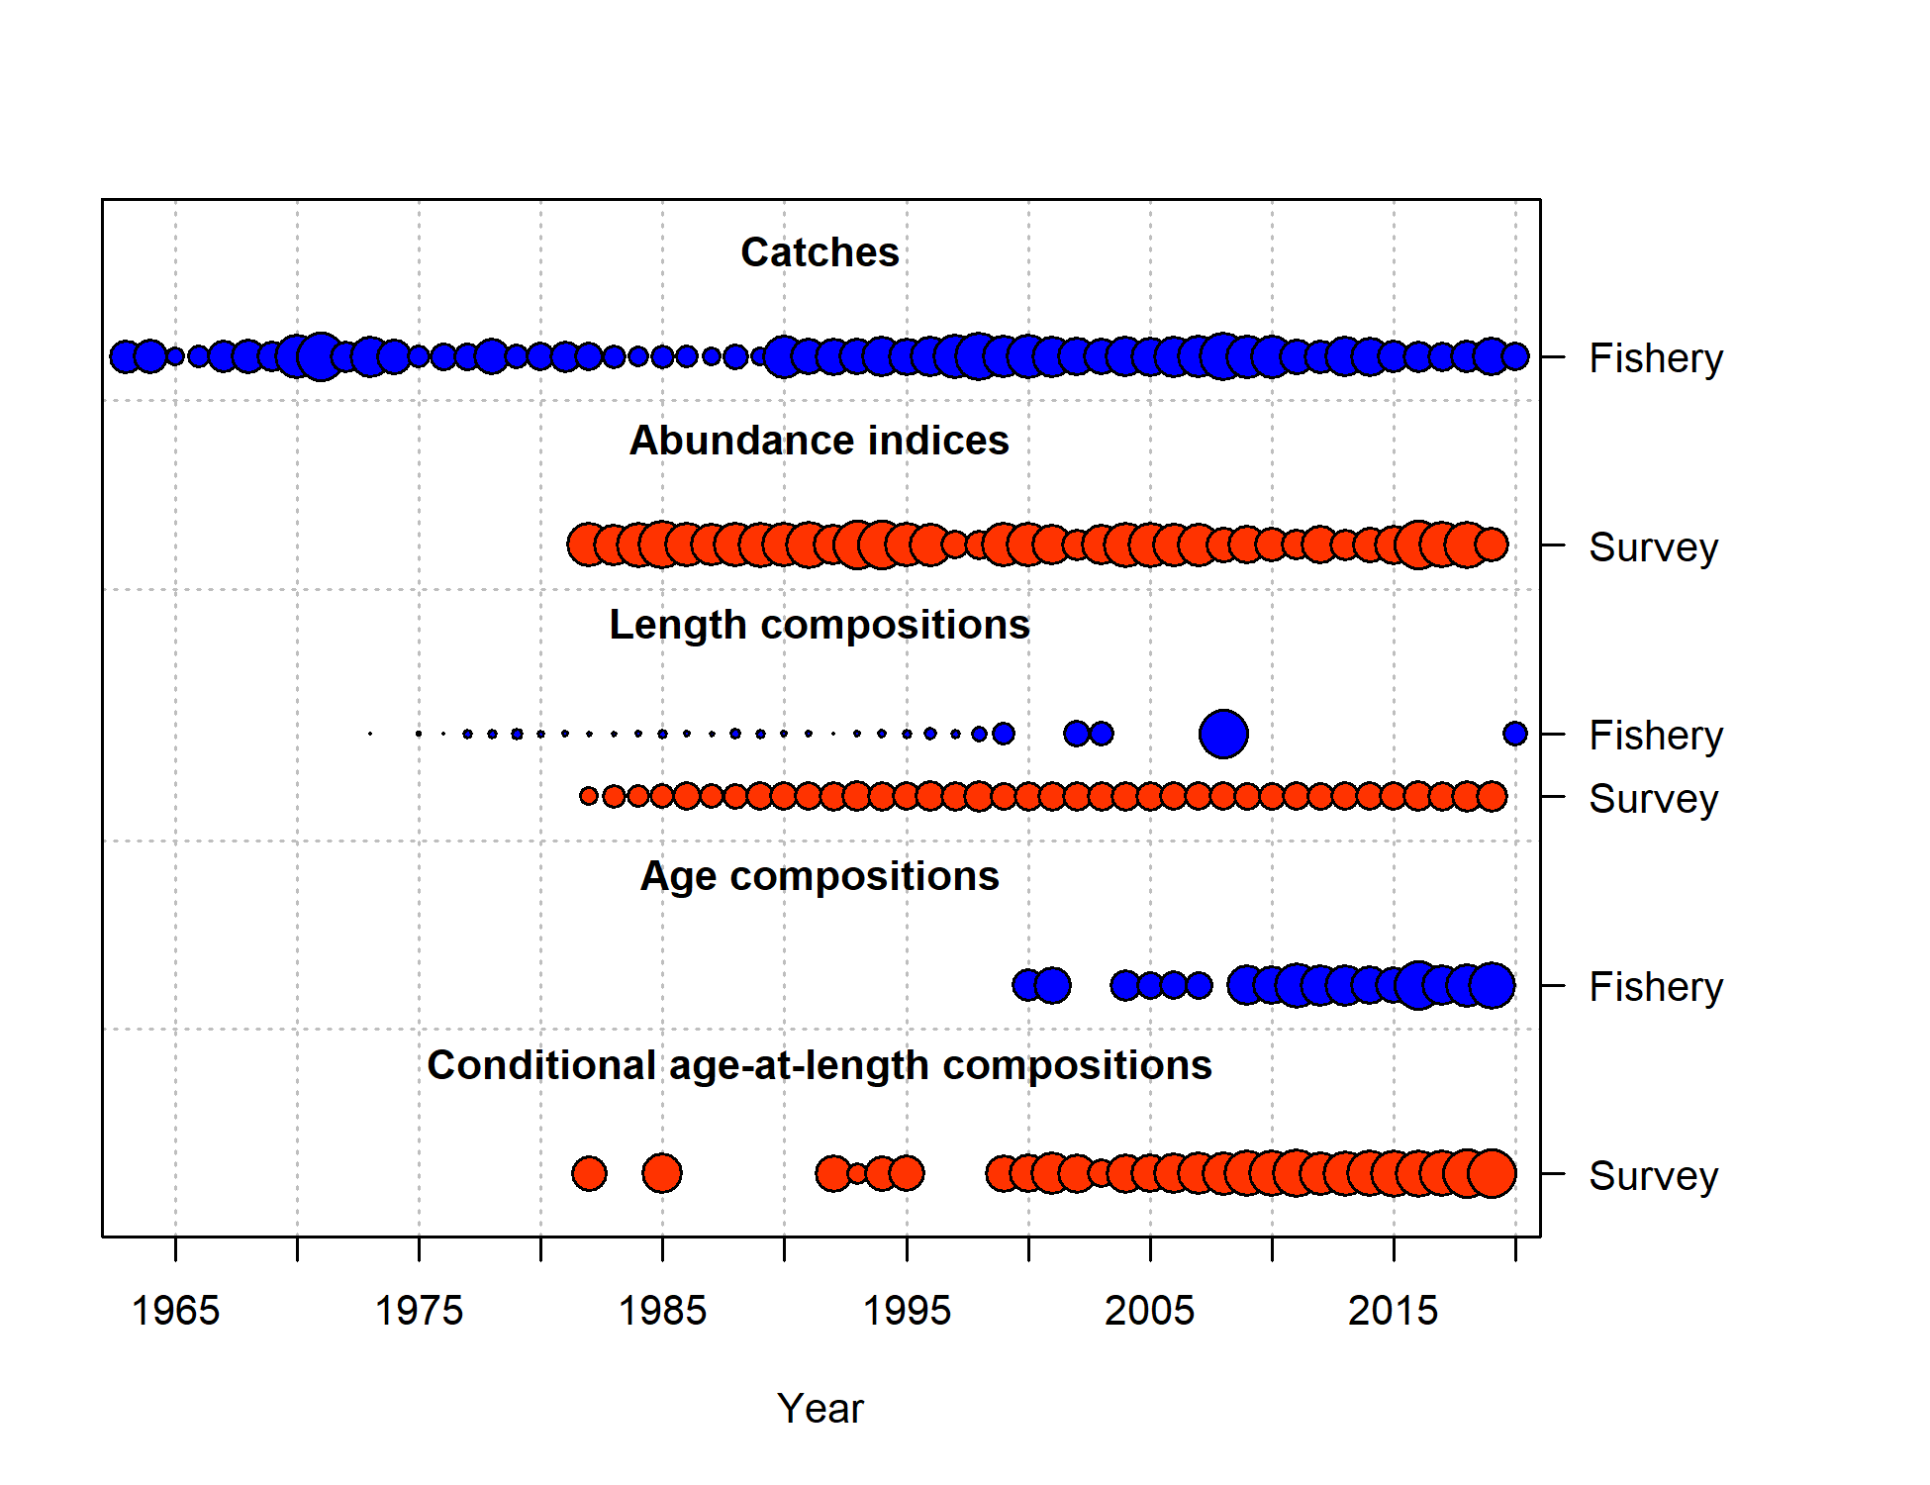

Figure 9.2. Data used in the assessment model, with sizes of circles indicating the relative catches or biomass for fishery catch or survey biomass (listed as “Abundance indices”), respectively, and indicating precision for the length and age composition data included. Circles are relative to the maximum value within each data source.

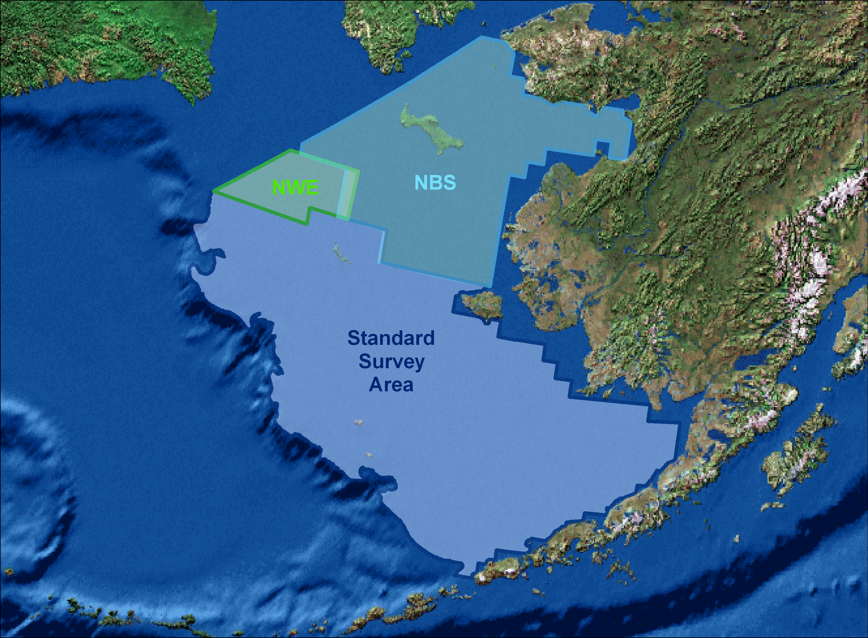

Figure 9.3. Eastern Bering Sea shelf survey areas. Only data from the standard survey area are used in the assessment model; data from the Northwest Extension (NWE) and Northern Bering Sea (NBS) are excluded.

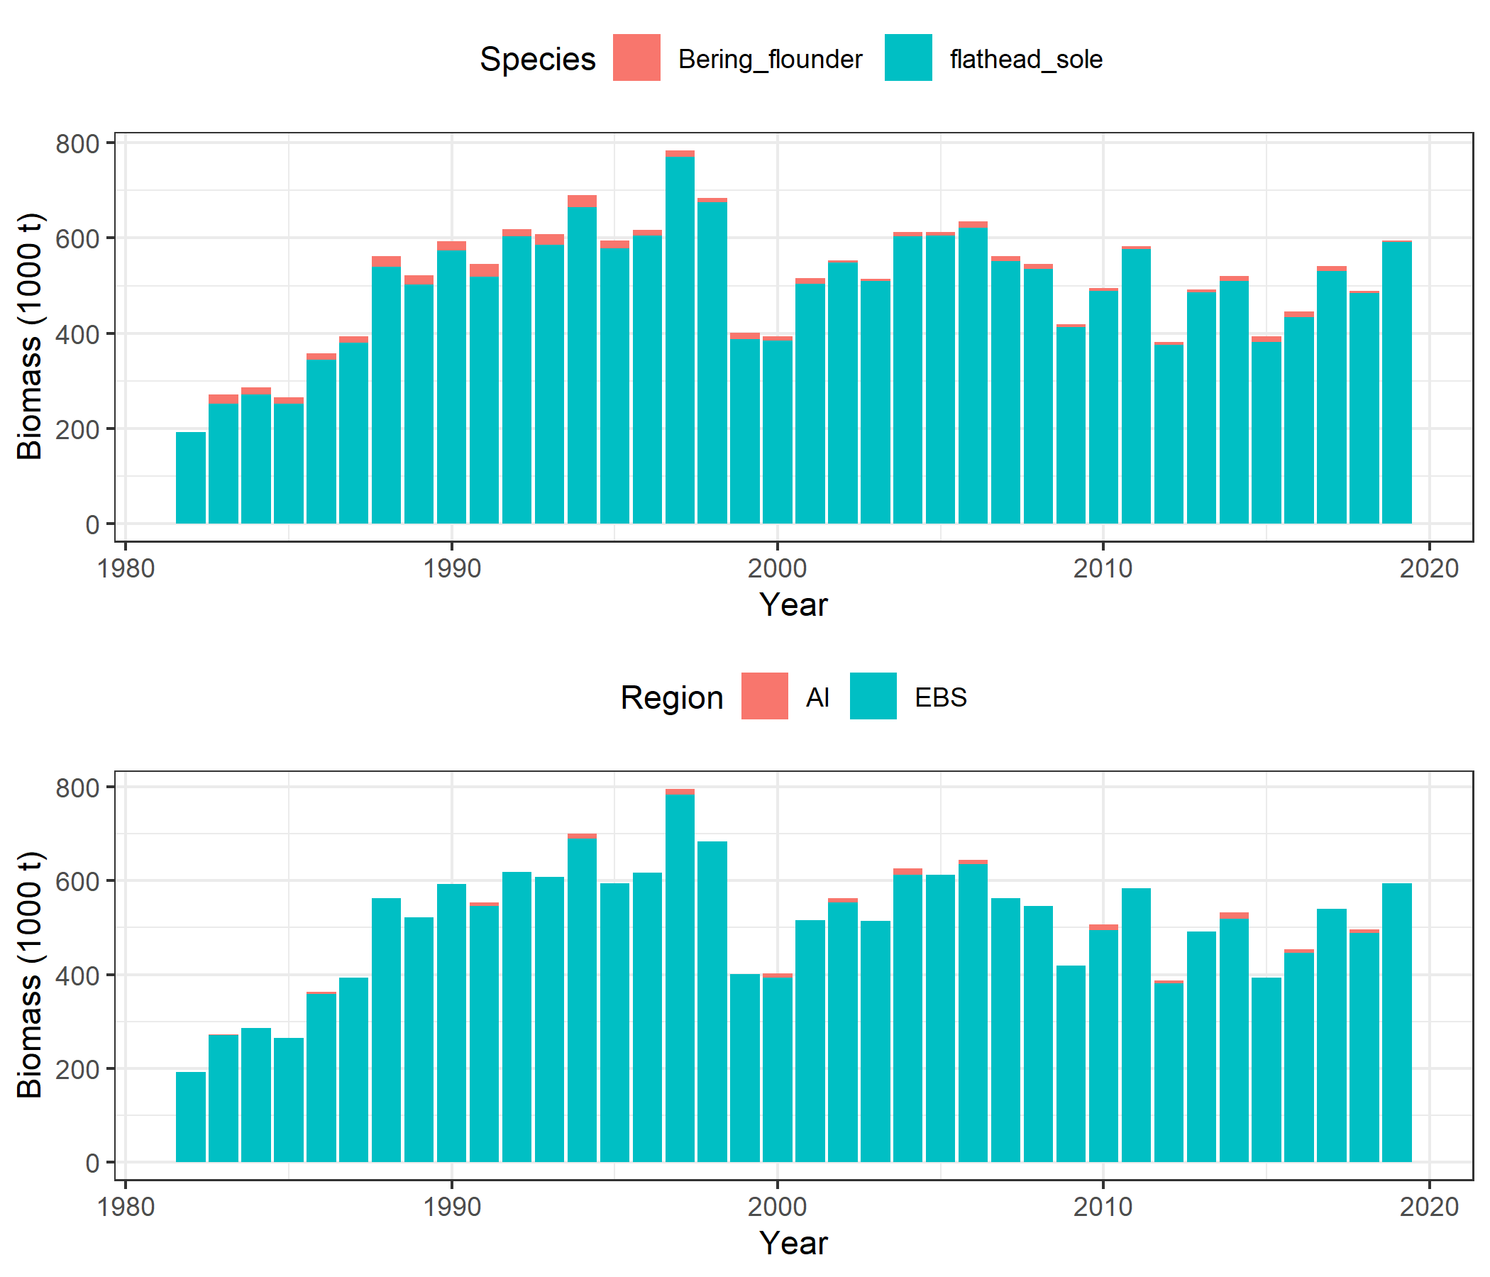

Figure 9.4. Flathead sole and Bering flounder biomass in the EBS shelf survey (top panel). Flathead sole (only) survey biomass from the EBS shelf survey and the Aleutian Islands survey (bottom panel).

Figure 9.5. Survey biomass and mean bottom temperatures from the EBS shelf survey for station depths less than or equal to 200 meters.

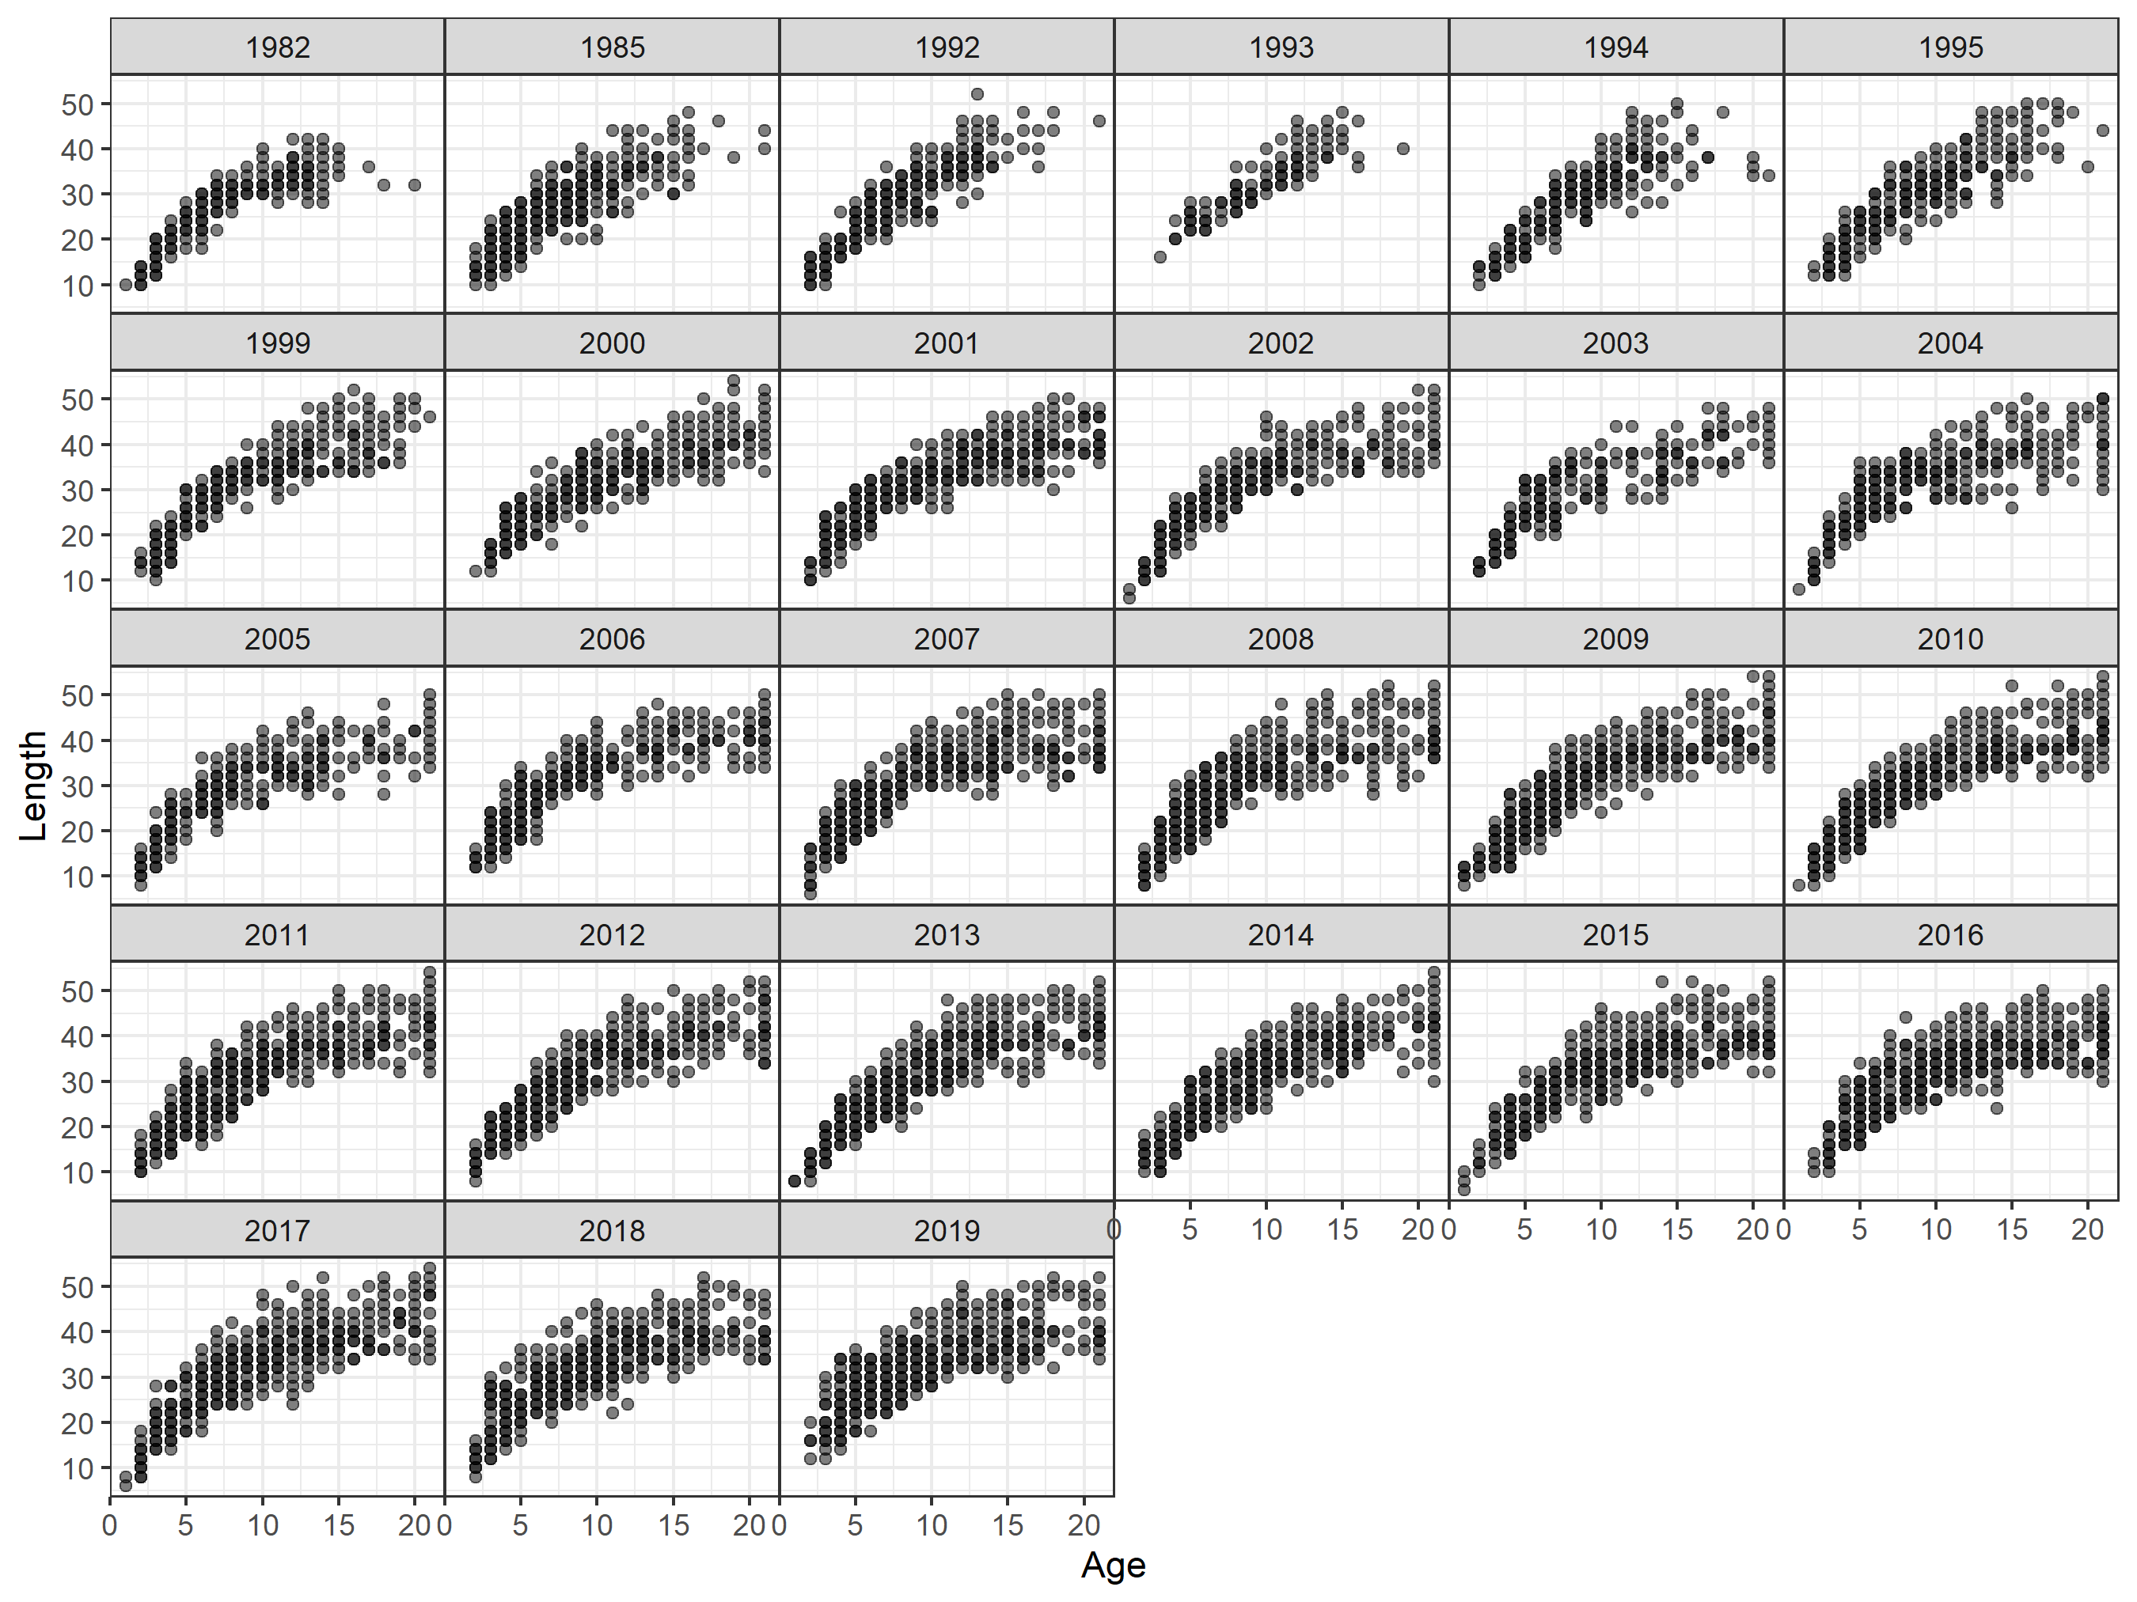

Figure 9.6. EBS shelf survey length-at-age data by cohort and year for females and for flathead sole only.



Figure 9.7. EBS shelf survey length-at-age data by cohort and year for males and for flathead sole only.

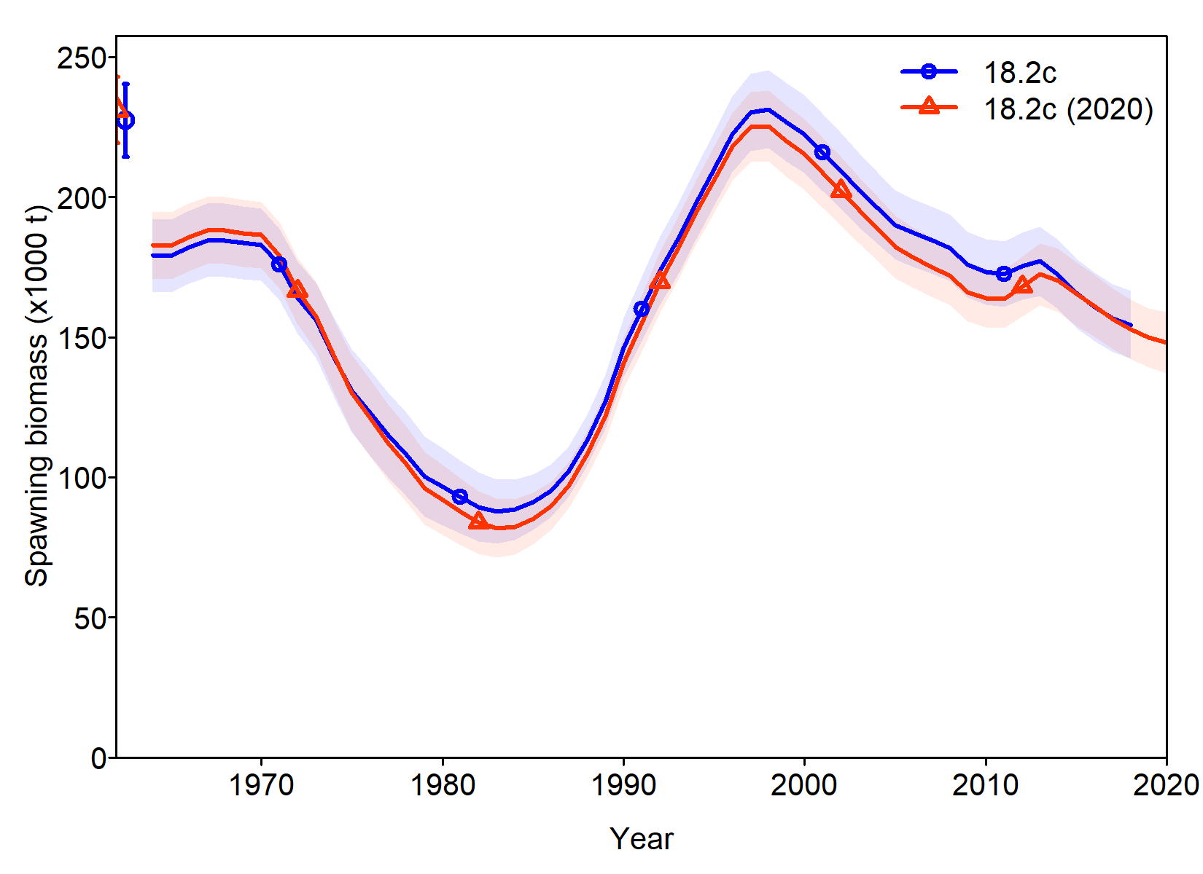

Figure 9.8. A comparison of spawning biomass for models 18.2c and 18.2c (2020).

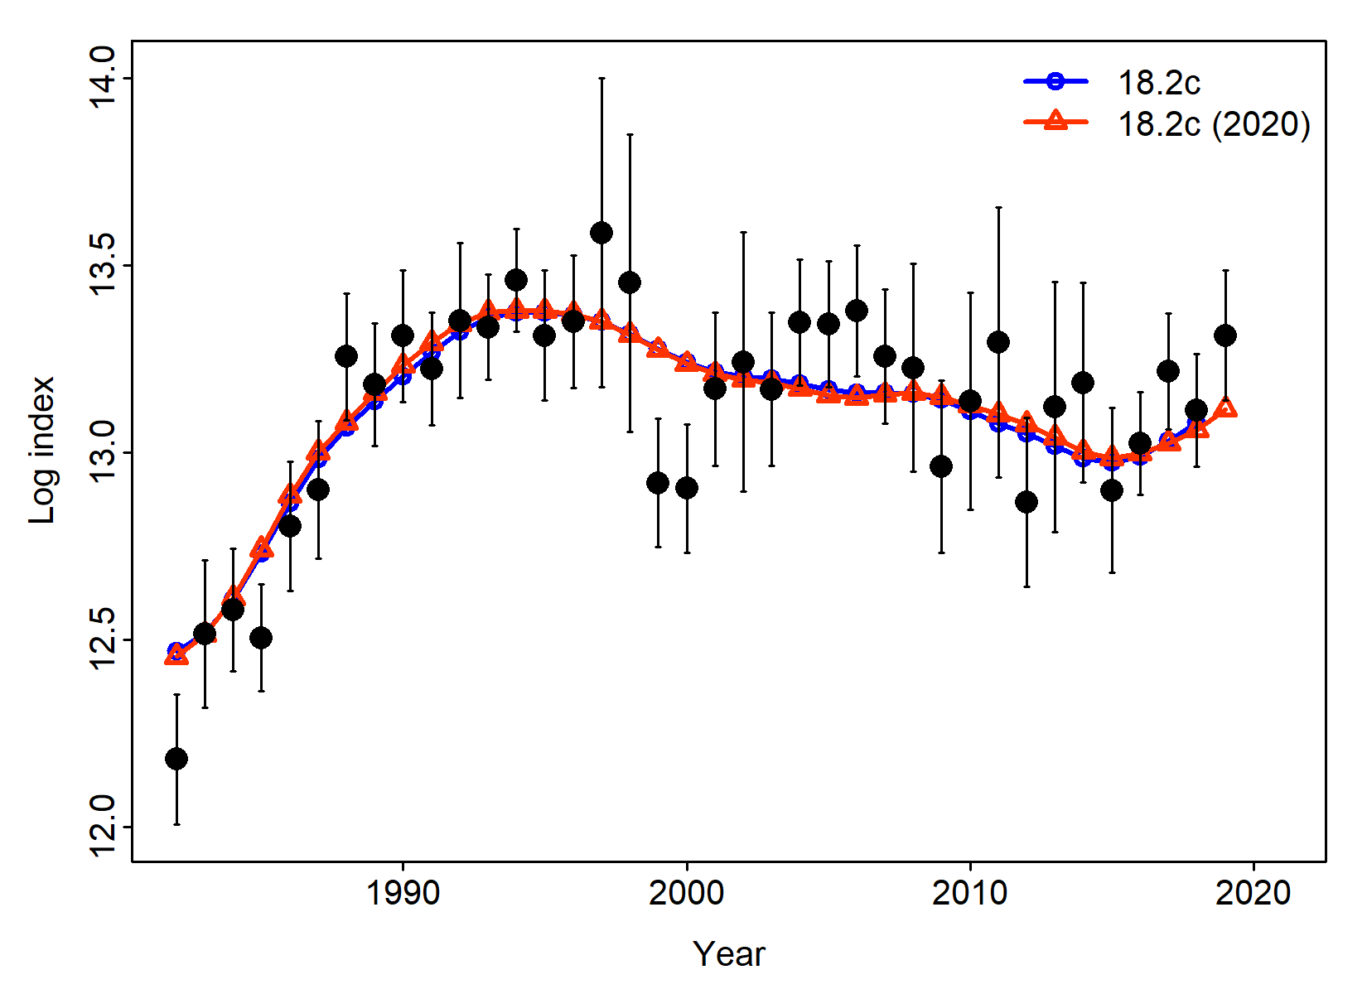

Figure 9.9. A comparison of fit to the survey biomass index for models 18.2c and 18.2c (2020).

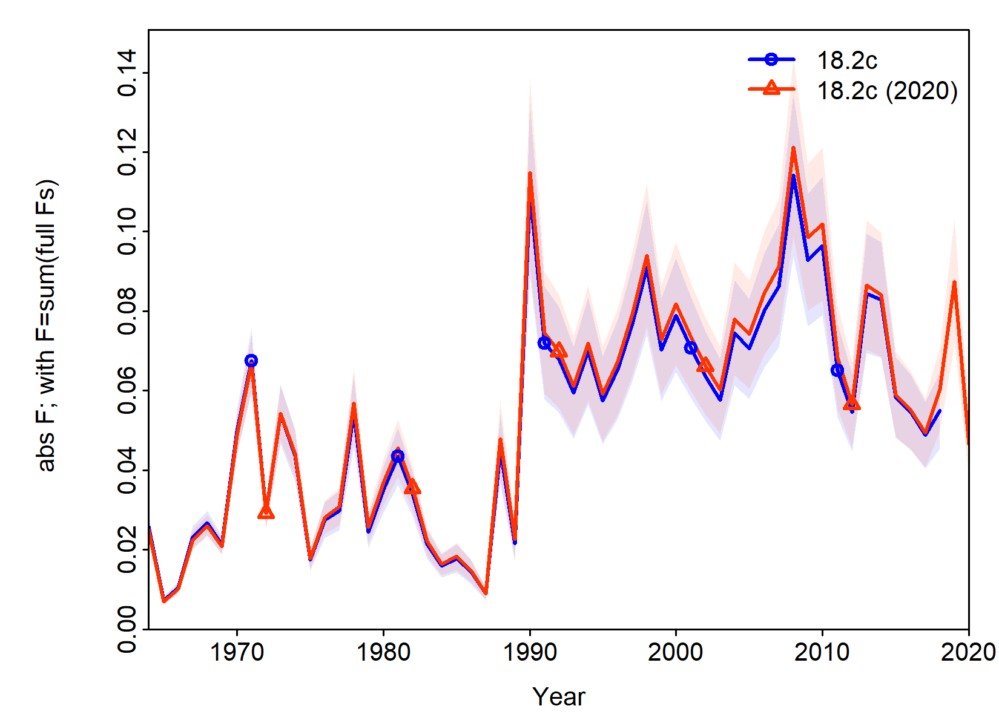

Figure 9.10. A comparison of estimated F values for models 18.2c and 18.2c (2020).

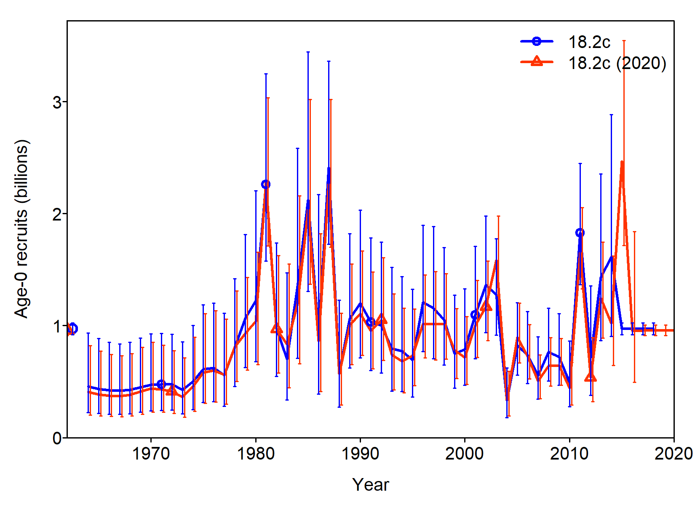

Figure 9.11. A comparison of estimated recruits for models 18.2c and 18.2c (2020).

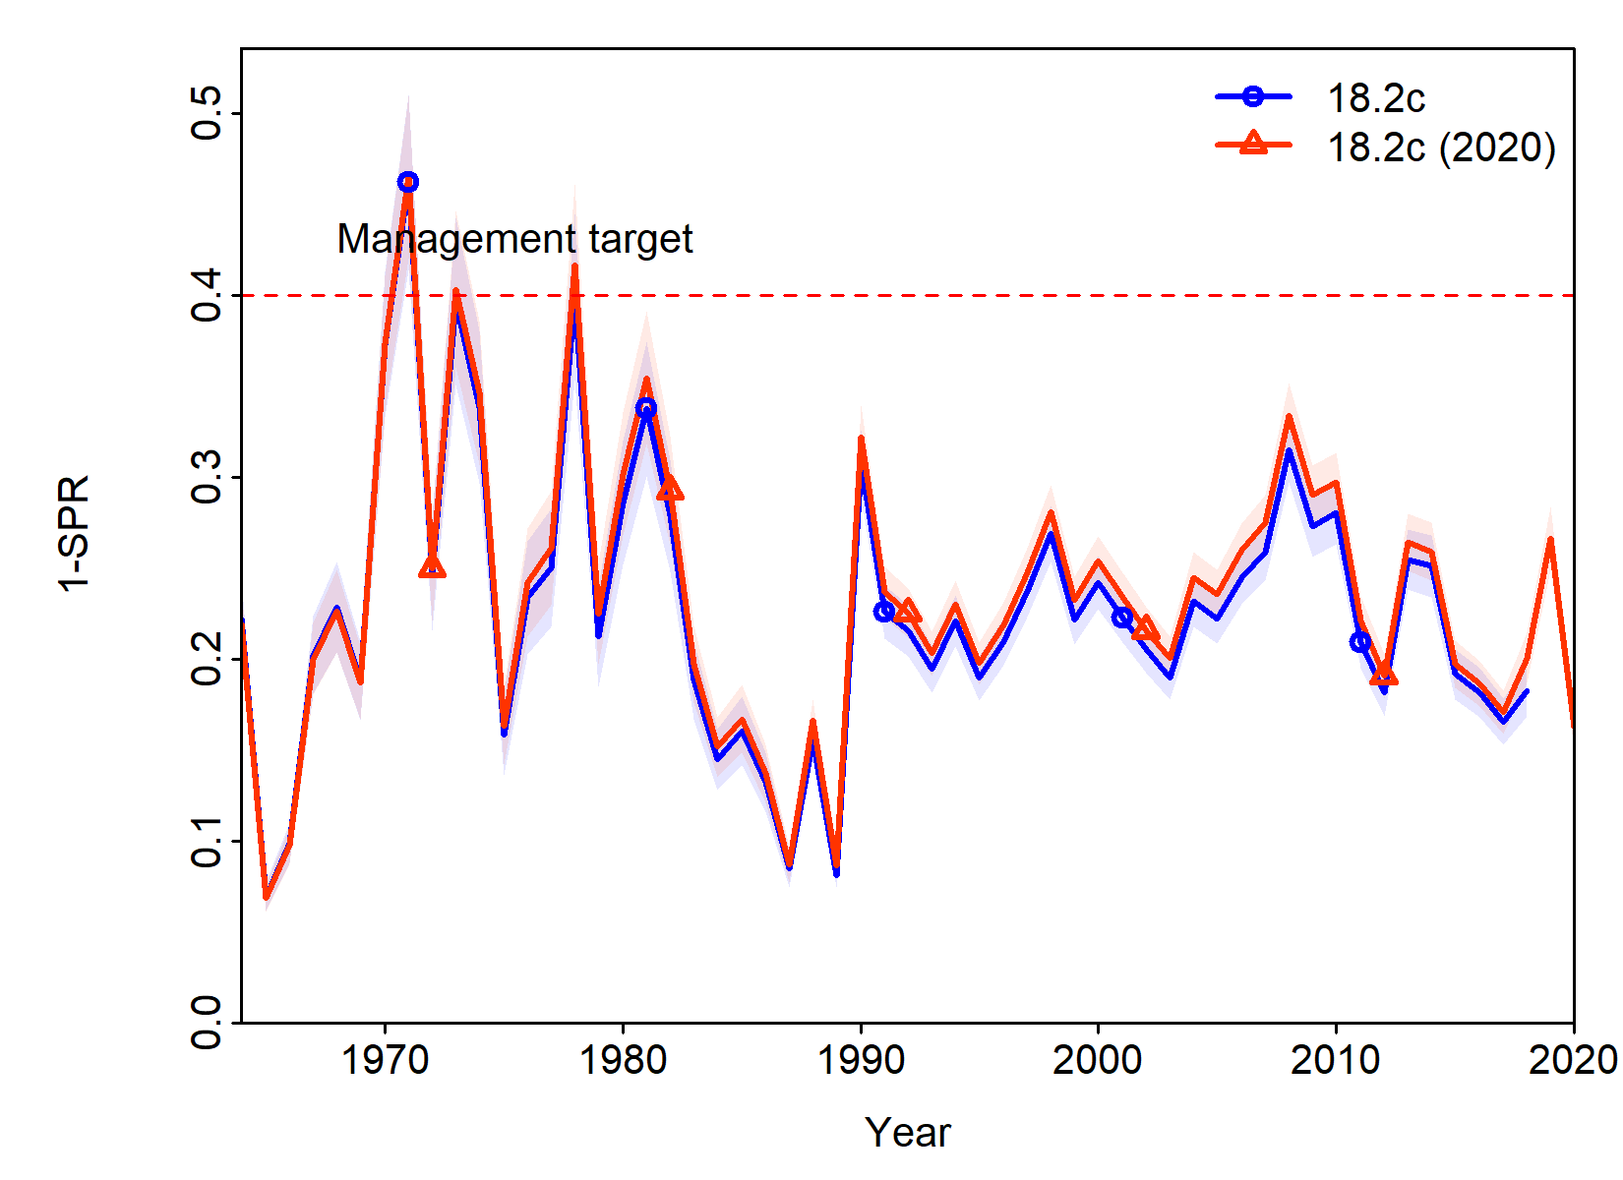

***Figure 9.12.*** A comparison of estimated stock status, represented as one minus the spawning potential ratio, for models 18.2c and 18.2c (2020).

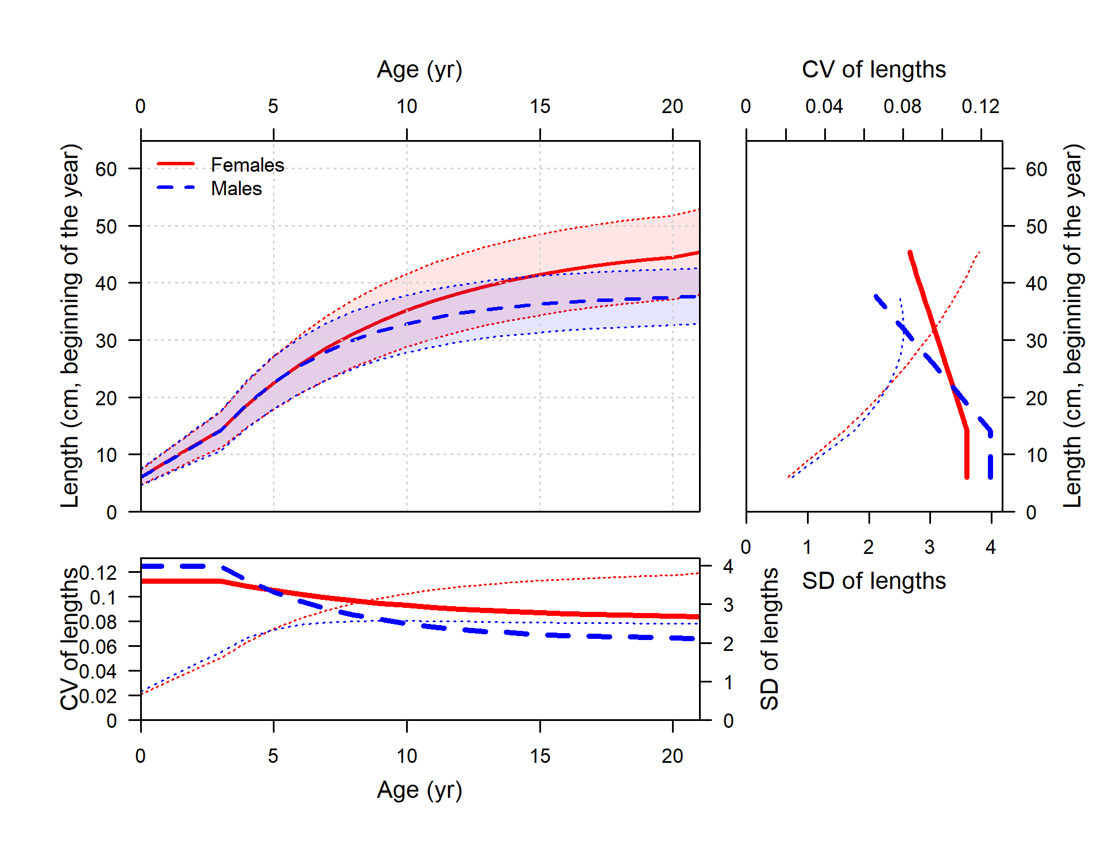

Figure 9.13. Estimated length-at-age and variability in length-at-age for Model 18.2c (2020), as well as estimates of CV in length-at-age over ages (bottom plot) and lengths (right plot) and translation into standard deviations of lengths. Thick lines are CVs and thin dotted lines are standard devations. Red indicates females and blue indicates males.

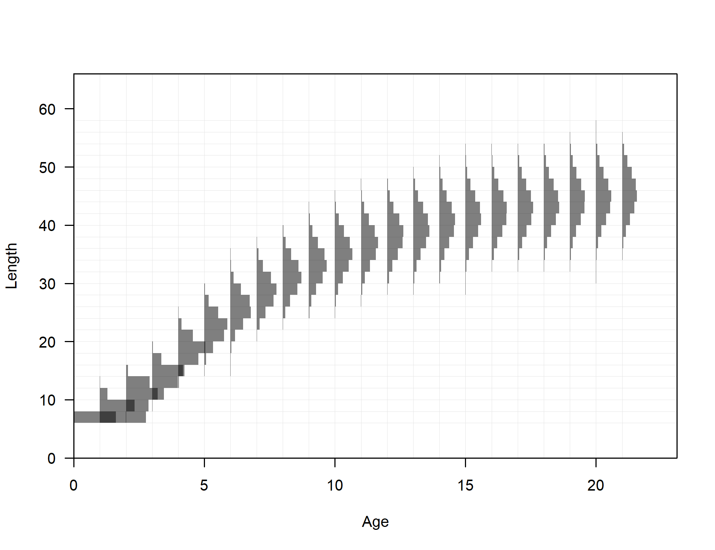

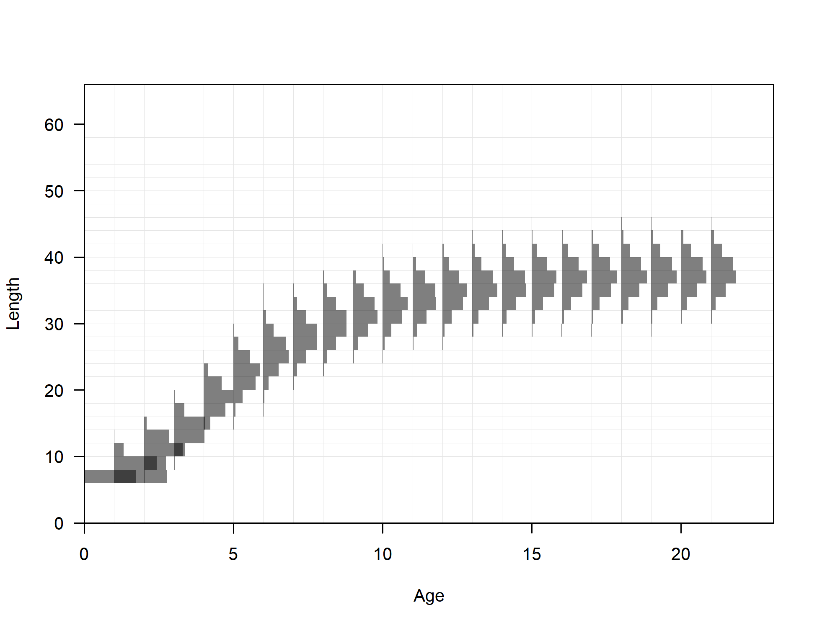

***Figure 9.14. Estimated distribution of lengths at each age for females (upper panel) and males (lower panel) for Model 18.2c (2020)***.

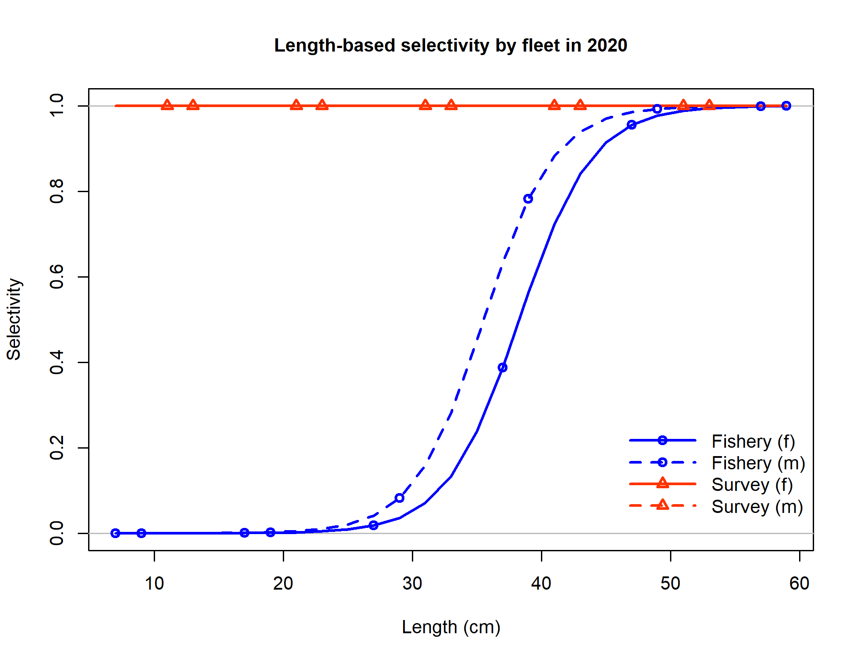

Figure 9.15. Fishery selectivity curves in the end year of the model (2020) for Model 18.2c (2020).

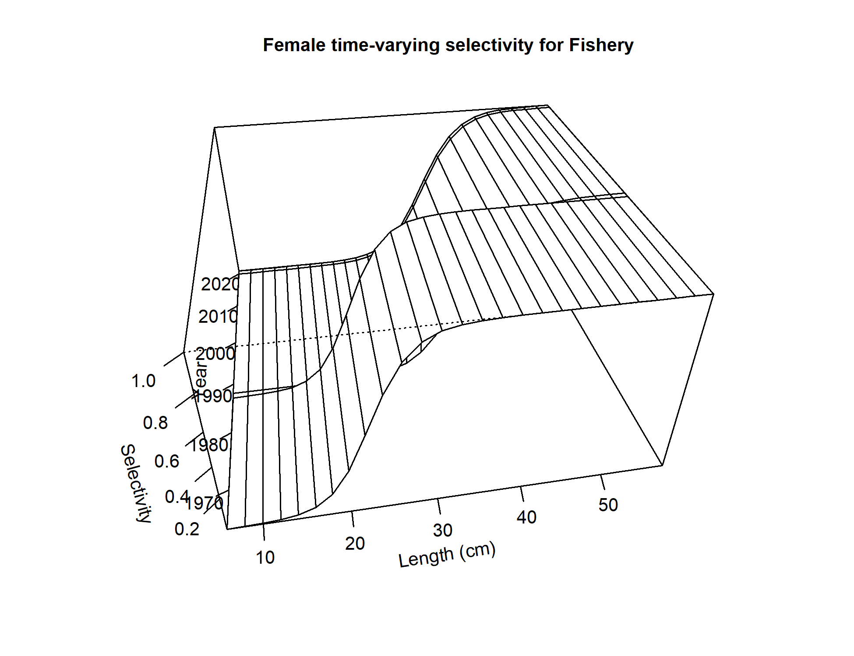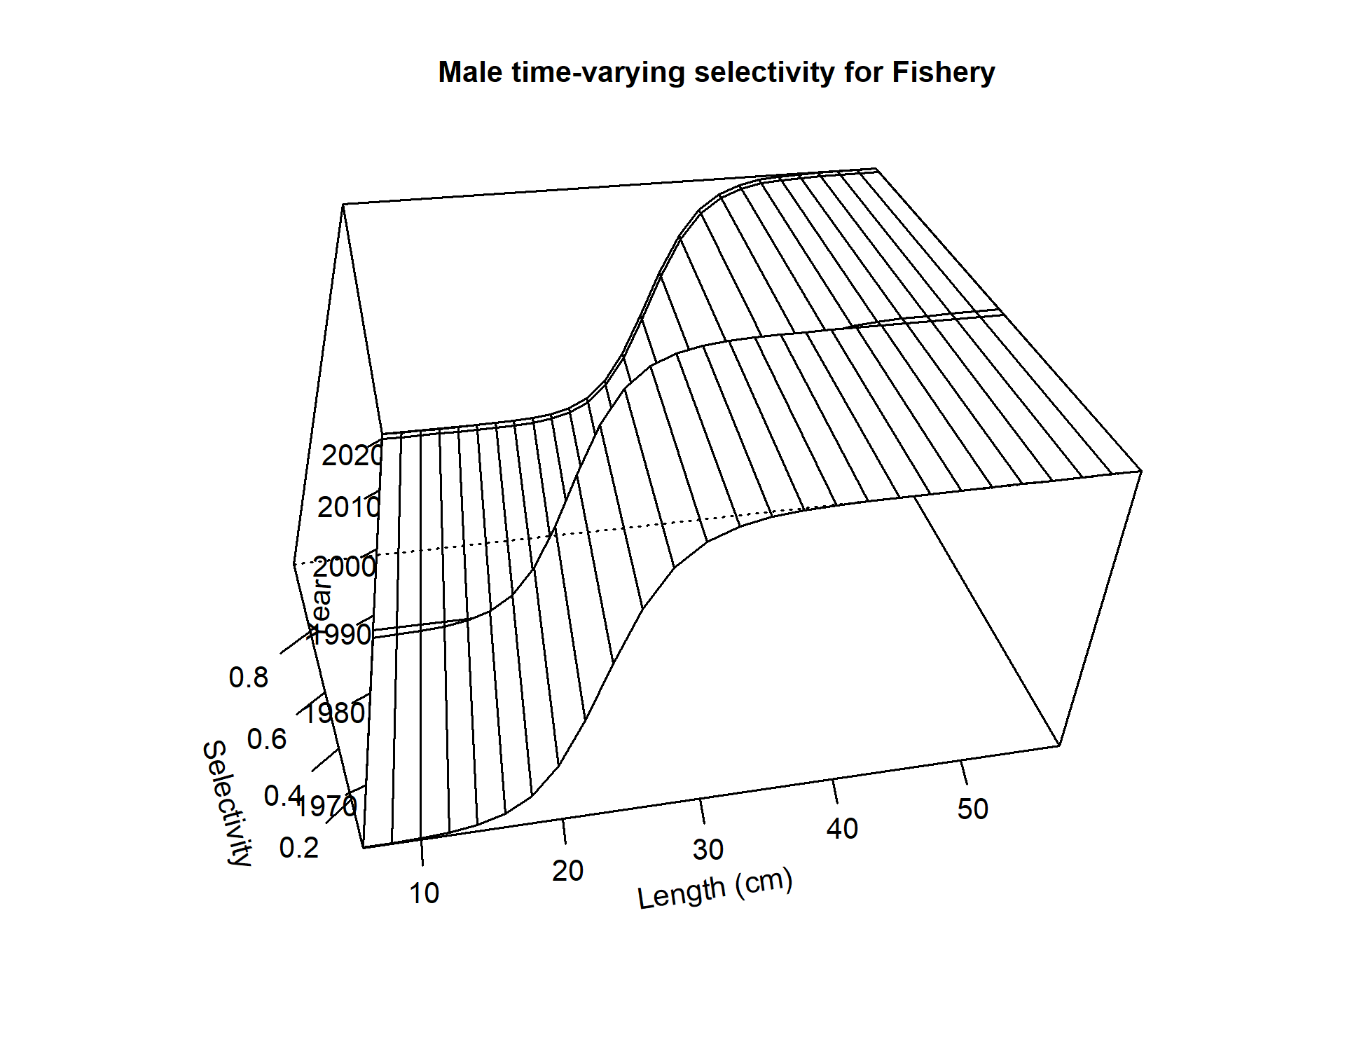

Figure 9.16. Annual fishery selectivity for model 18.2c (2020) which is estimated for 2 time periods,) for females (top panel) and males (bottom panel).

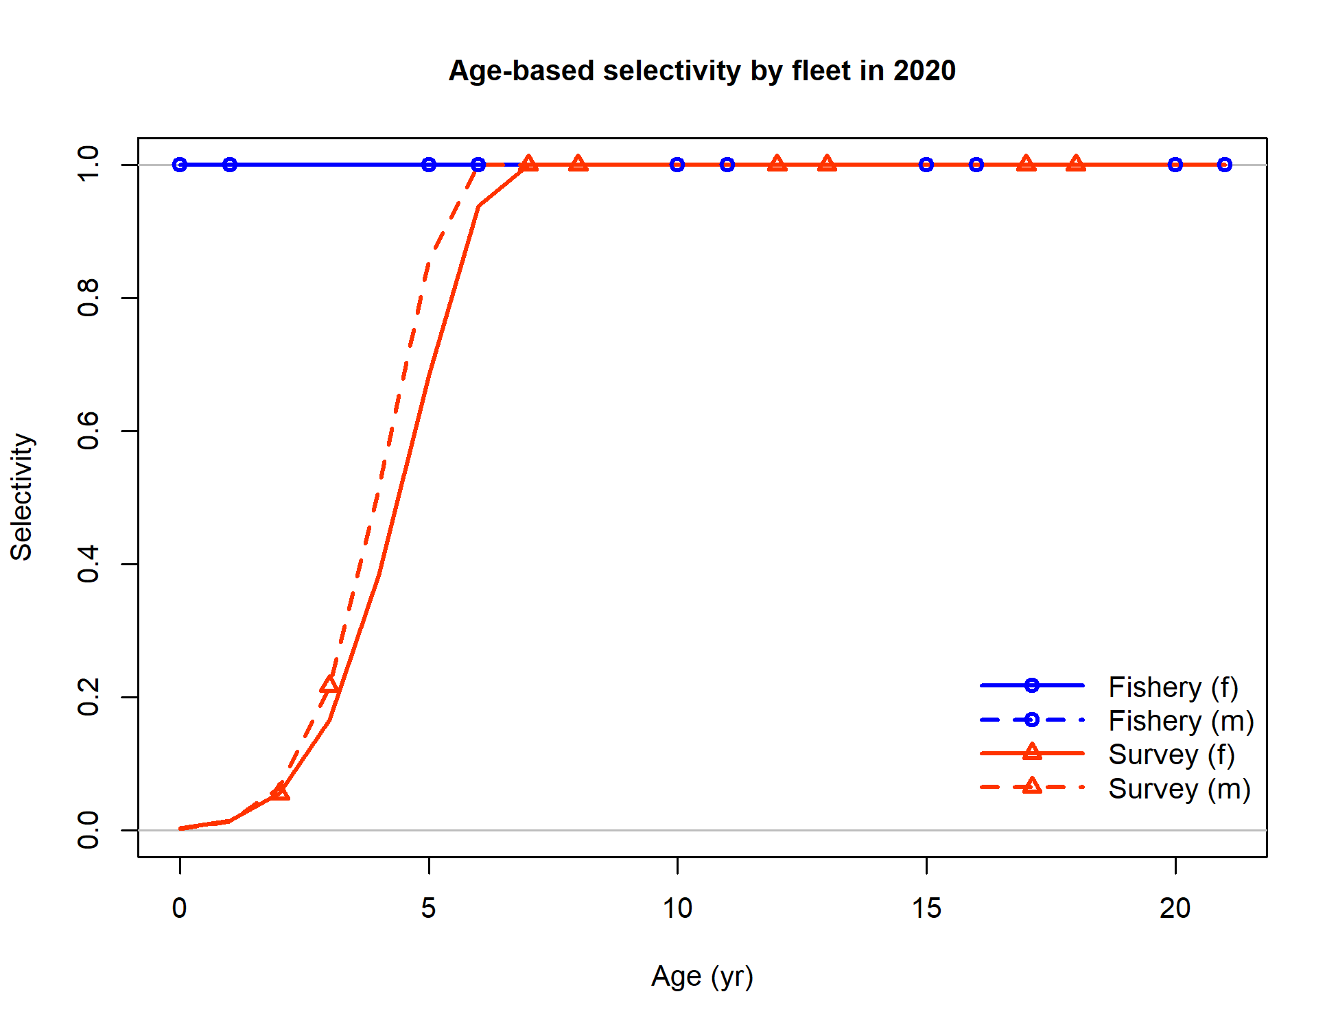

Figure 9.17. Survey selectivity curves for model 18.2c (2020) as a function of age.

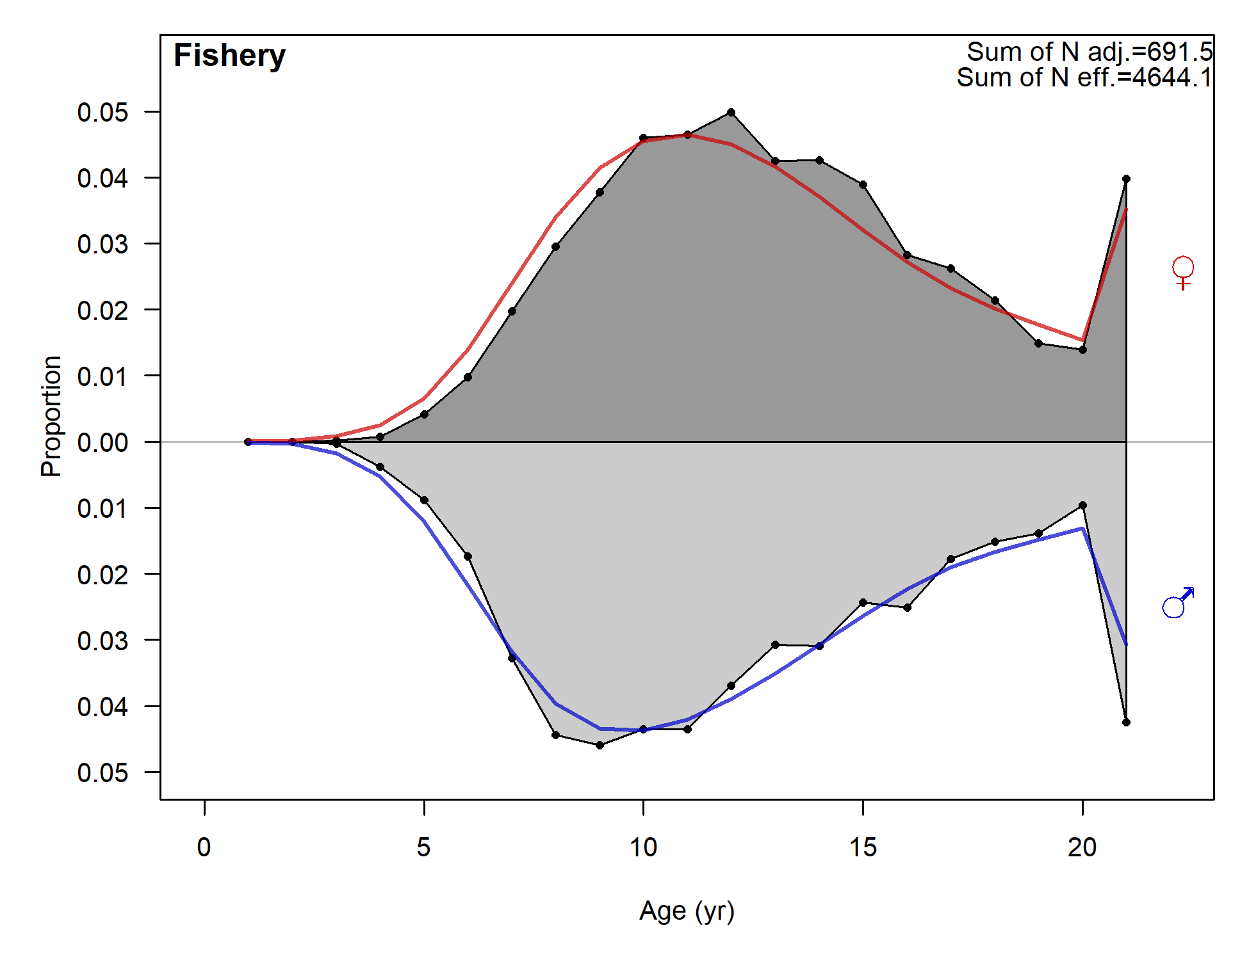

Figure 9.18. Fit to fishery age data, aggregated across time, for Model 18.2c (2020).

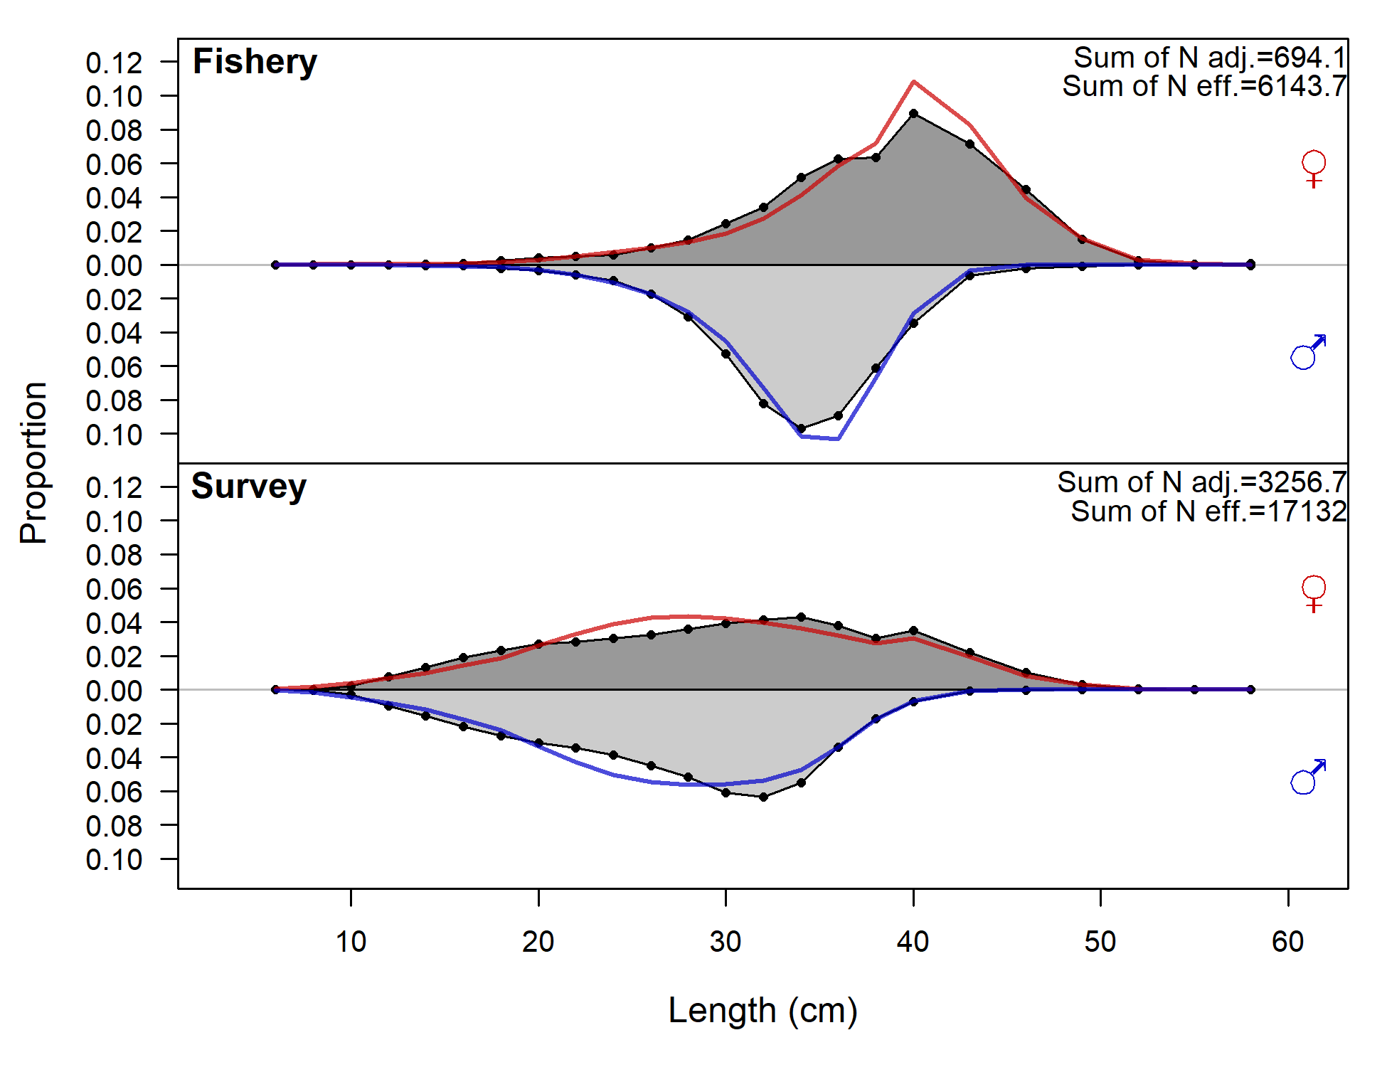

Figure 9.19. Fit to fishery and survey length composition data, aggregated across time, for Model 18.2c (2020).

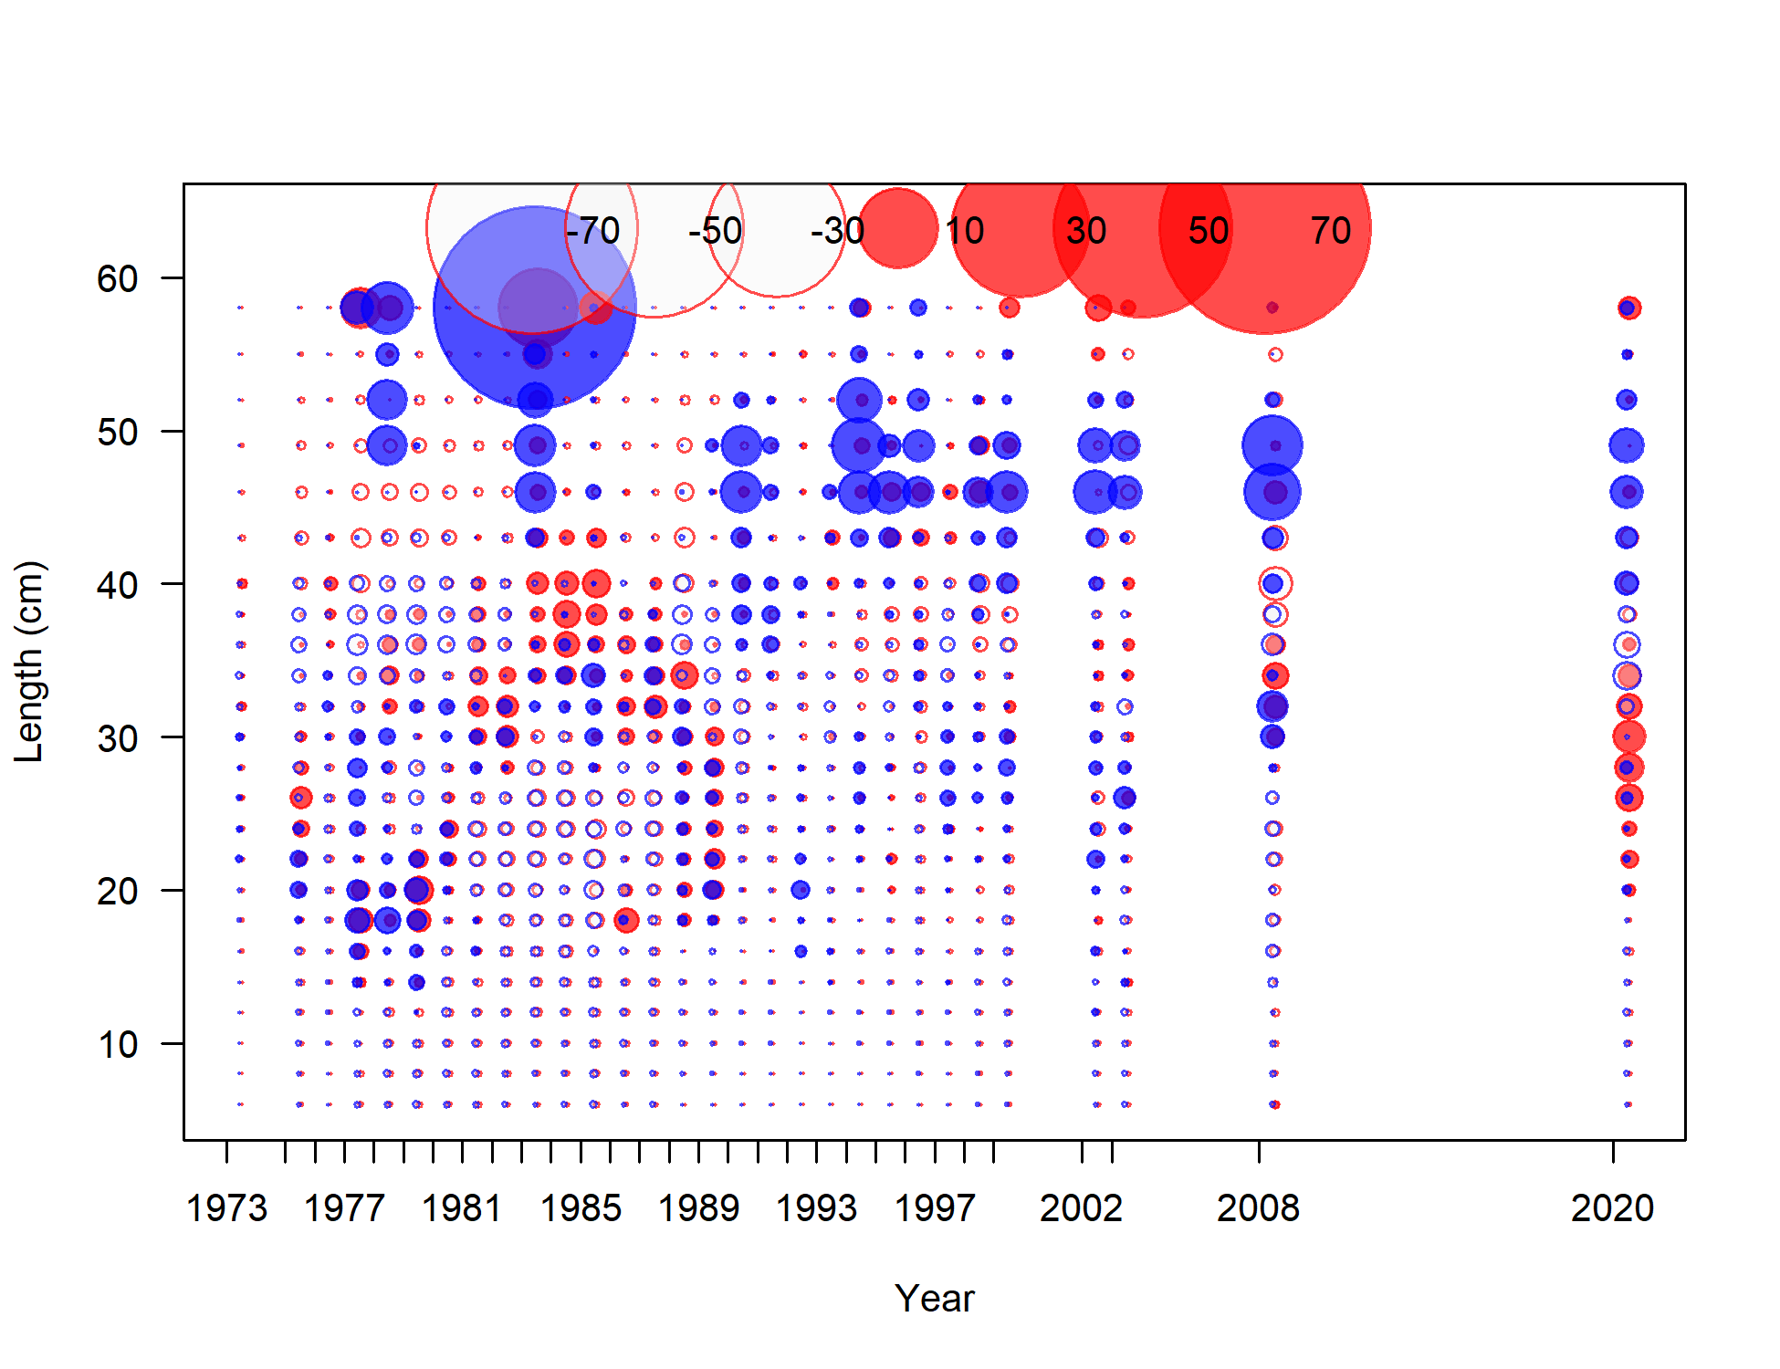

Figure 9.20. Pearson residuals showing fits to fishery length composition data for Model 18.2.c (2020). Red bubbles along the top of the plots show the scale. Filled circles are positive residuals (observed > expected) and open circles are negative residuals (observed < expected), blue indicates males and red indicates females. Circles across the top of the plots are a legend.

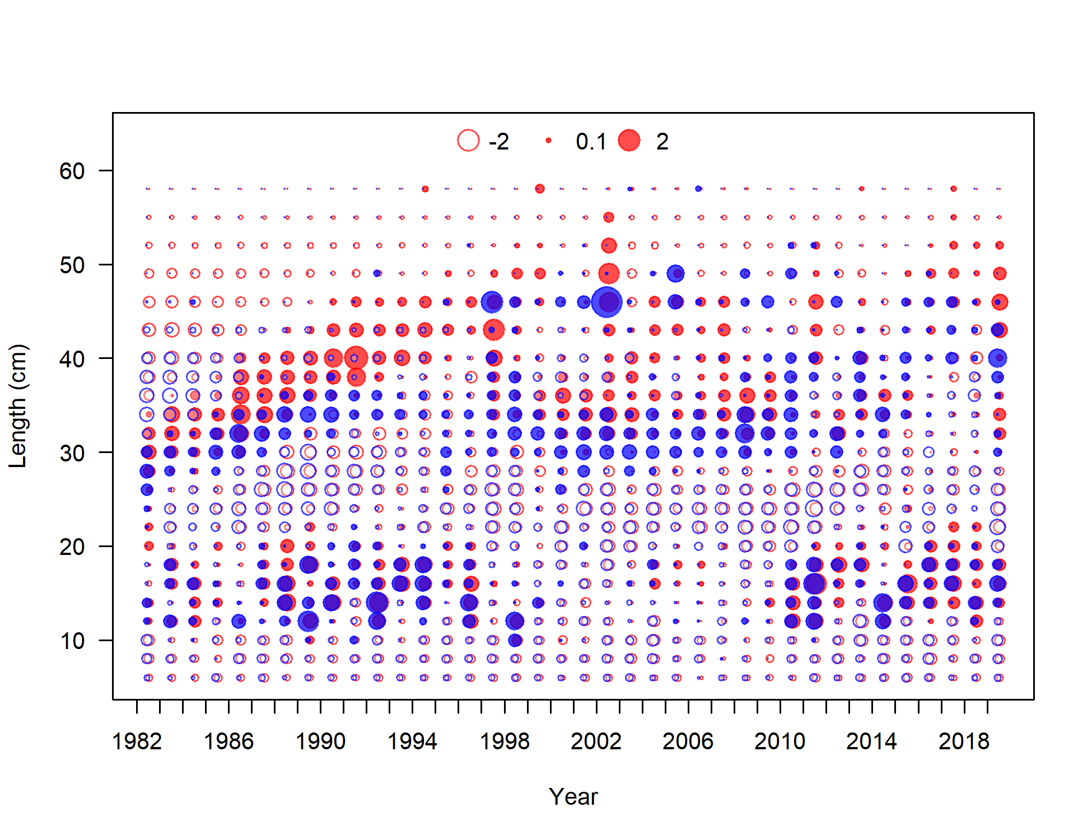

Figure 9.21. Pearson residuals showing fits to the survey length composition data for Model 18.2c (2020). Filled circles are positive residuals (observed > expected) and open circles are negative residuals (observed < expected), blue indicates males and red indicates females. Circles across the top of the plots are a legend.

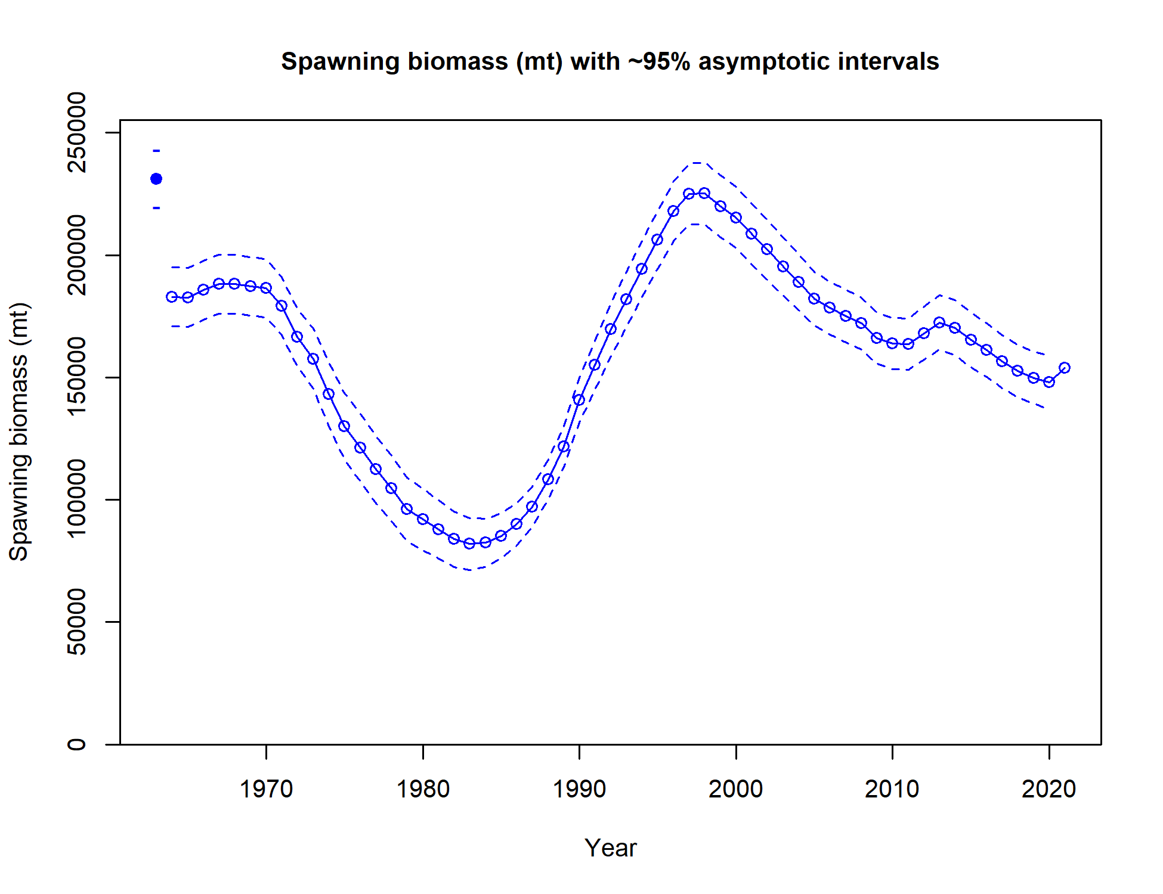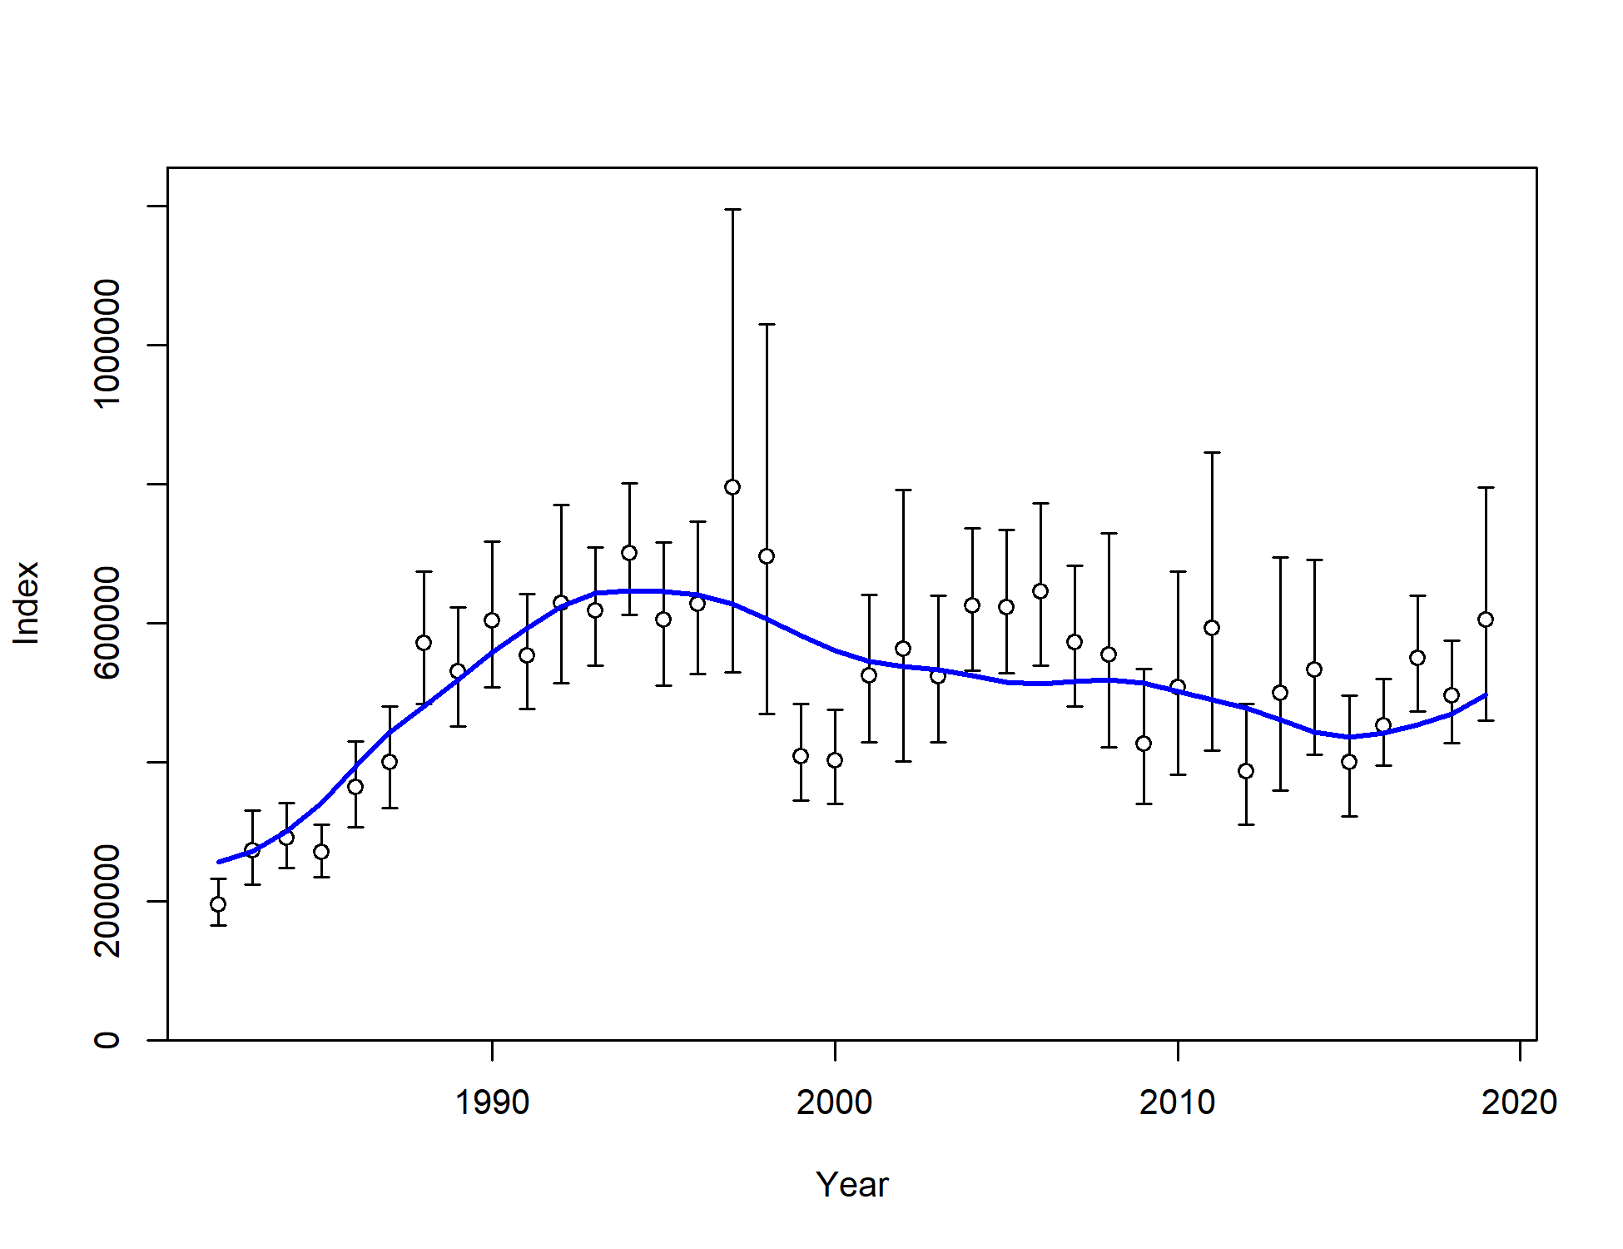

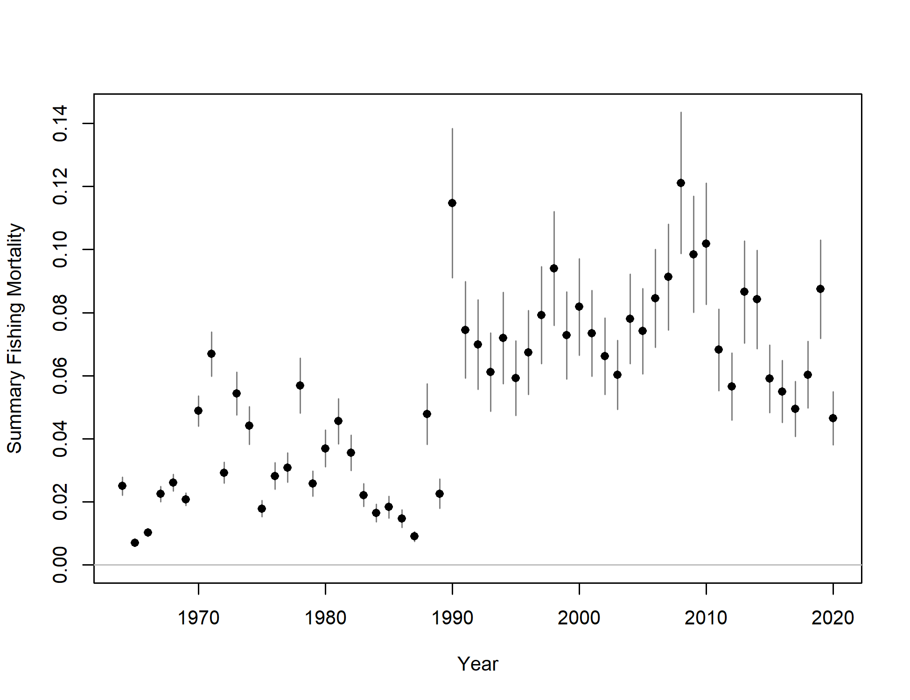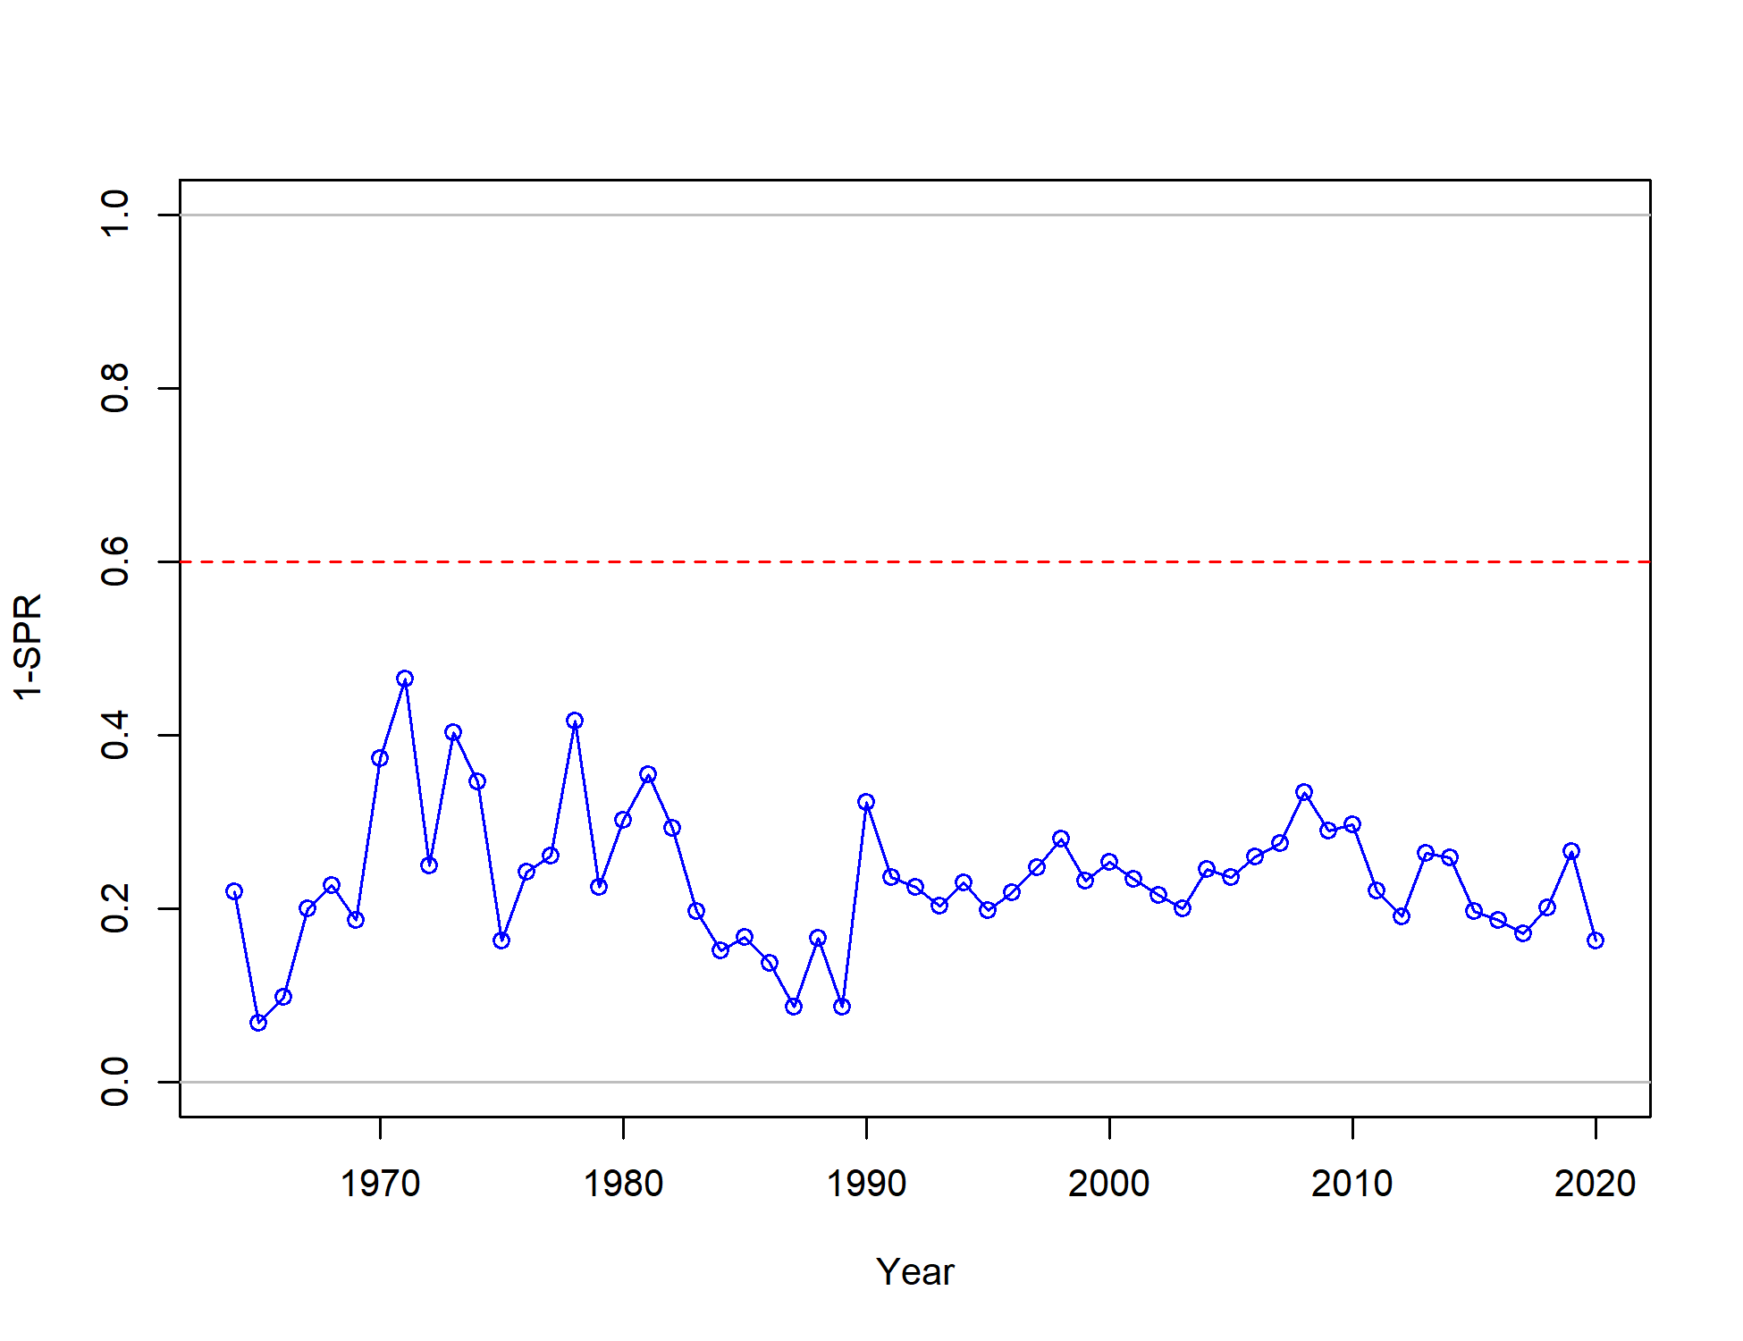

Figure 9.22. Model 18.2c estimated trends over time for spawning biomass (top left), survey biomass (dots) with 95% asymptotic intervals (vertical lines) and model fit to survey biomass (blue line; top right), apical fishing mortality with 95% asymptotic intervals (bottom left), and 1-spawning potential ratio (bottom right).

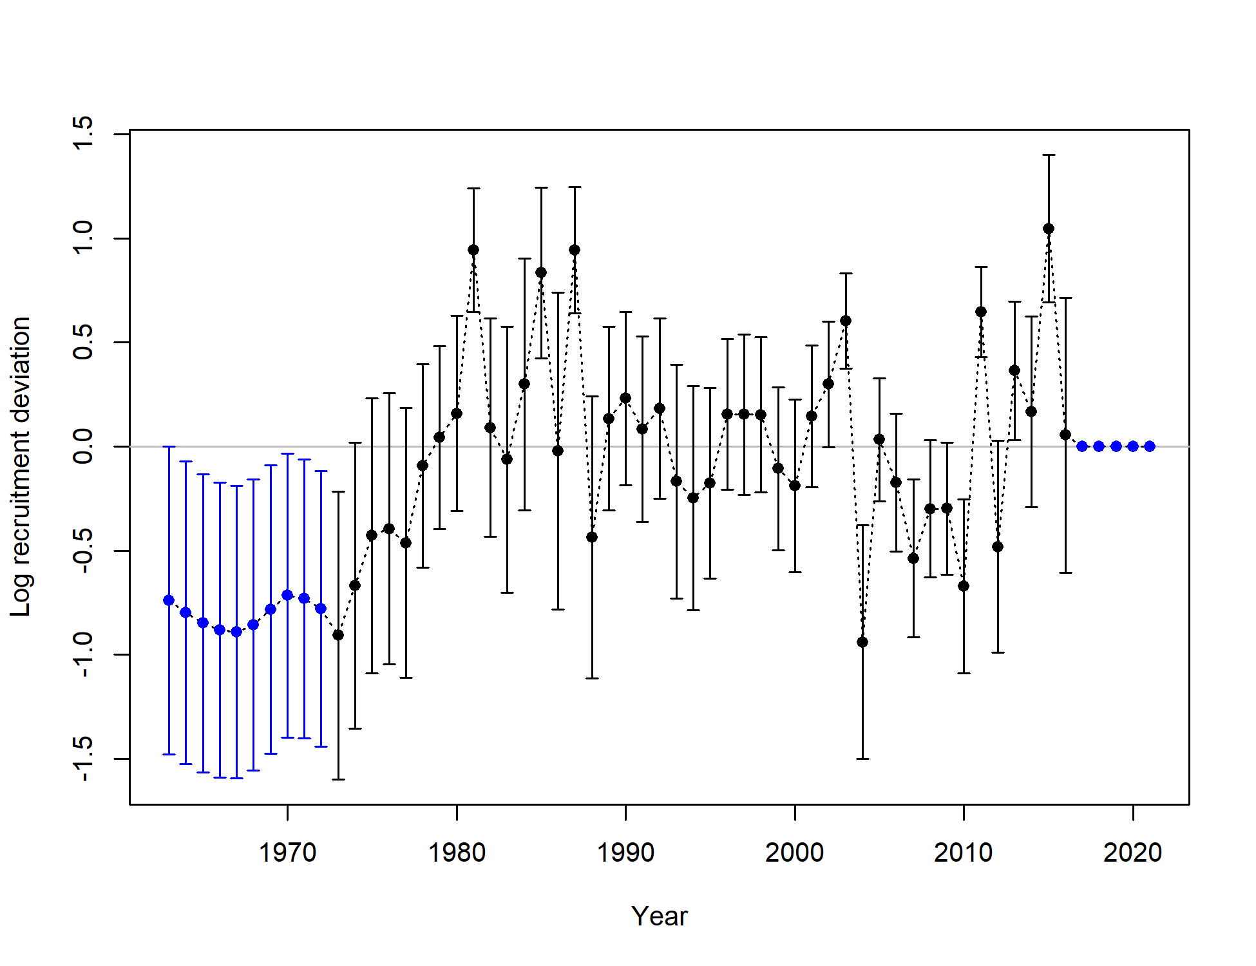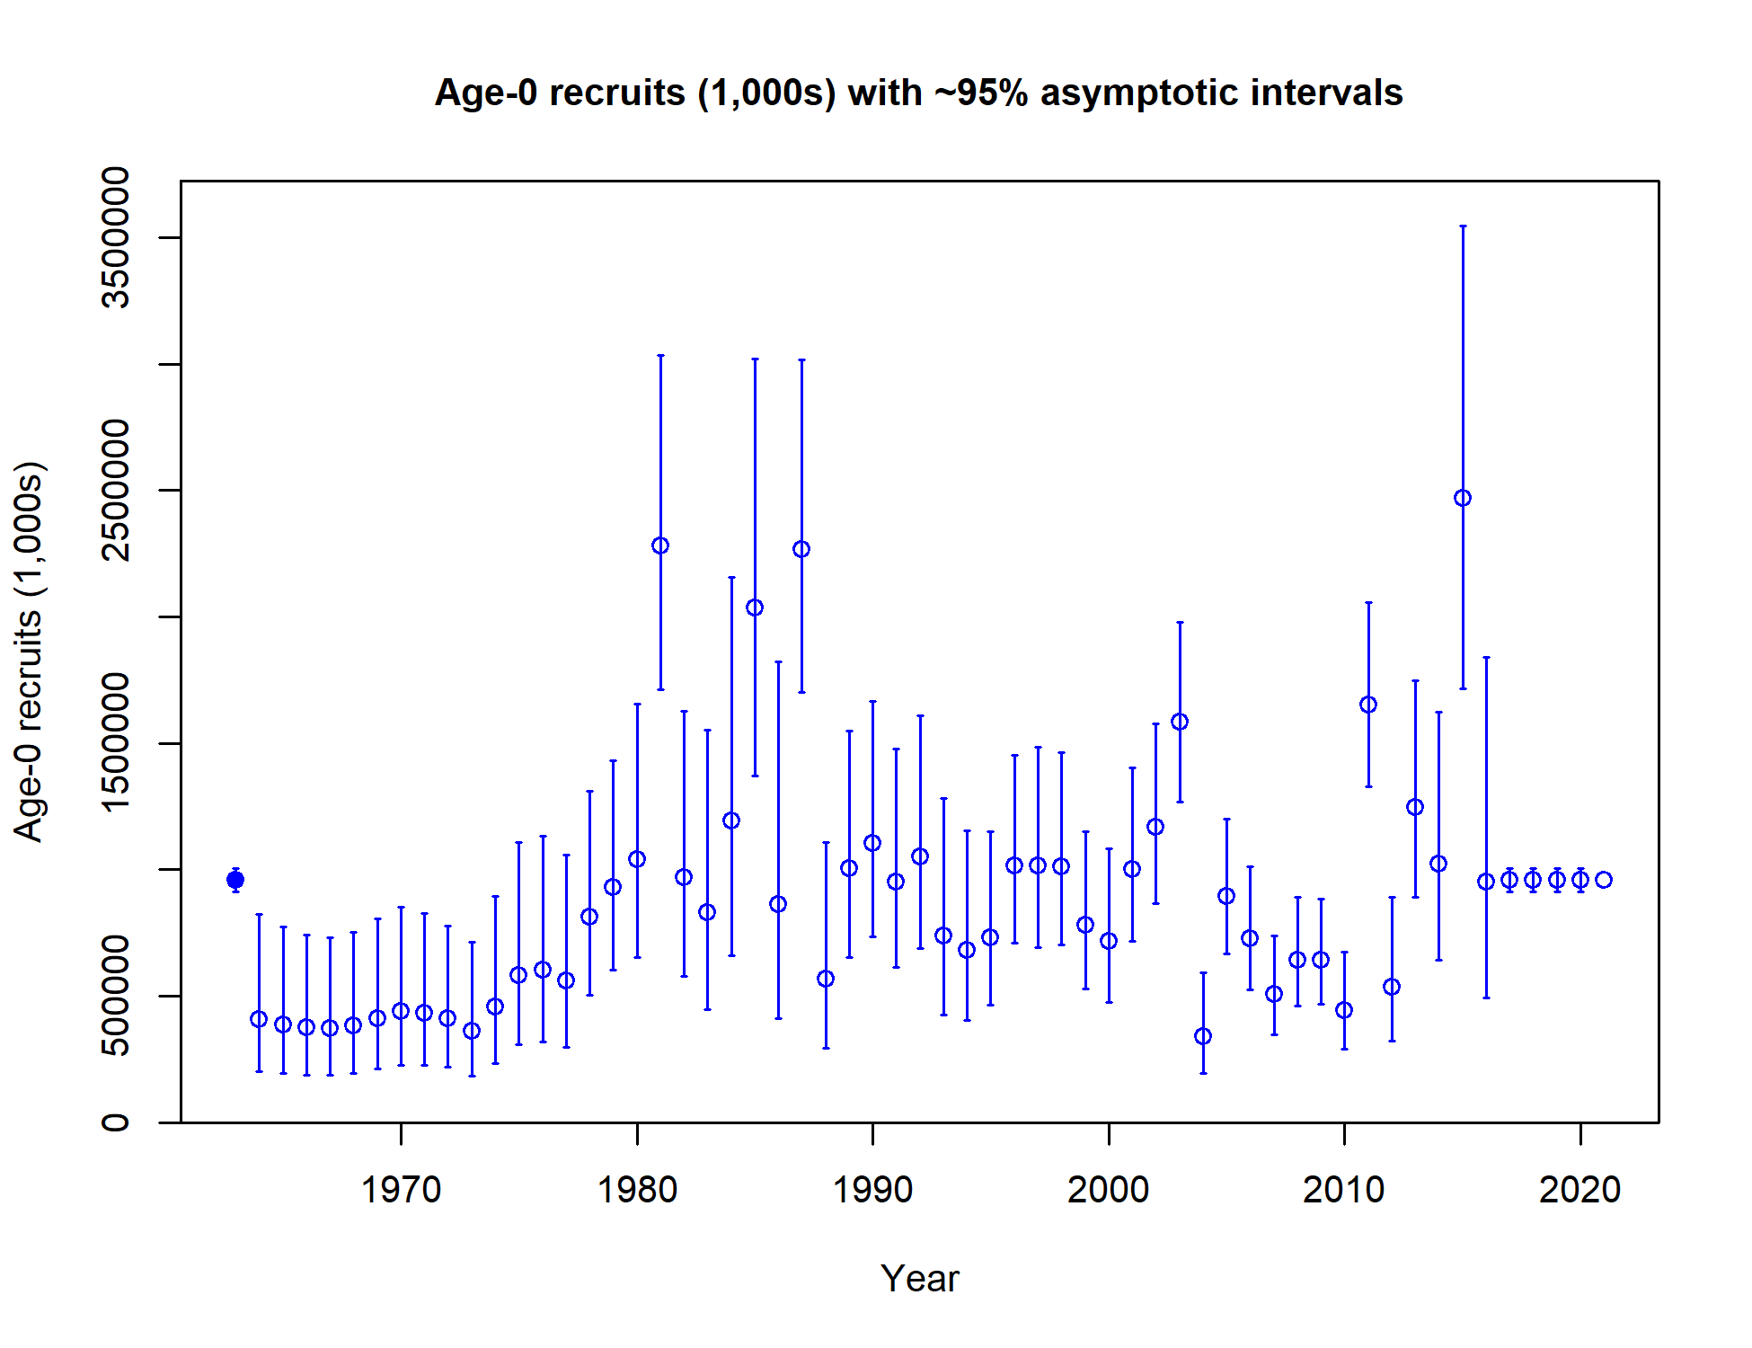

Figure 9.23. Model 18.2 (2020) estimated recruitment. Recruitment deviations in log-space (left), age-0 recruits with 95% asymptotic intervals (right).

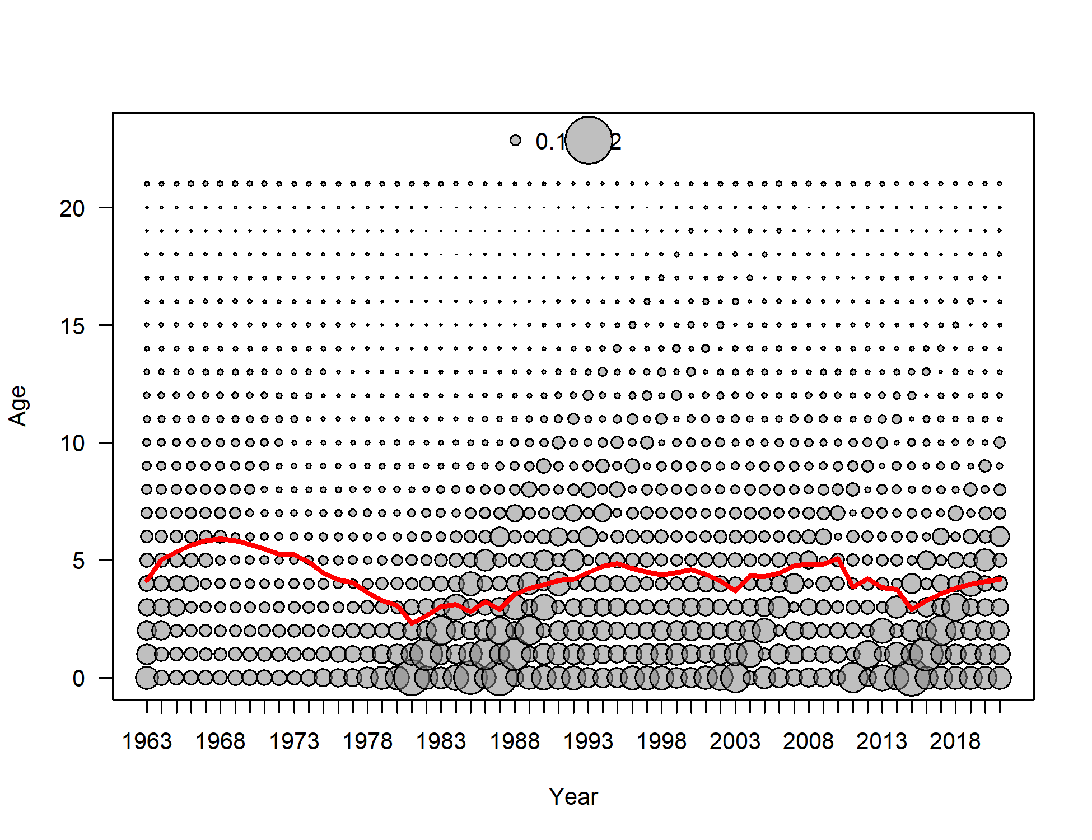

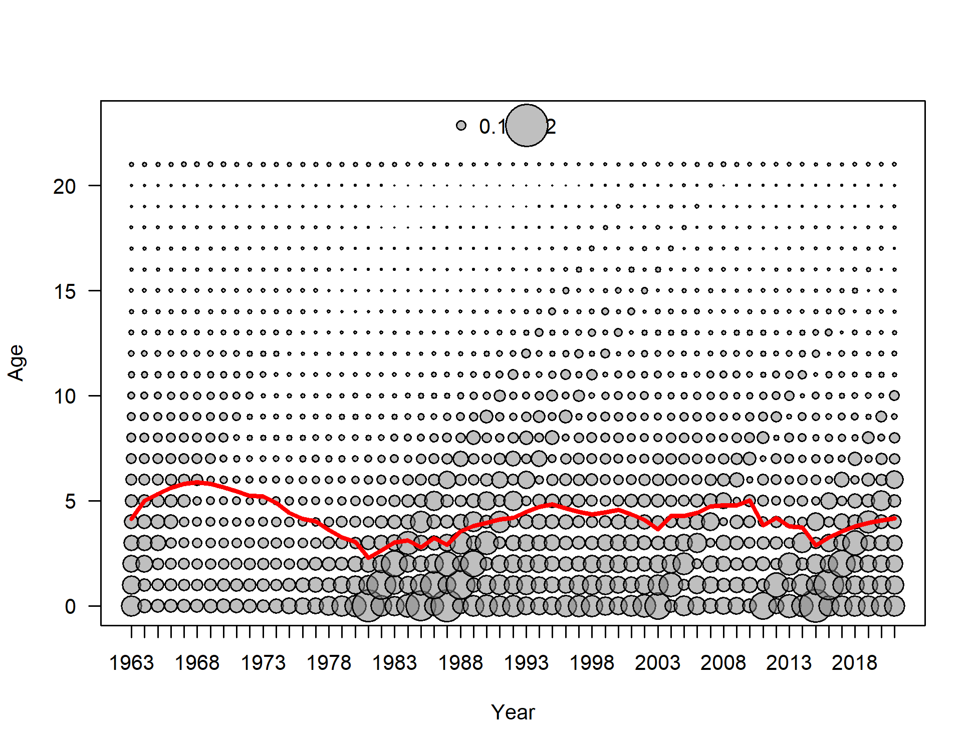

Figure 9.24. Expected numbers-at-age at the beginning of the year for females (top panel) and males (bottom panel) for Model 18.2c (2020). Red lines show expected mean numbers-at-age.

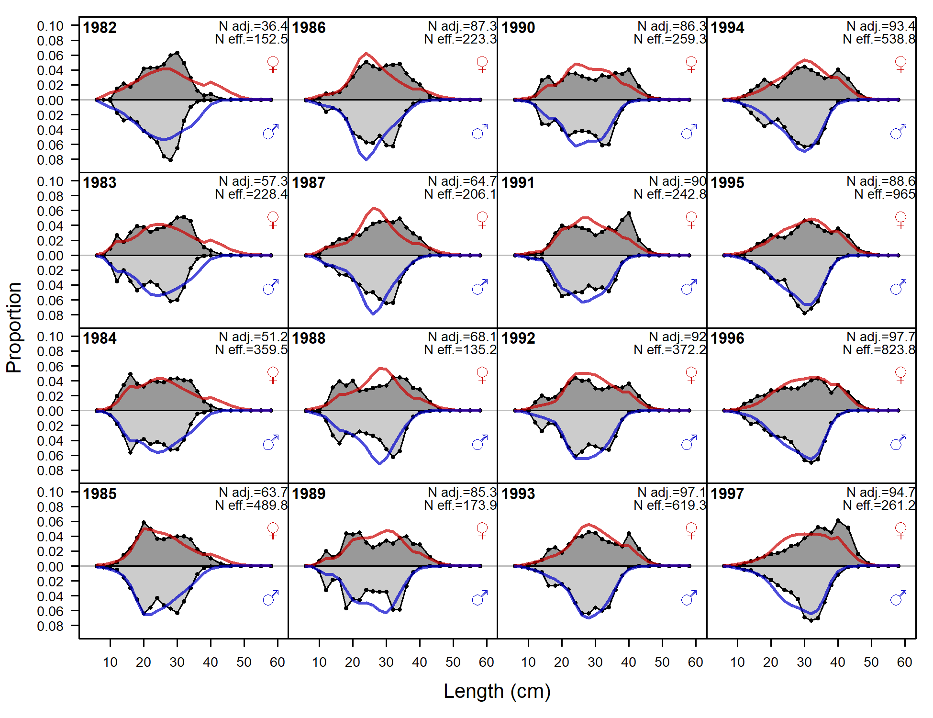

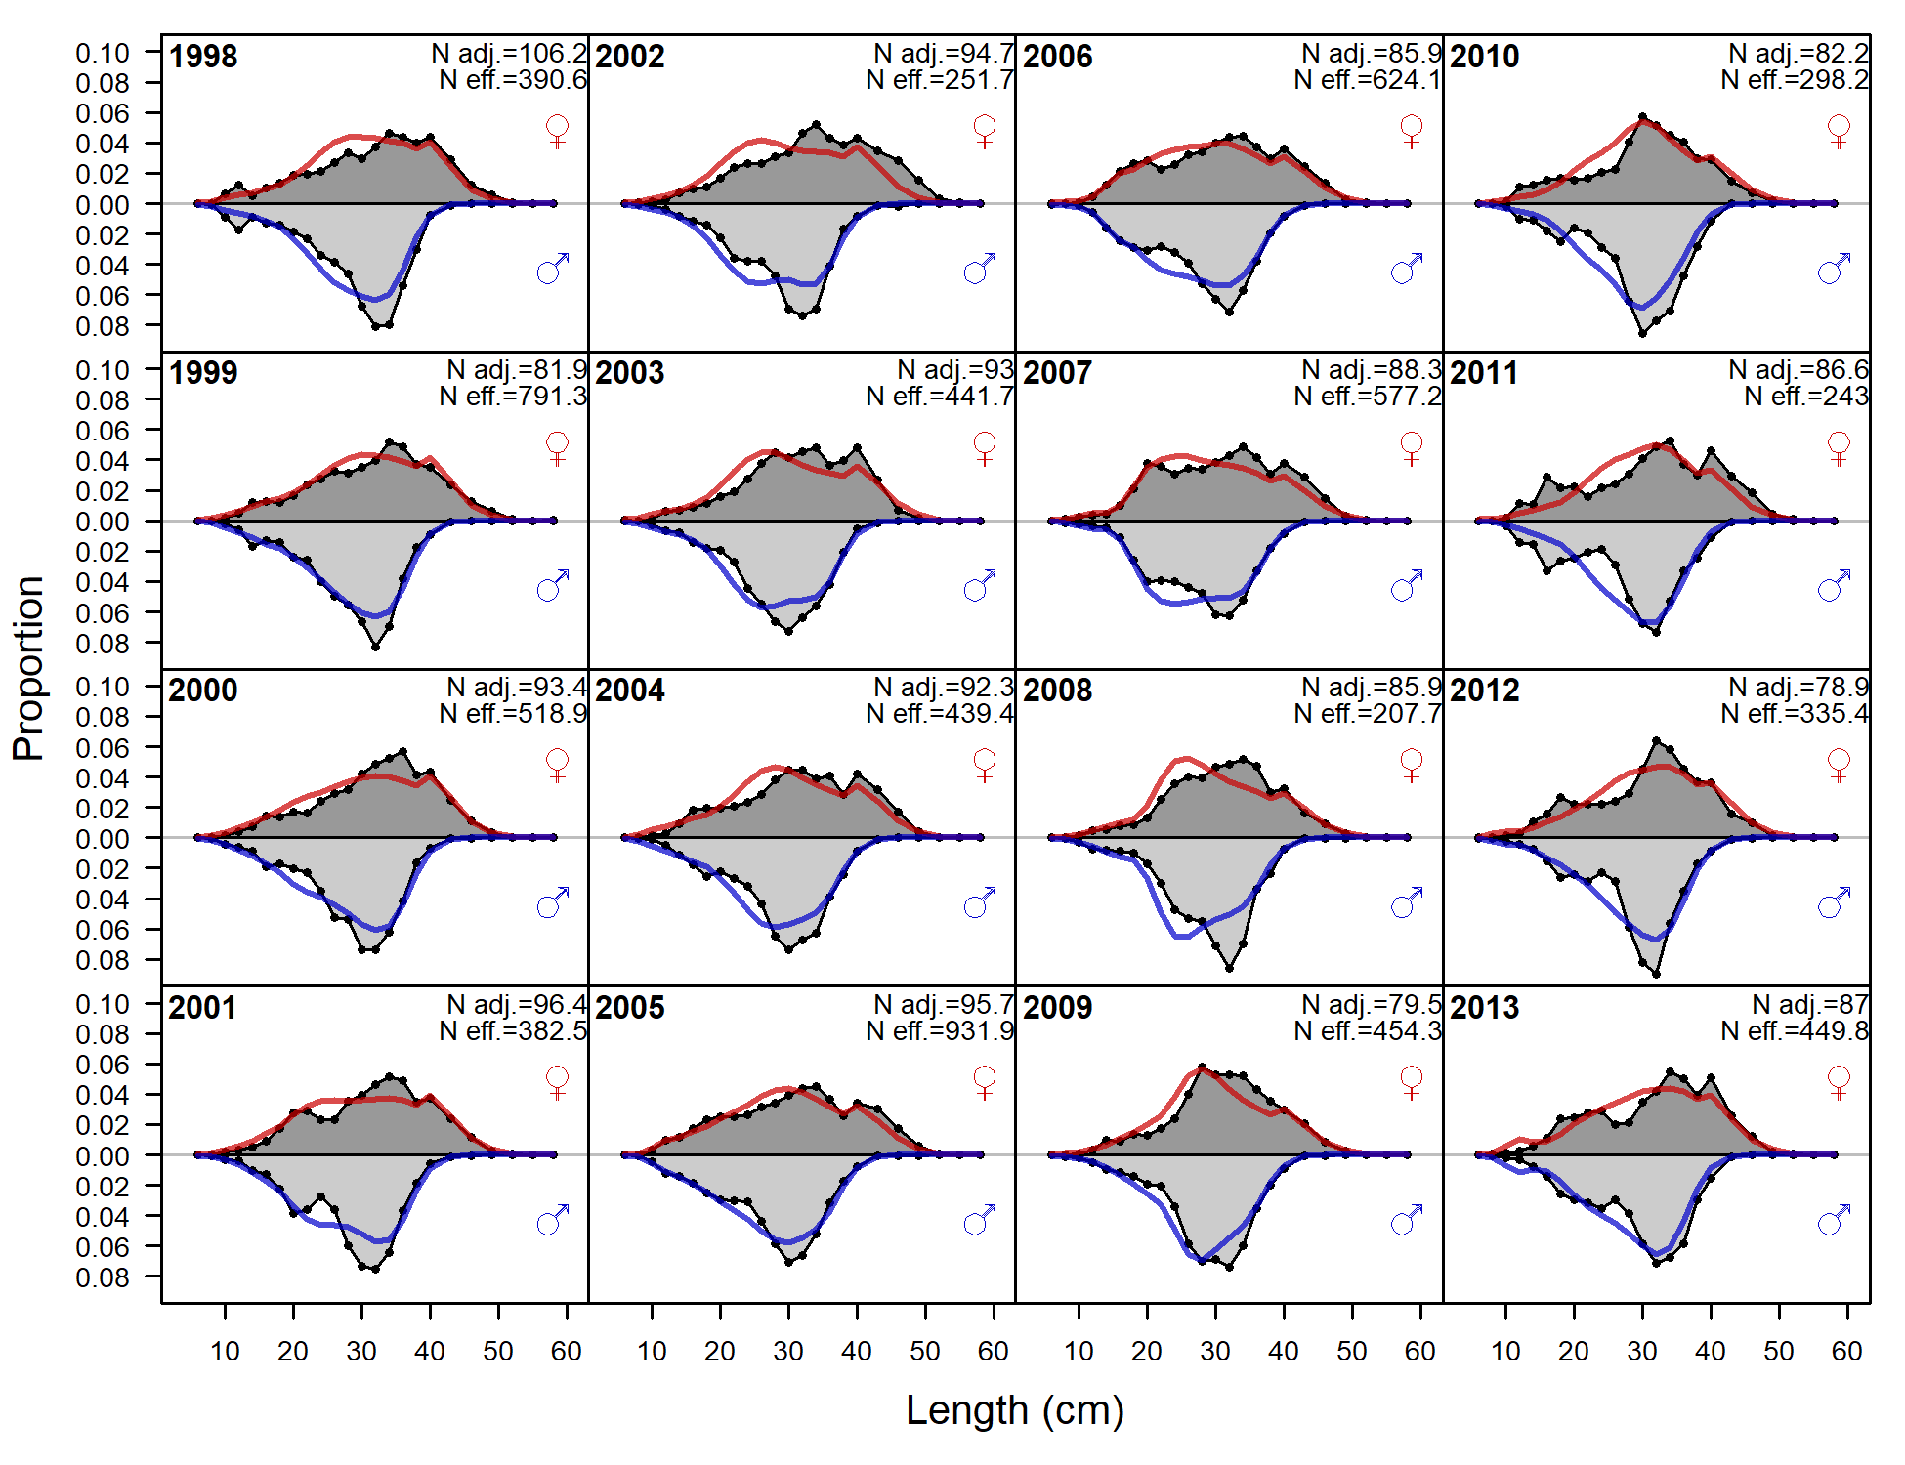

Figure 9.25. Observed (grey filled area and black line) and expected (red and blue lines) survey length compositions for males (blue lines) and females (red lines) for 1982-2013 for Model 18.2c (2020).

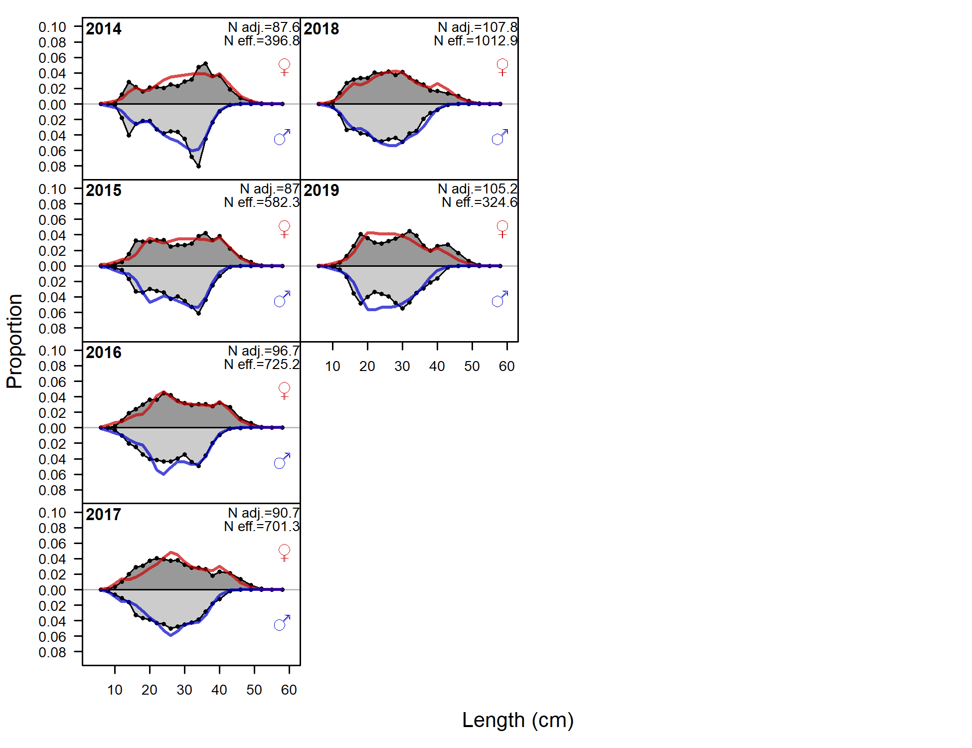

Figure 9.26. As for Figure 9.25, but for 2014-2019.

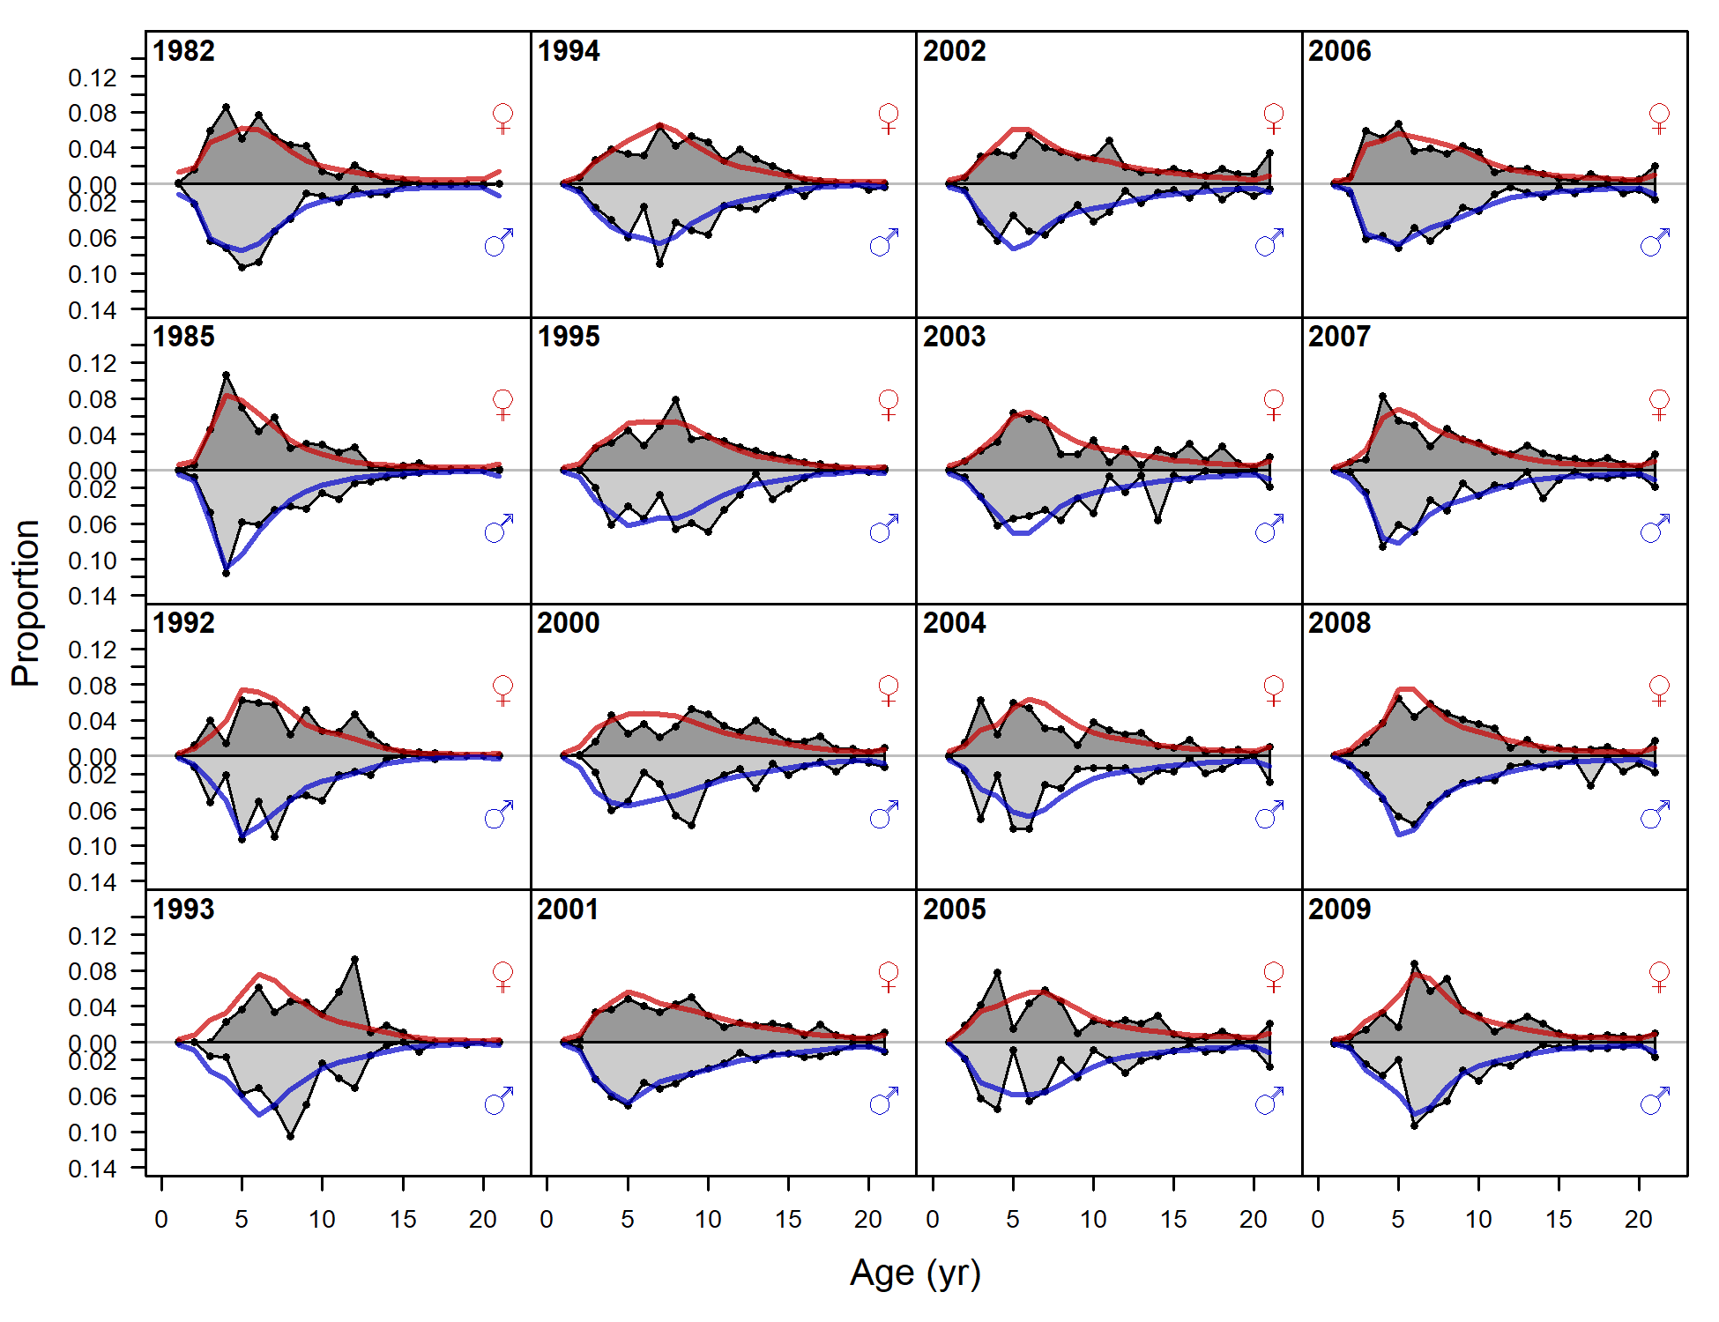

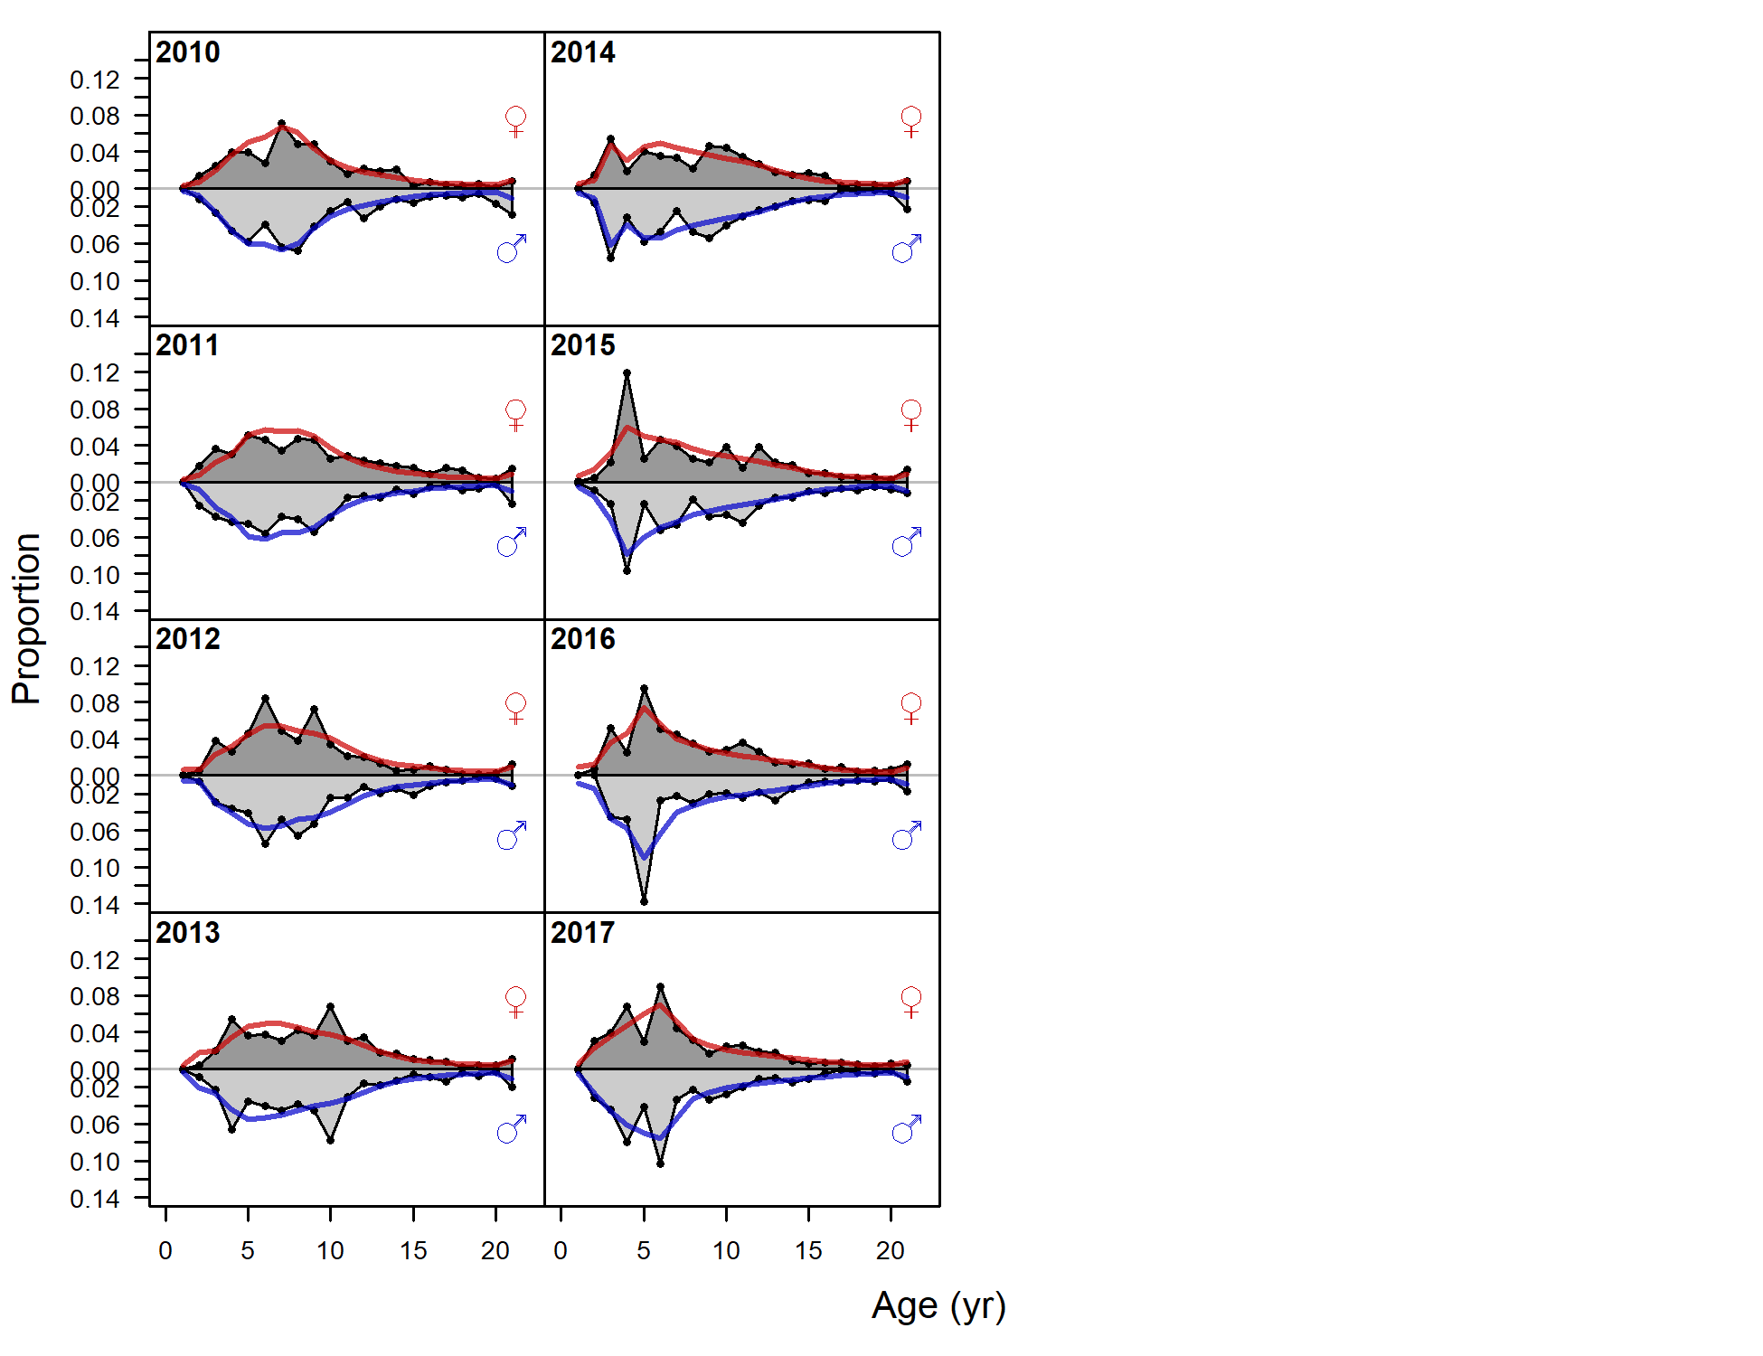

Figure 9.27. Observed (grey filled area and black line) and expected (red and blue lines) ghost survey age compositions for males (blue lines) and females (red lines) for all years of age composition data for Model 18.2c (2020). A conditional age-at-length approach was used and age composition aggregated over length bins was not fit in the objective function.

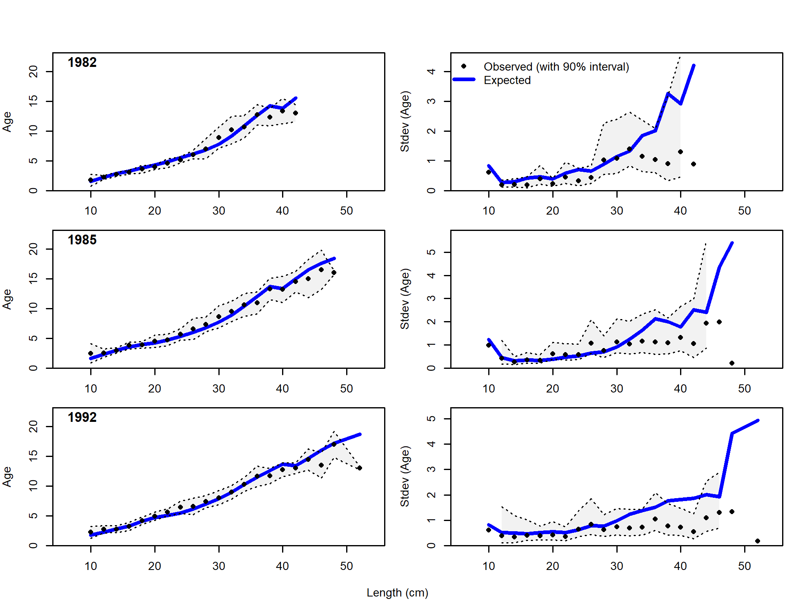

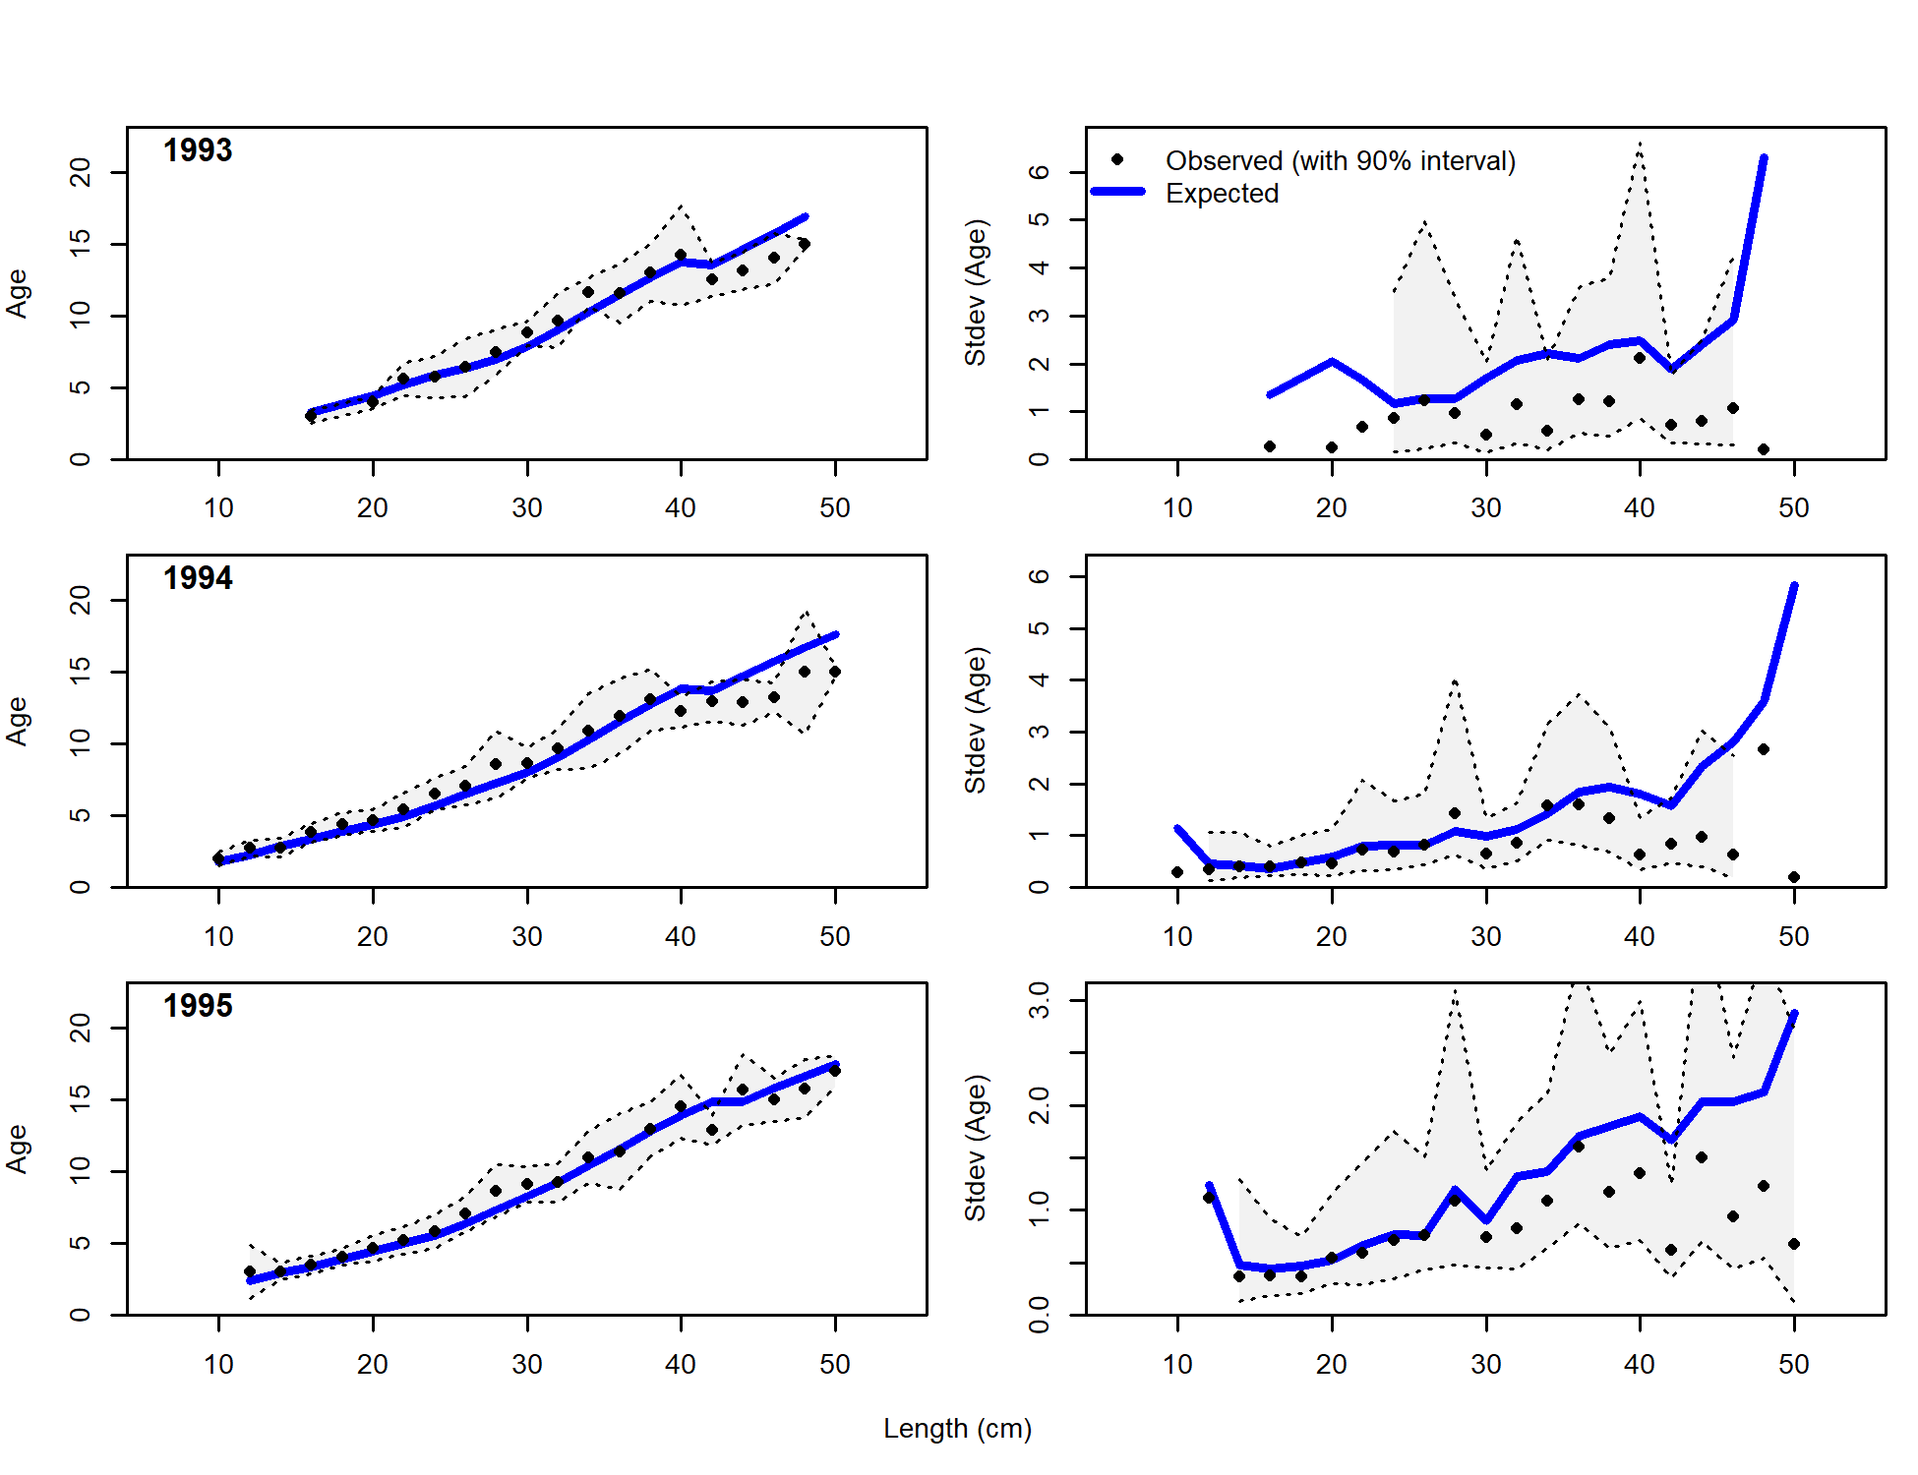

Figure 9.28. Observed and expected mean age-at-length for both females and males with 90% intervals about observed age-at-length (left panels) and observed and expected standard deviation in age-at-length (right panels) for Model 18.2c for years 1982-1995.

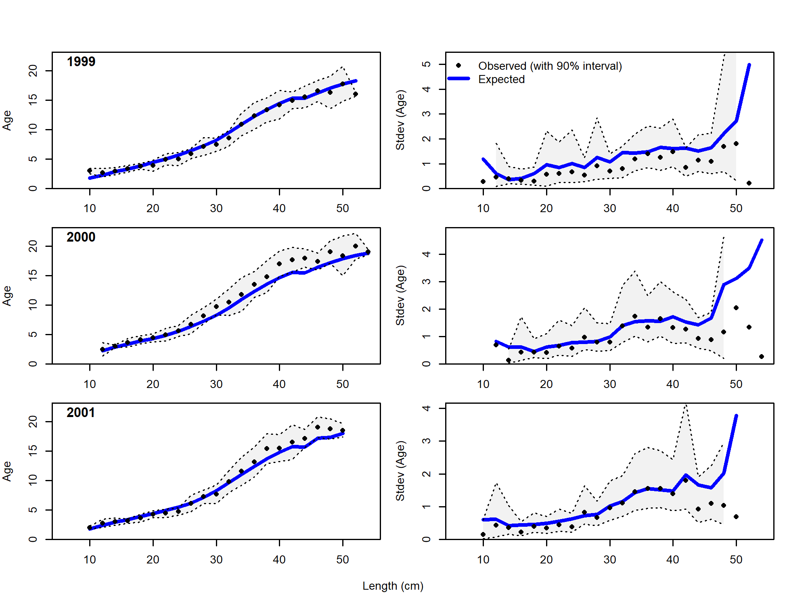

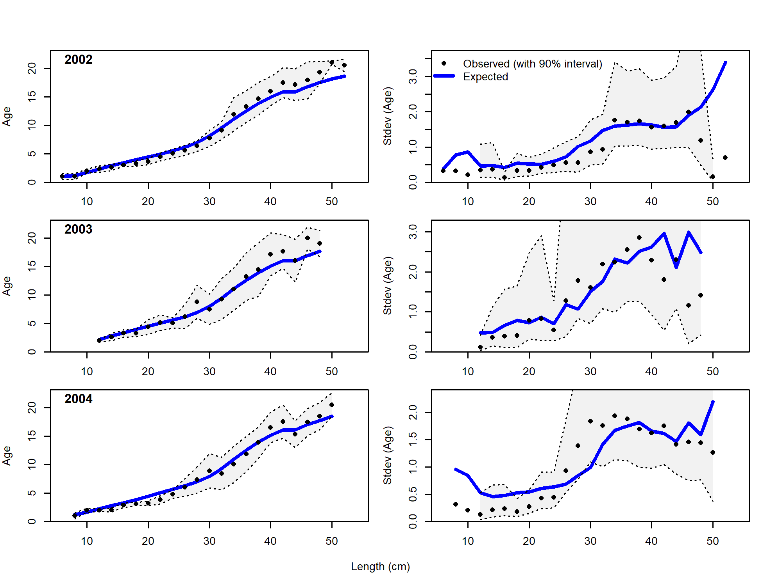

Figure 9.29. As for Figure 9.28, but for years 1999-2004.

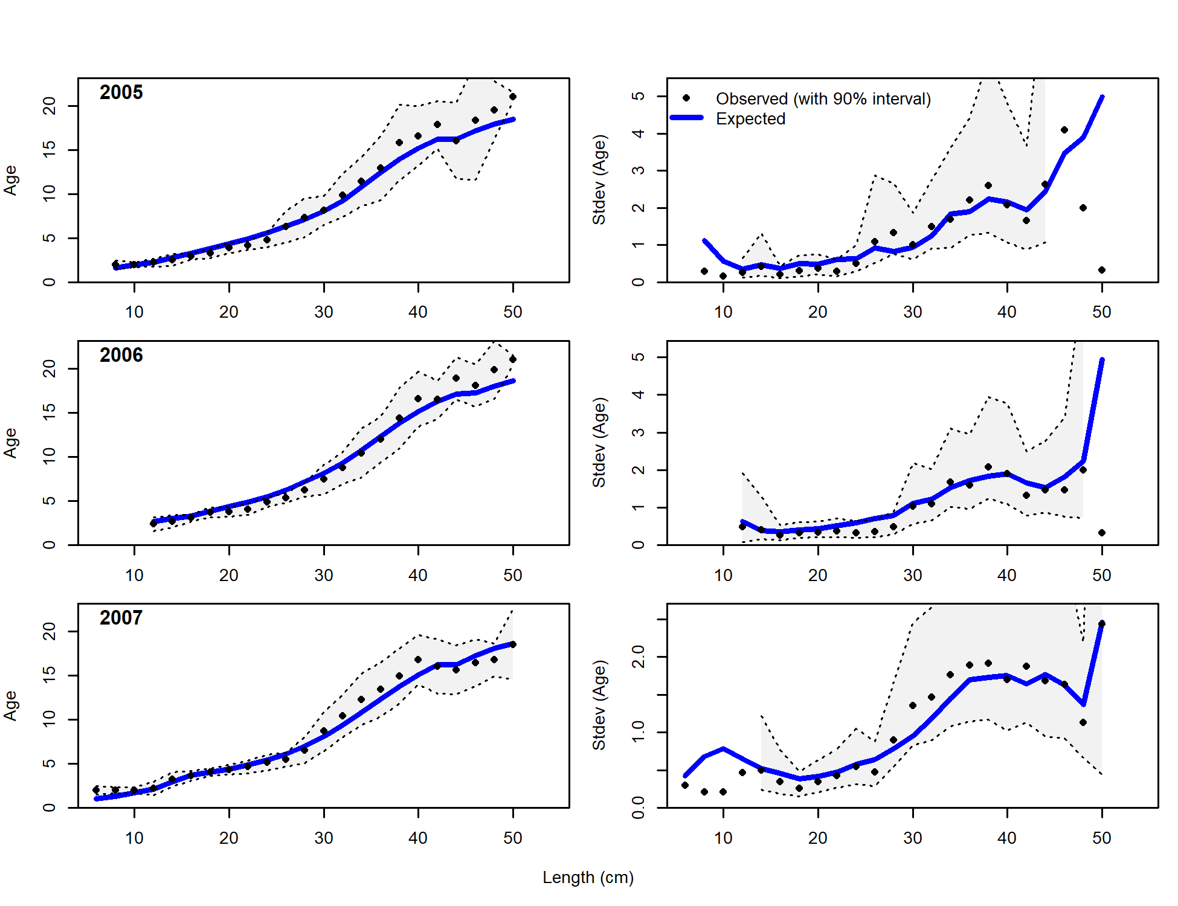

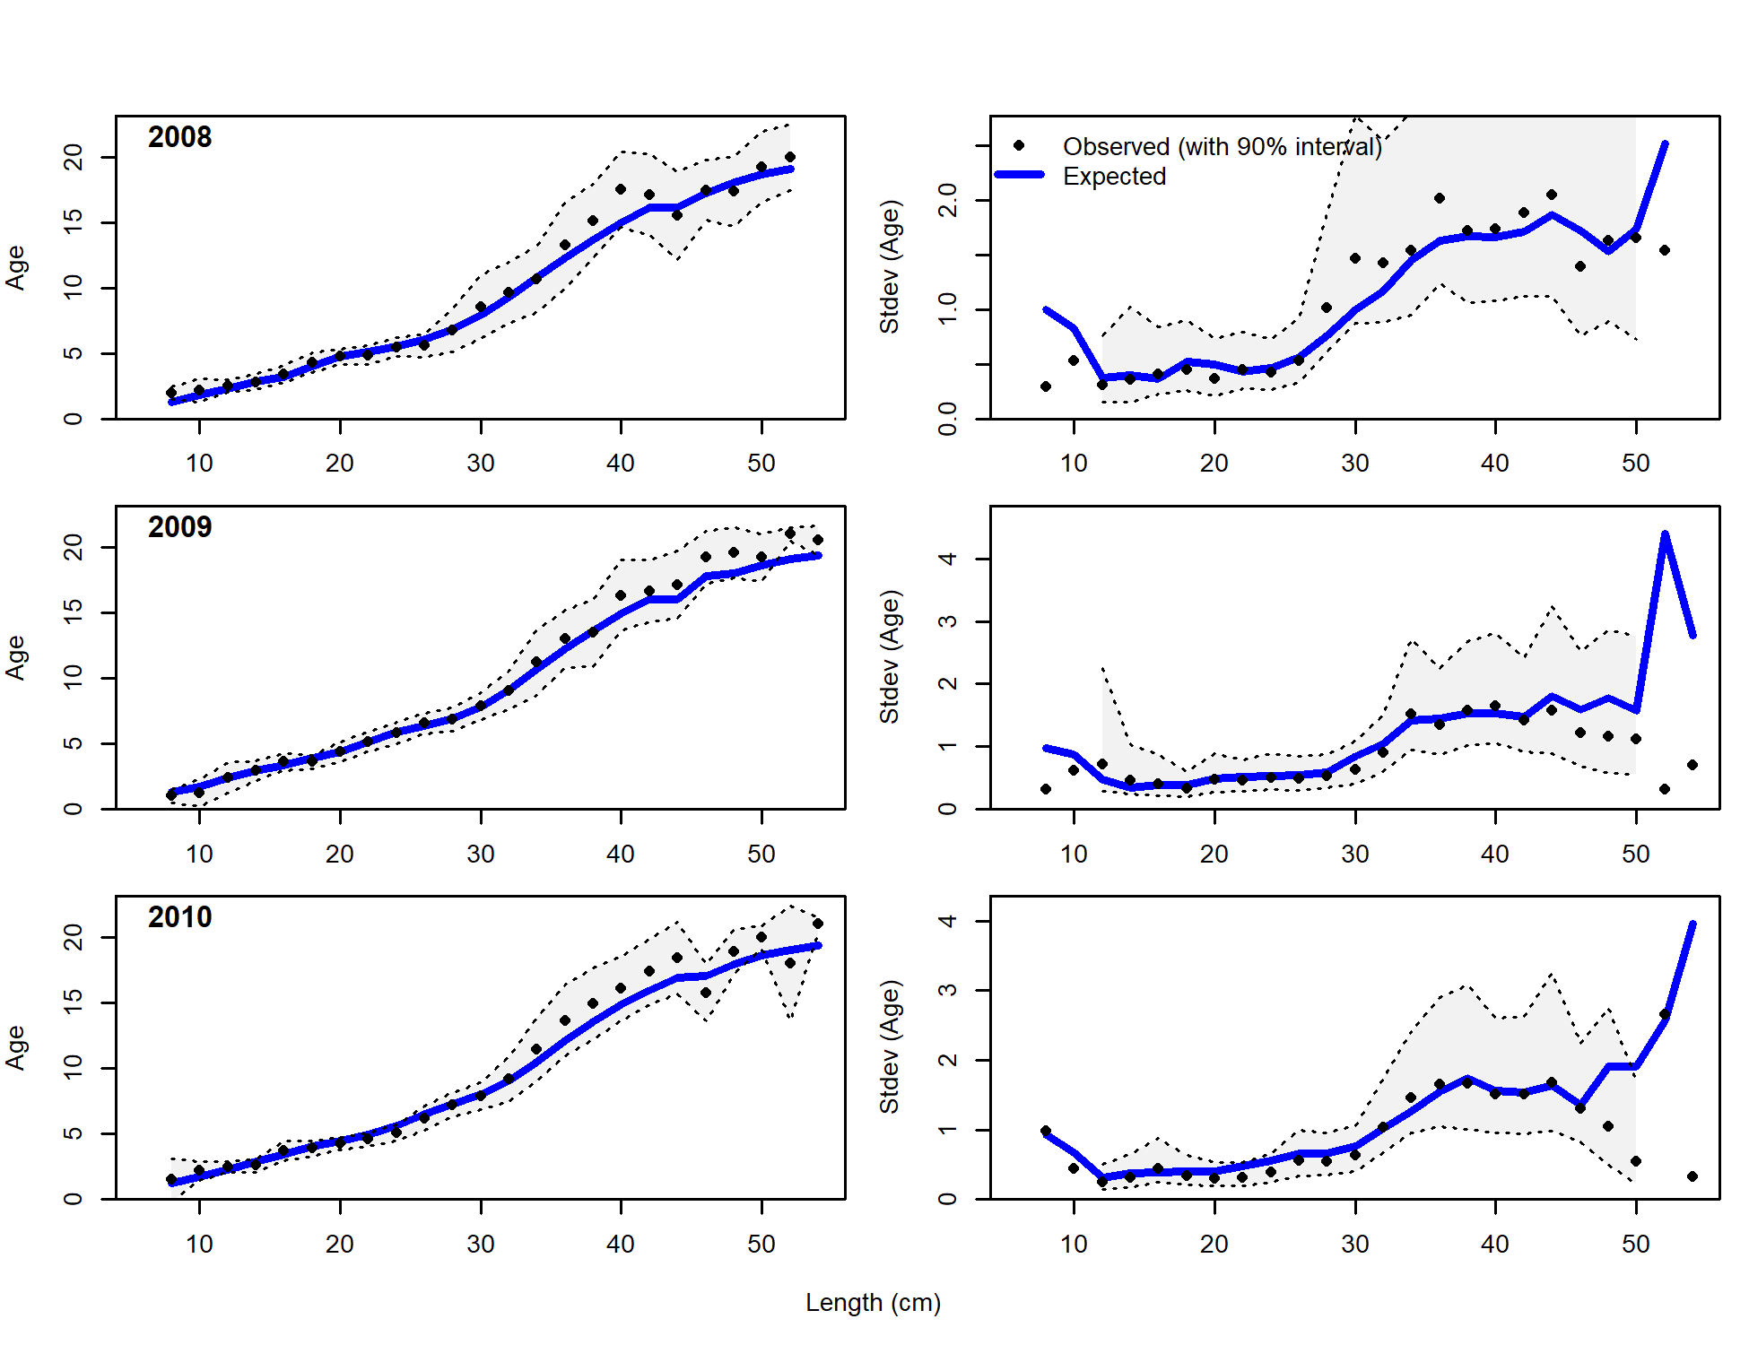

Figure 9.30. As for Figure 9.28, but for years 2005-2010.

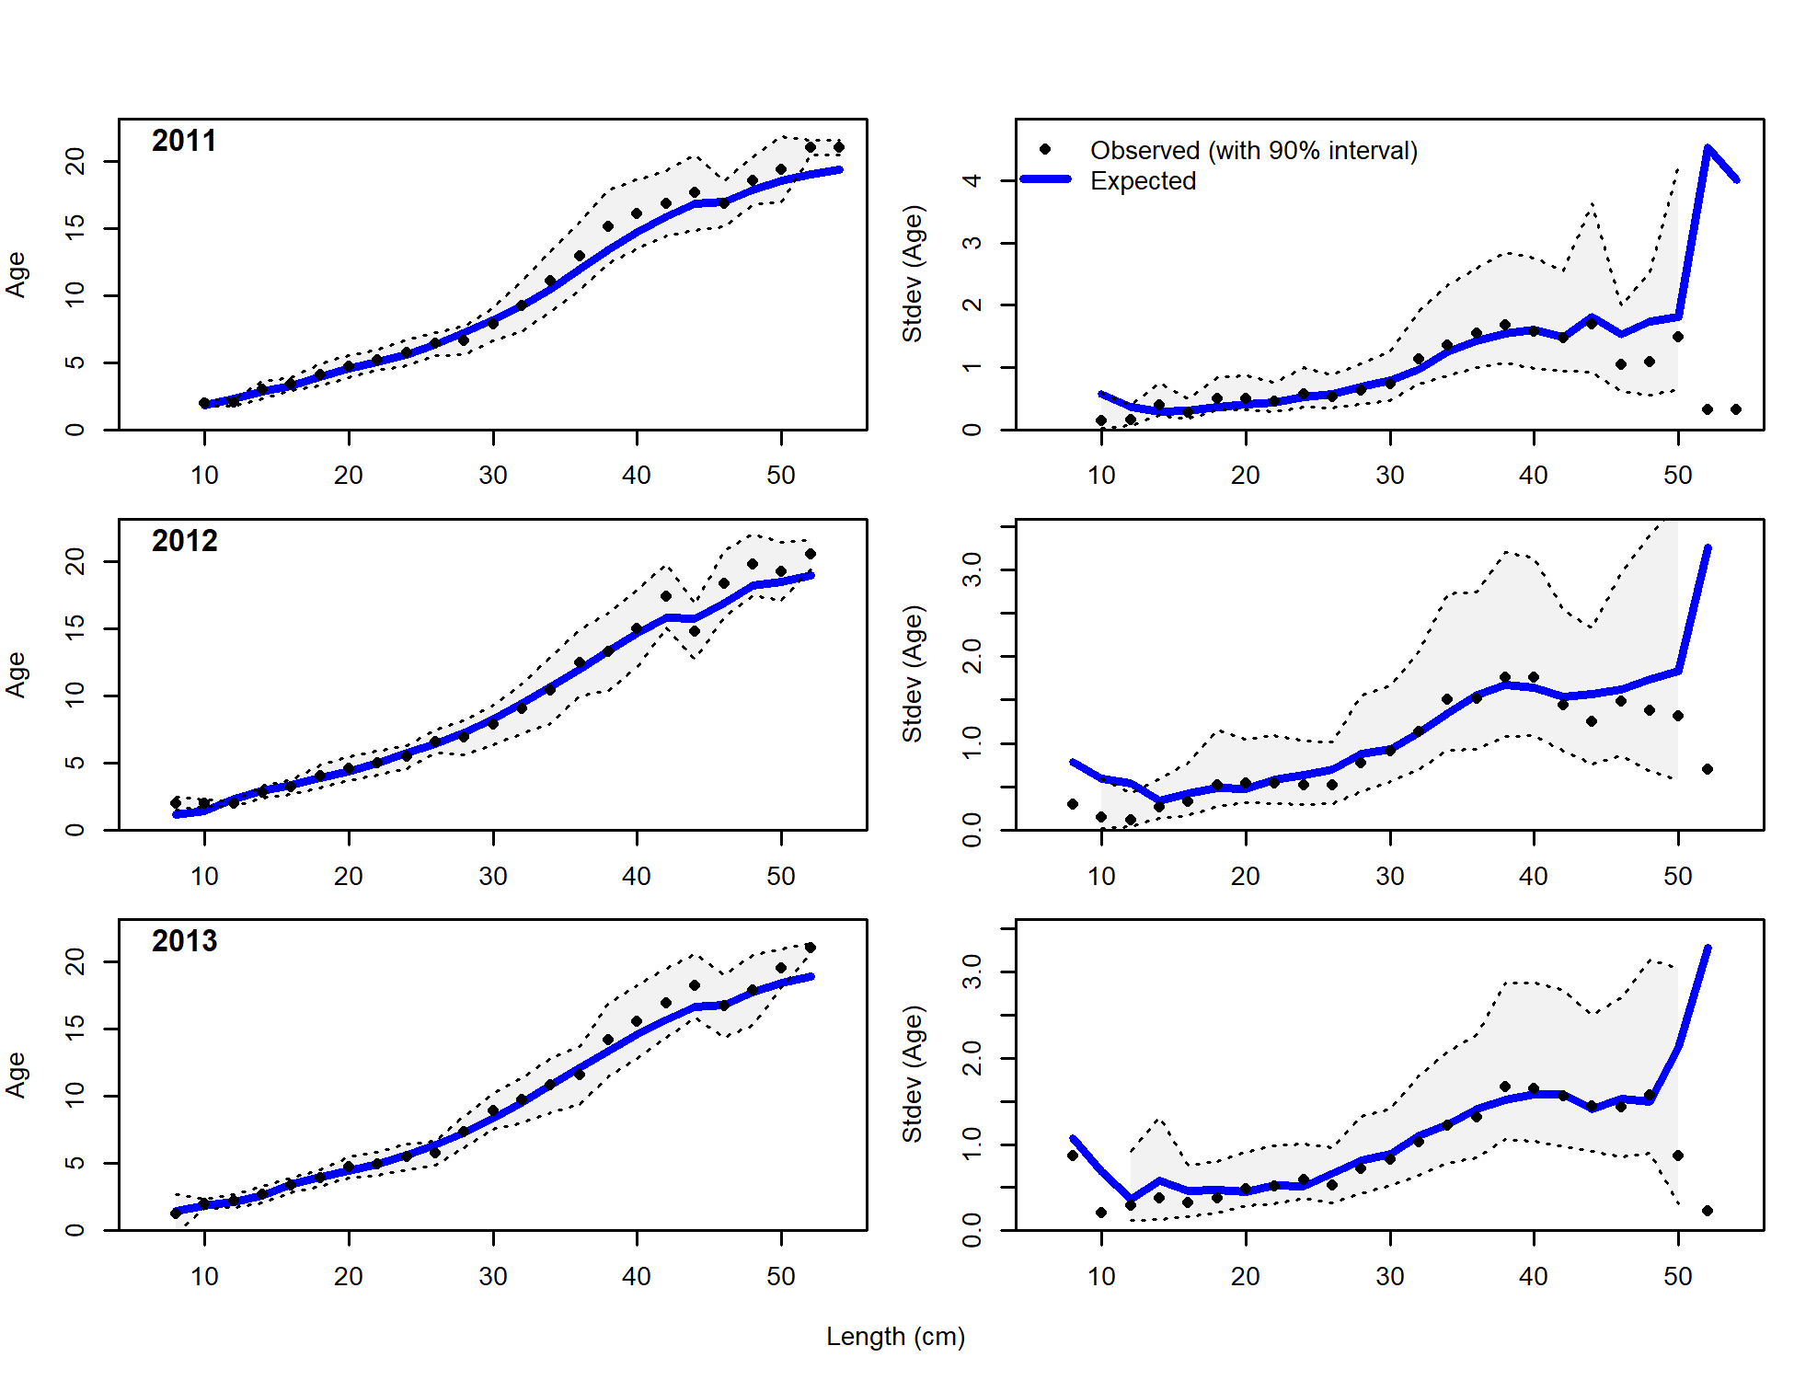

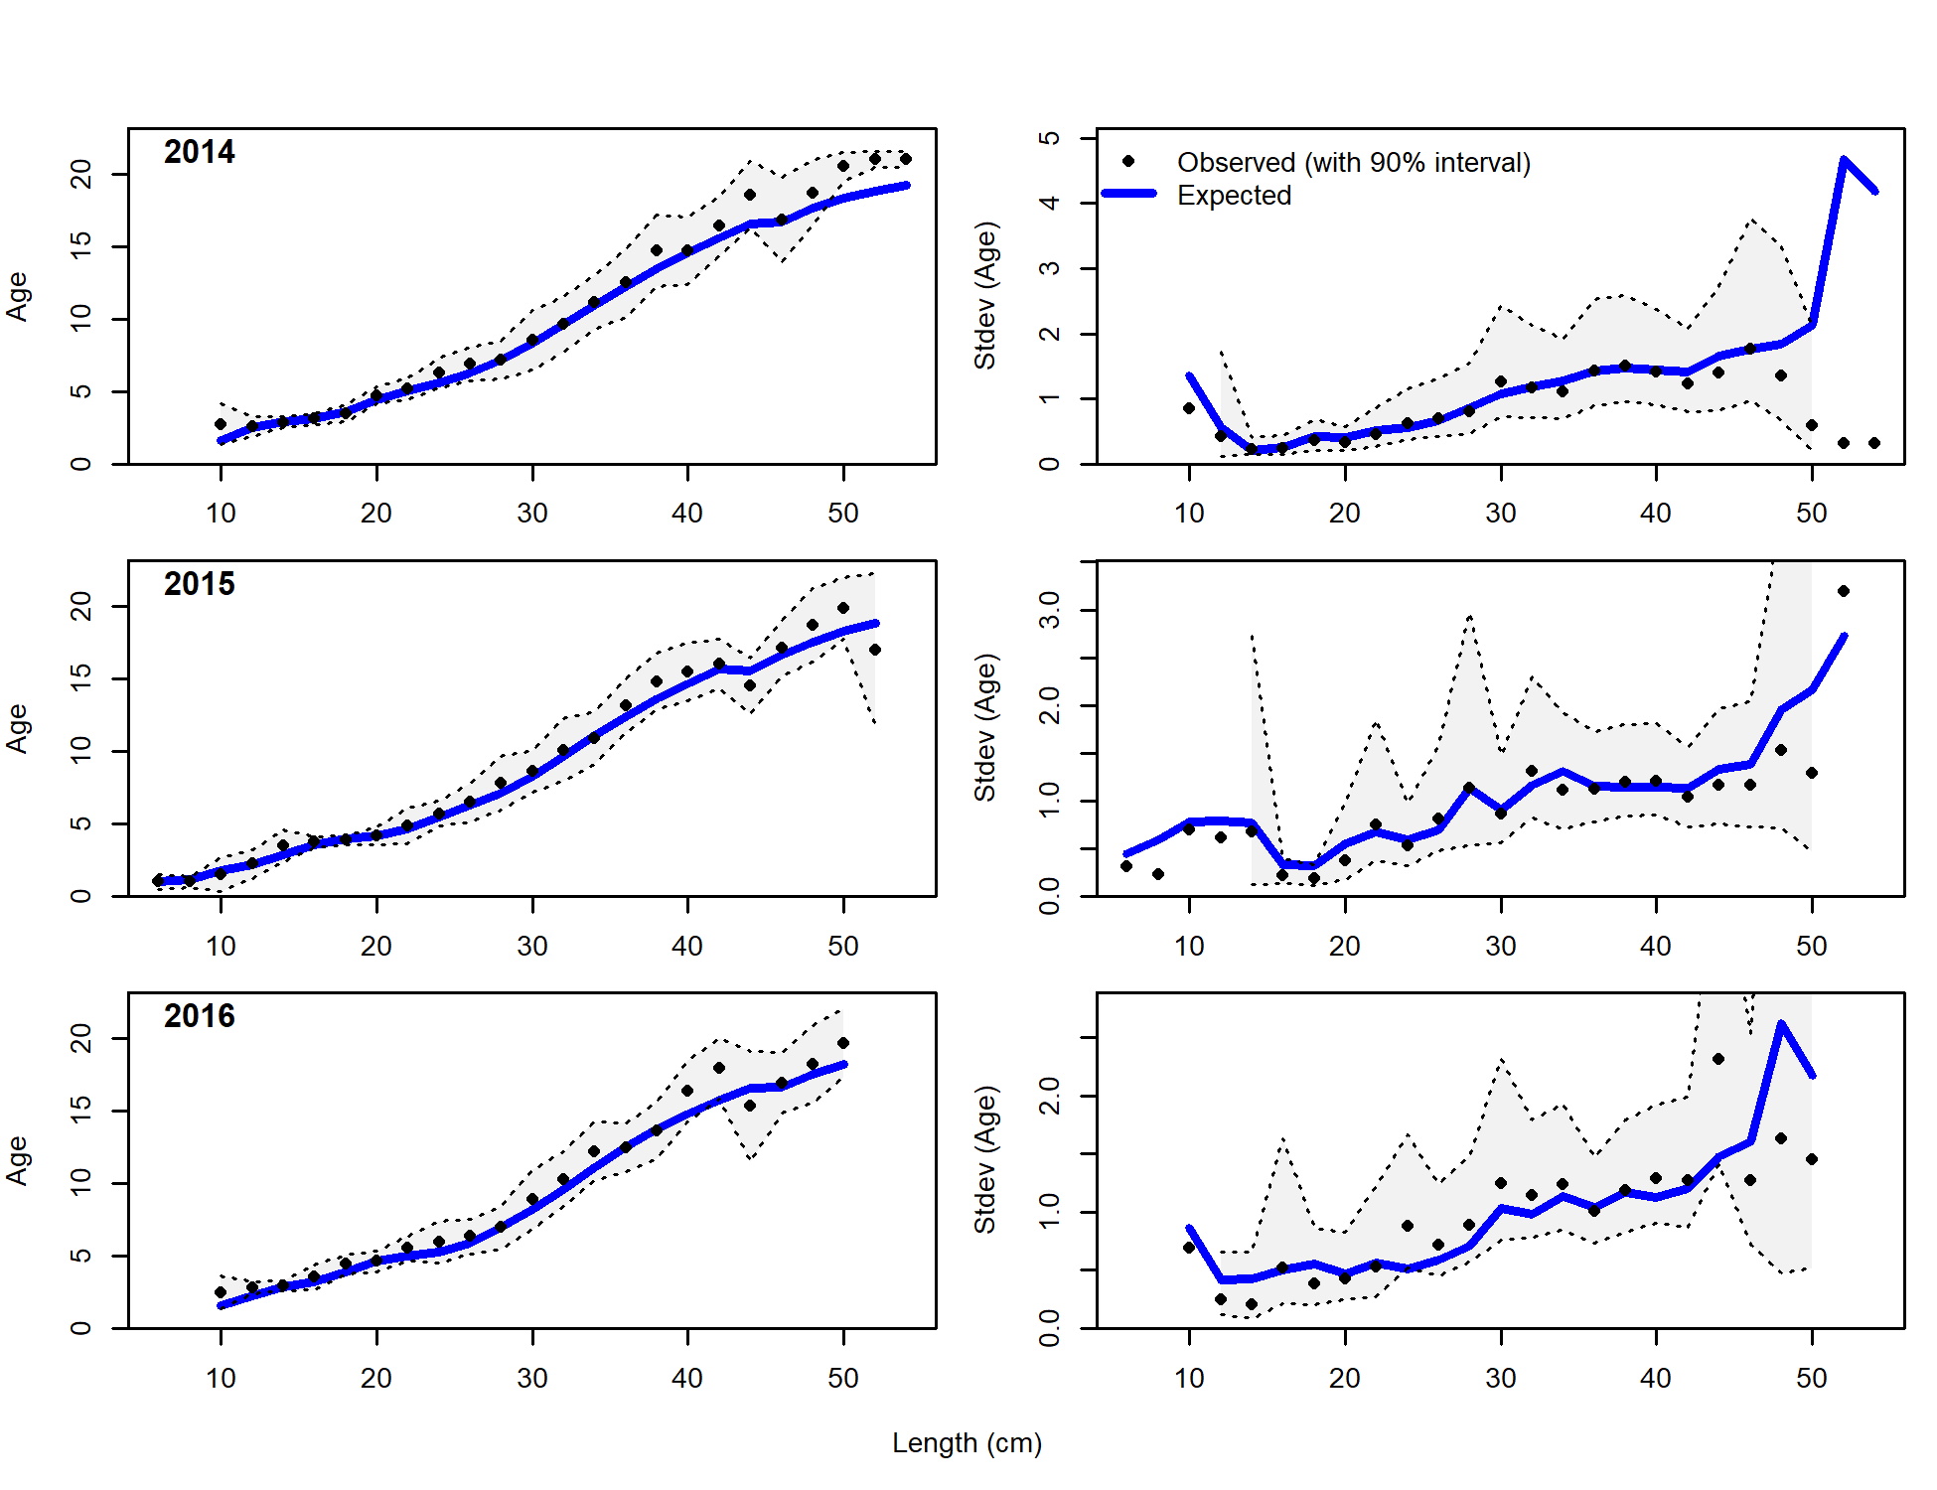

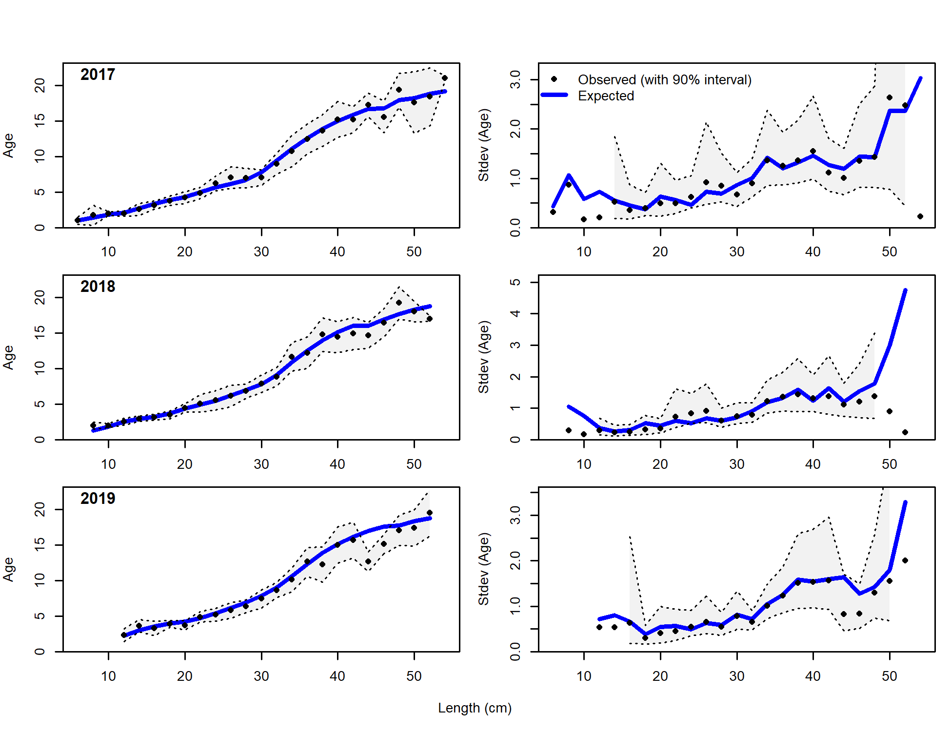

Figure 9.31. As for Figure 9.28, but for years 2011-2019.

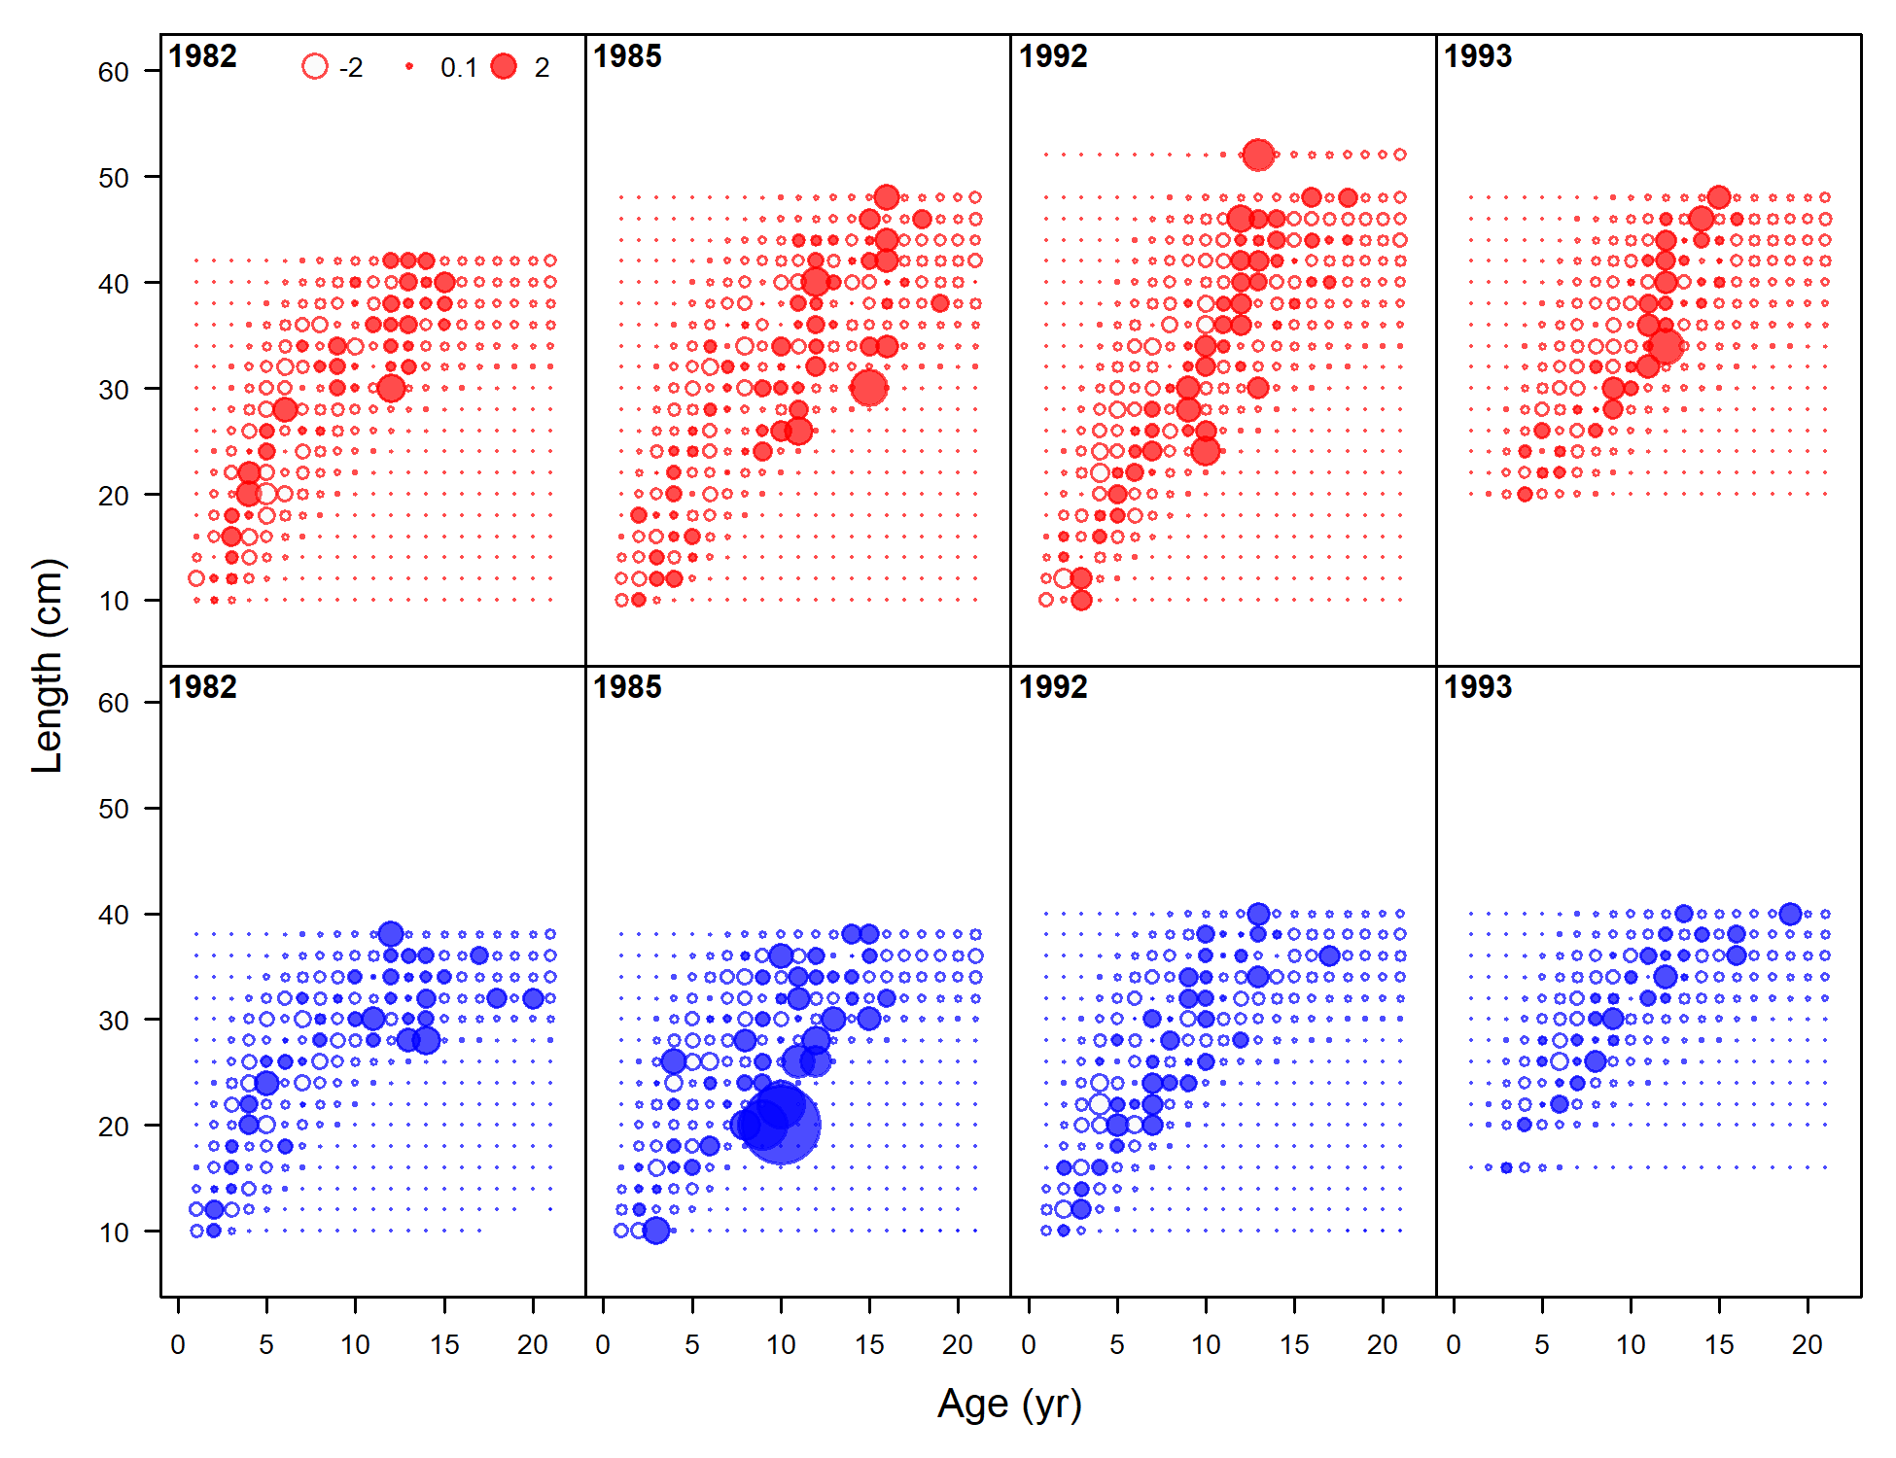

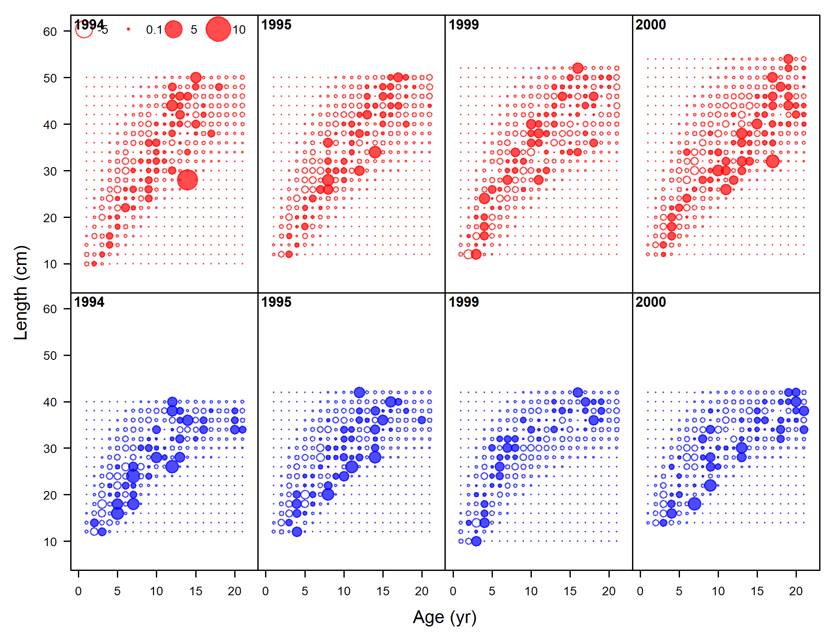

Figure 9.32. Pearson residuals for model fits to conditional age-at-length data for females (red) and males (blue) for years 1982-2001. Filled circles indicate positive residuals (observed>expected) and open circles indicate negative residuals (observed<expected). The maximum value was 20.55.

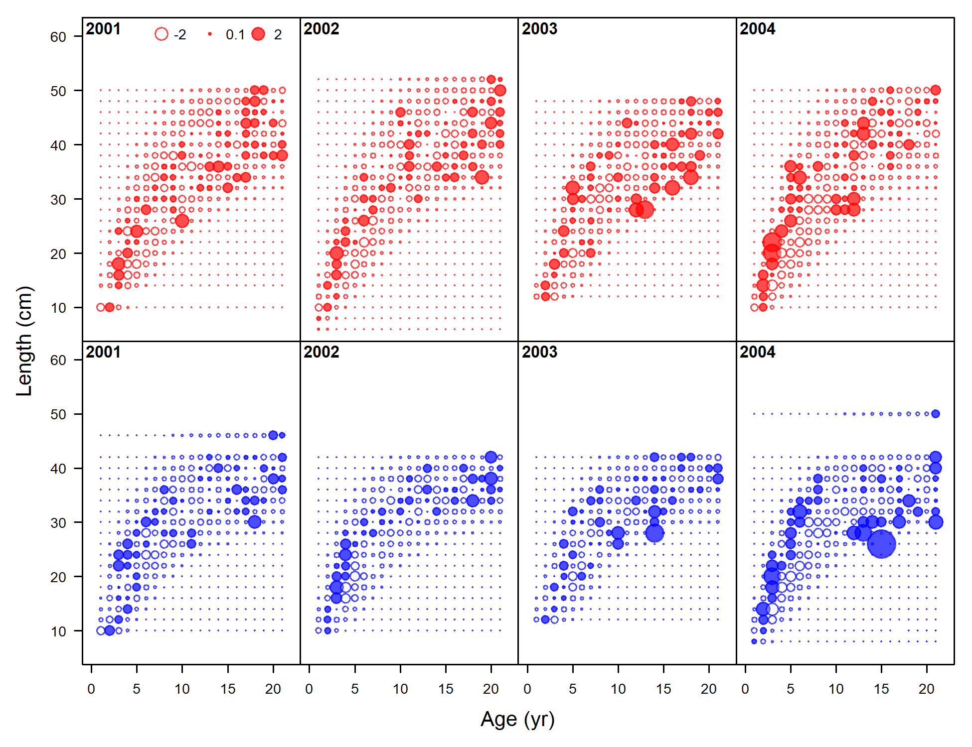

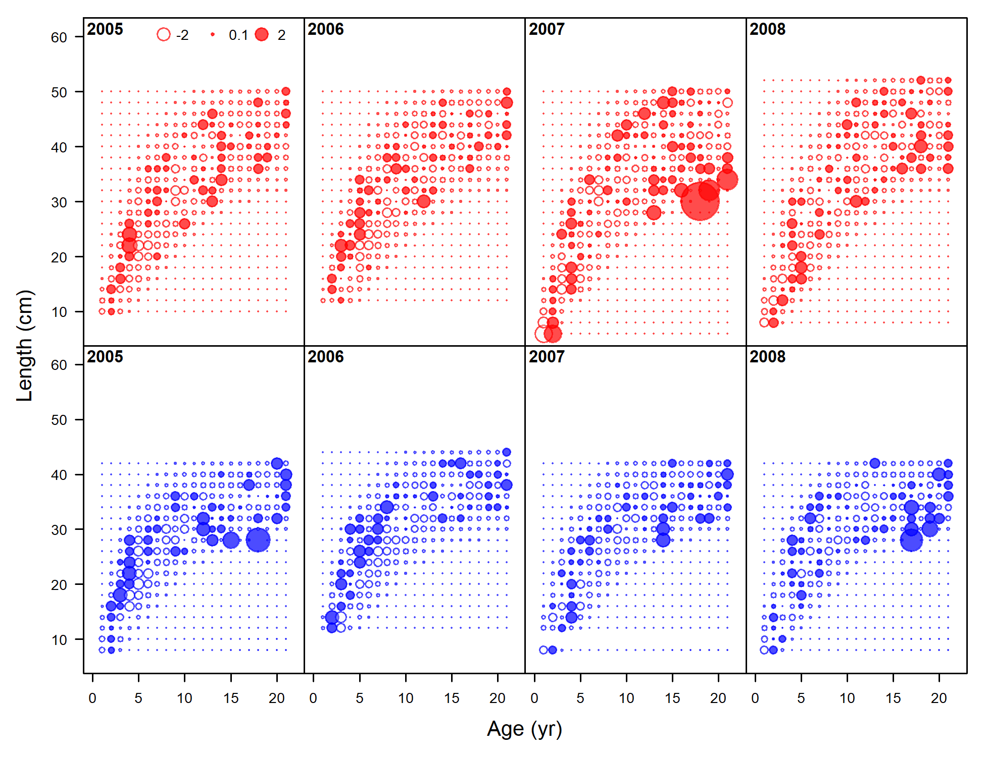

Figure 9.33. As for Figure 9.32, but for years 2002-2009.

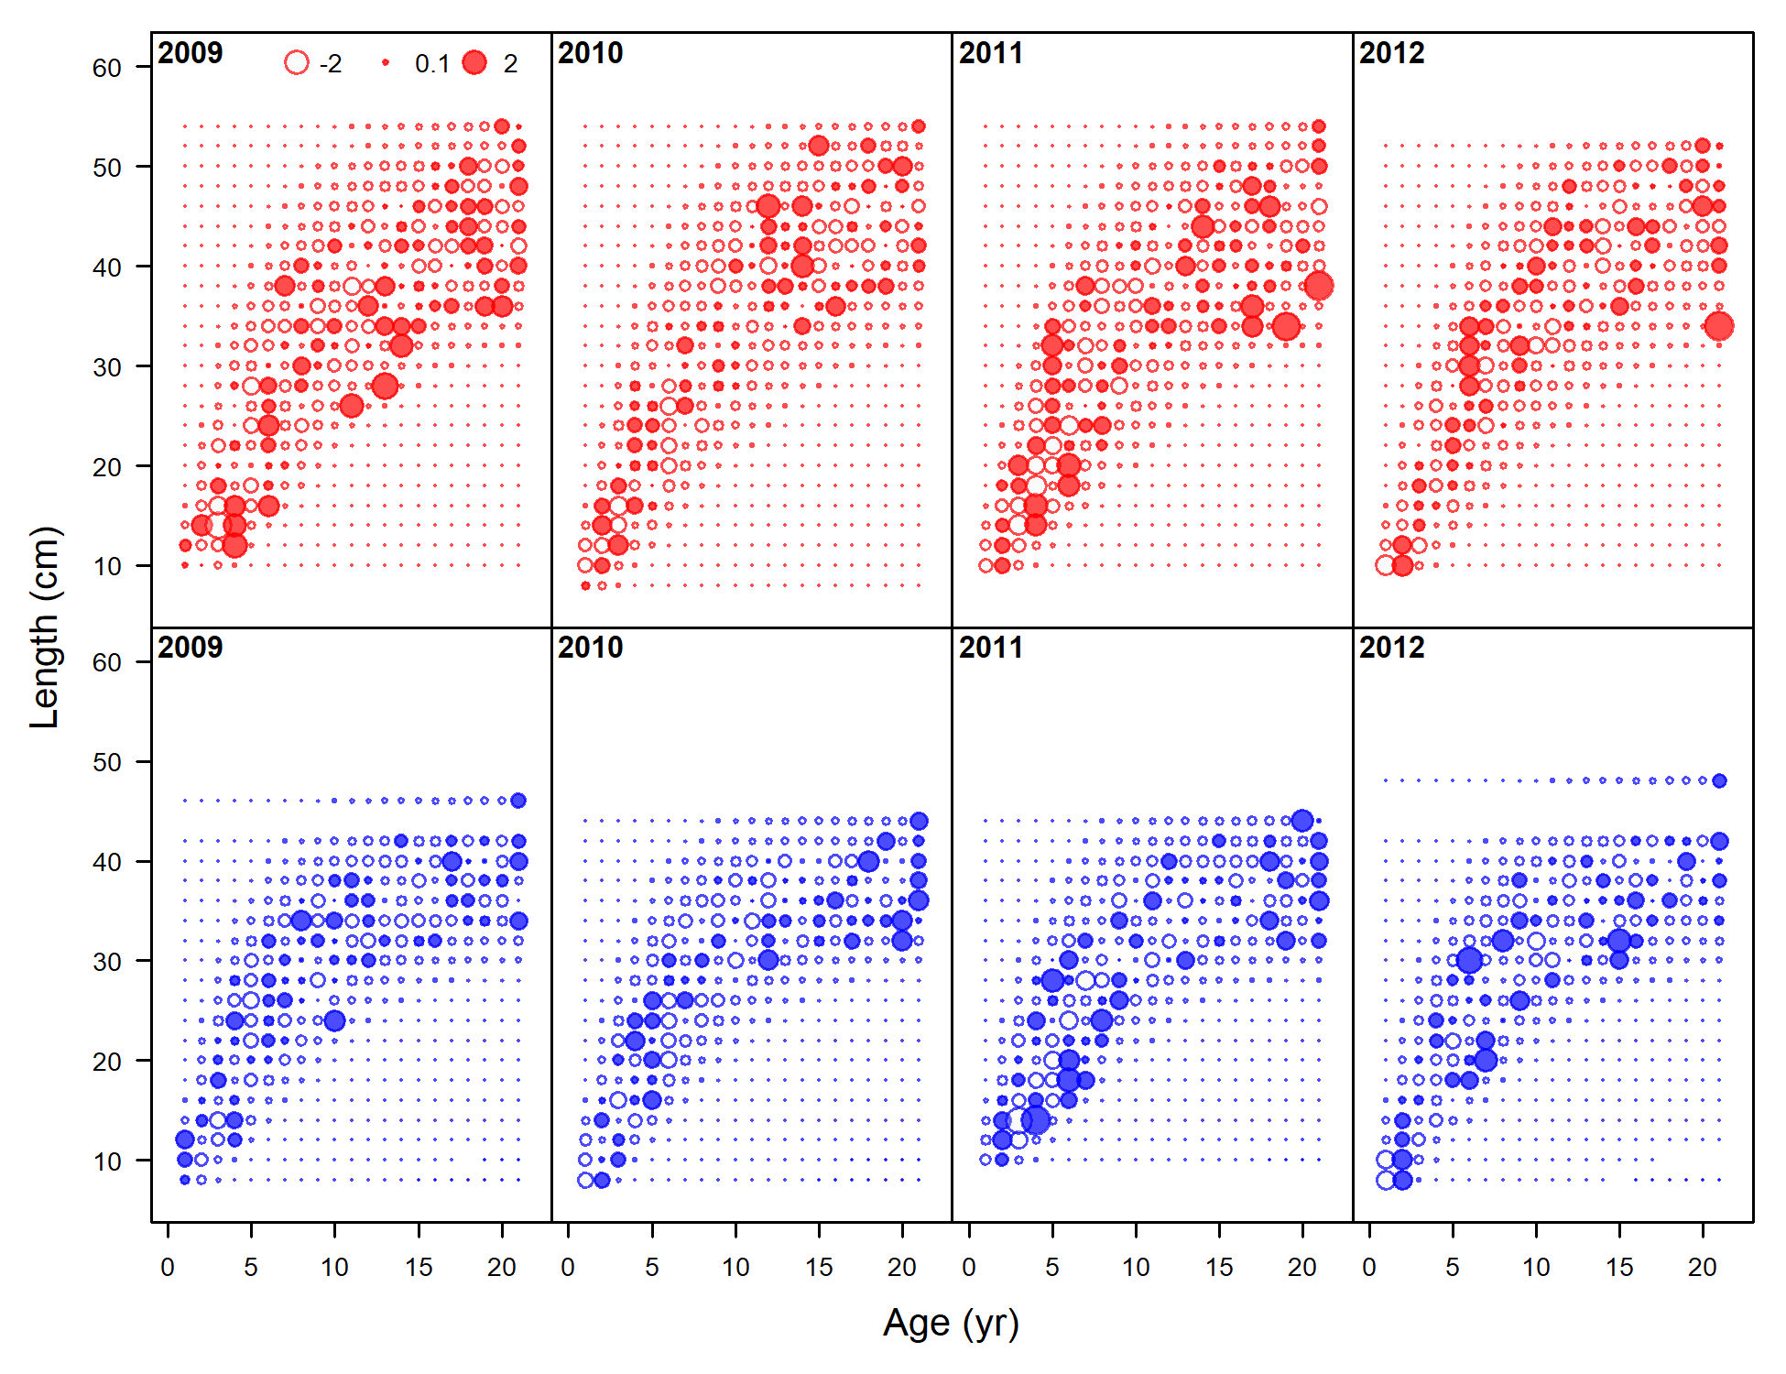

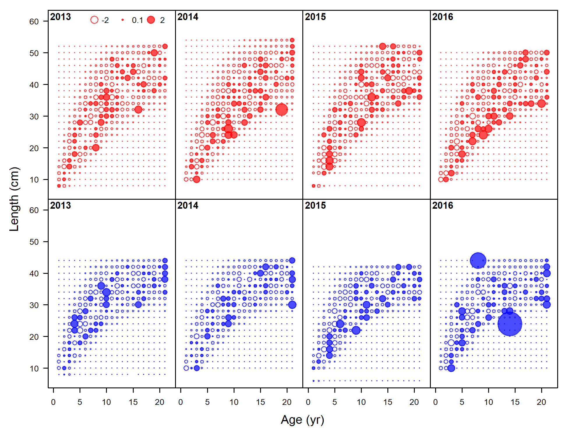

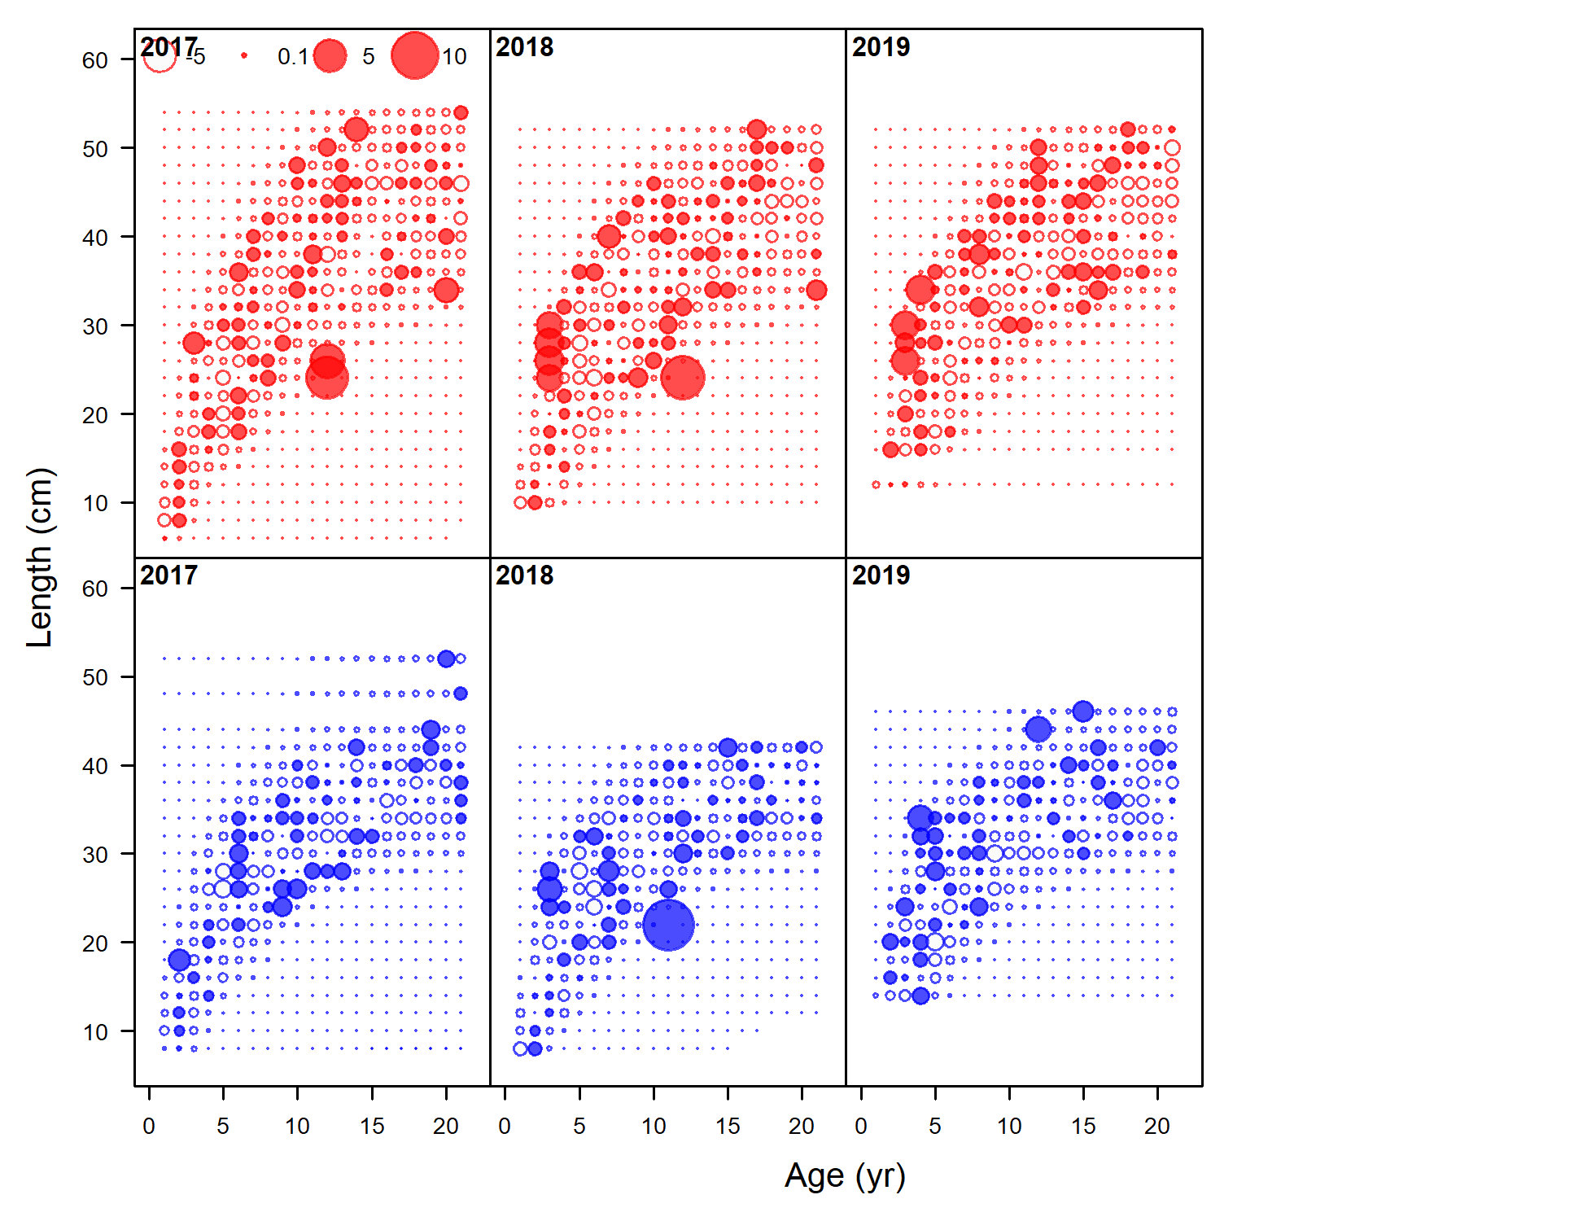

Figure 9.34. As for Figure 9.32, but for years 2010-2019.

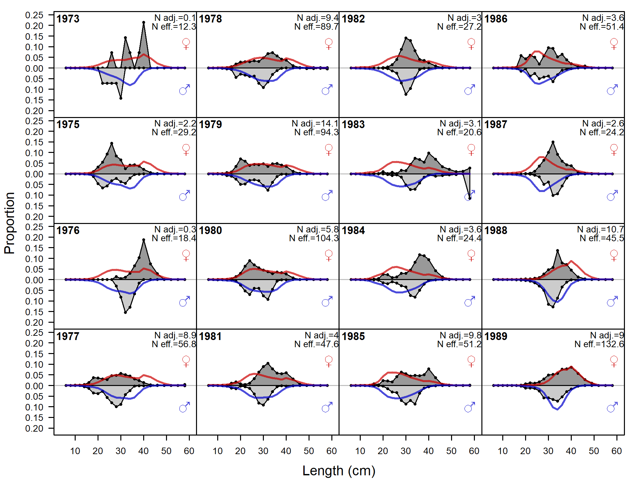

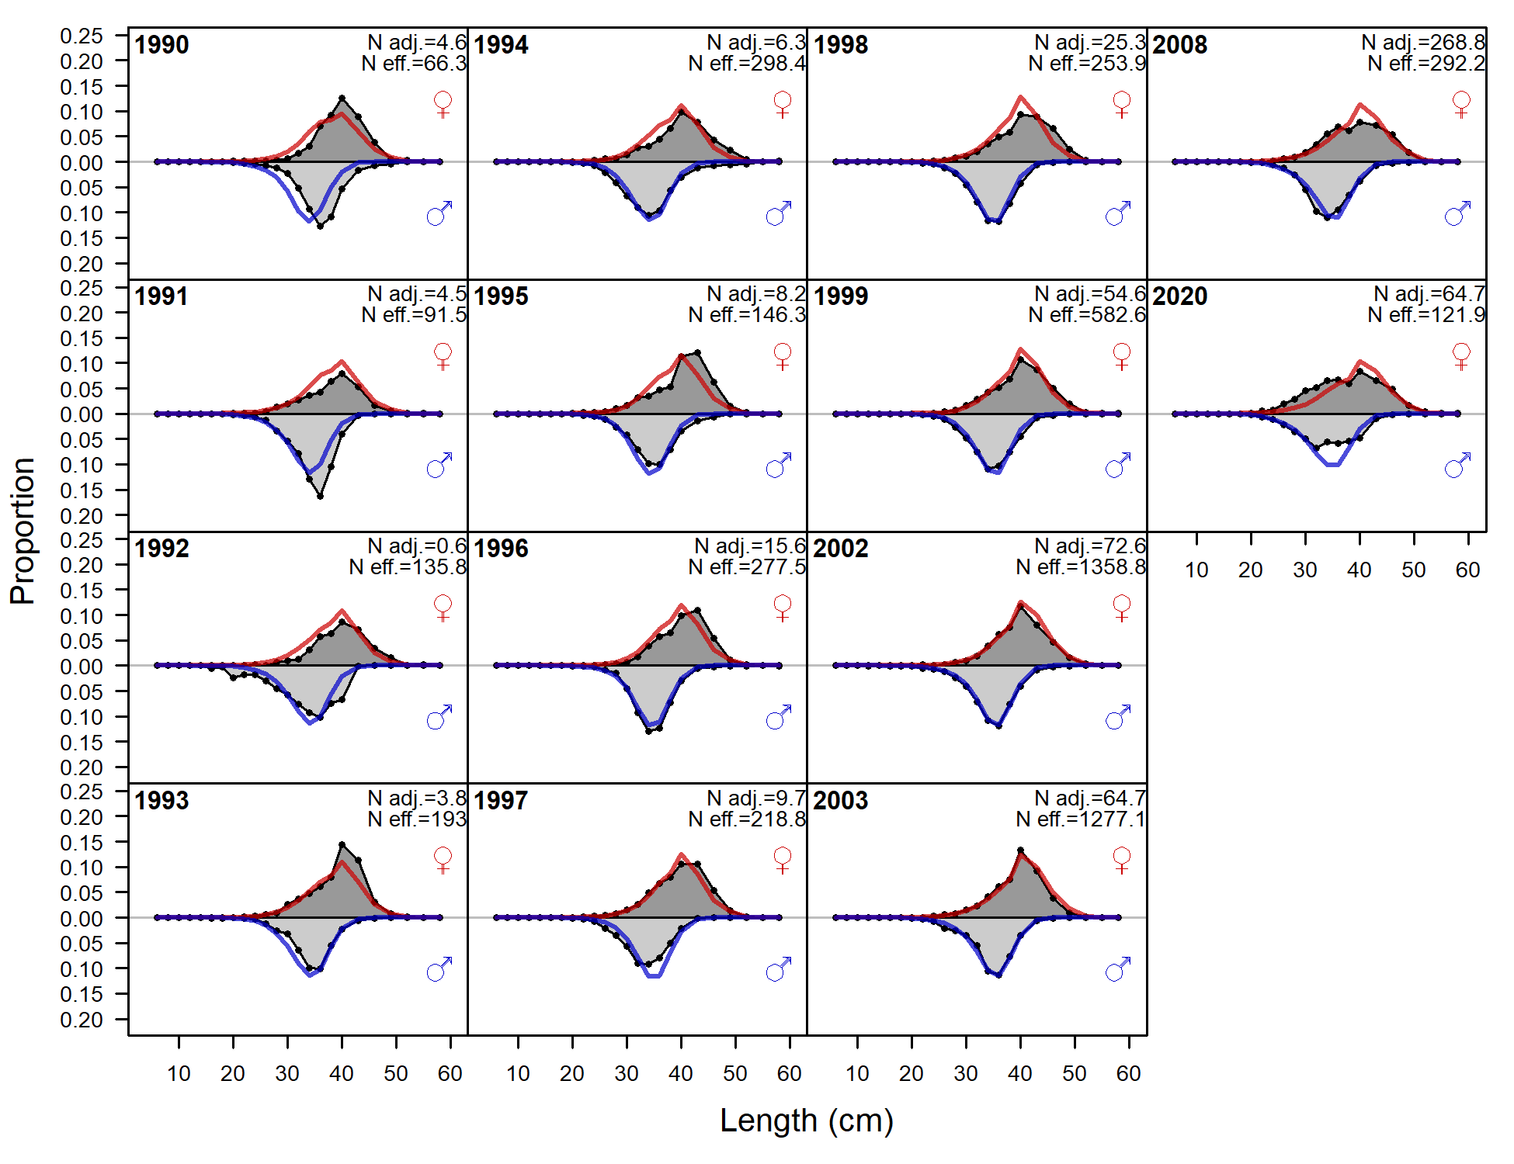

Figure 9.35. Observed (grey filled area and black line) and expected (red and blue lines) fishery length compositions for males (blue lines) and females (red lines) for all years for Model 18.2c (2020). Lengths compositions are only included in the model likelhiood for years when there are not age compositions, otherwise the lengths are included as a ghost fleet (Fig. 9.36).

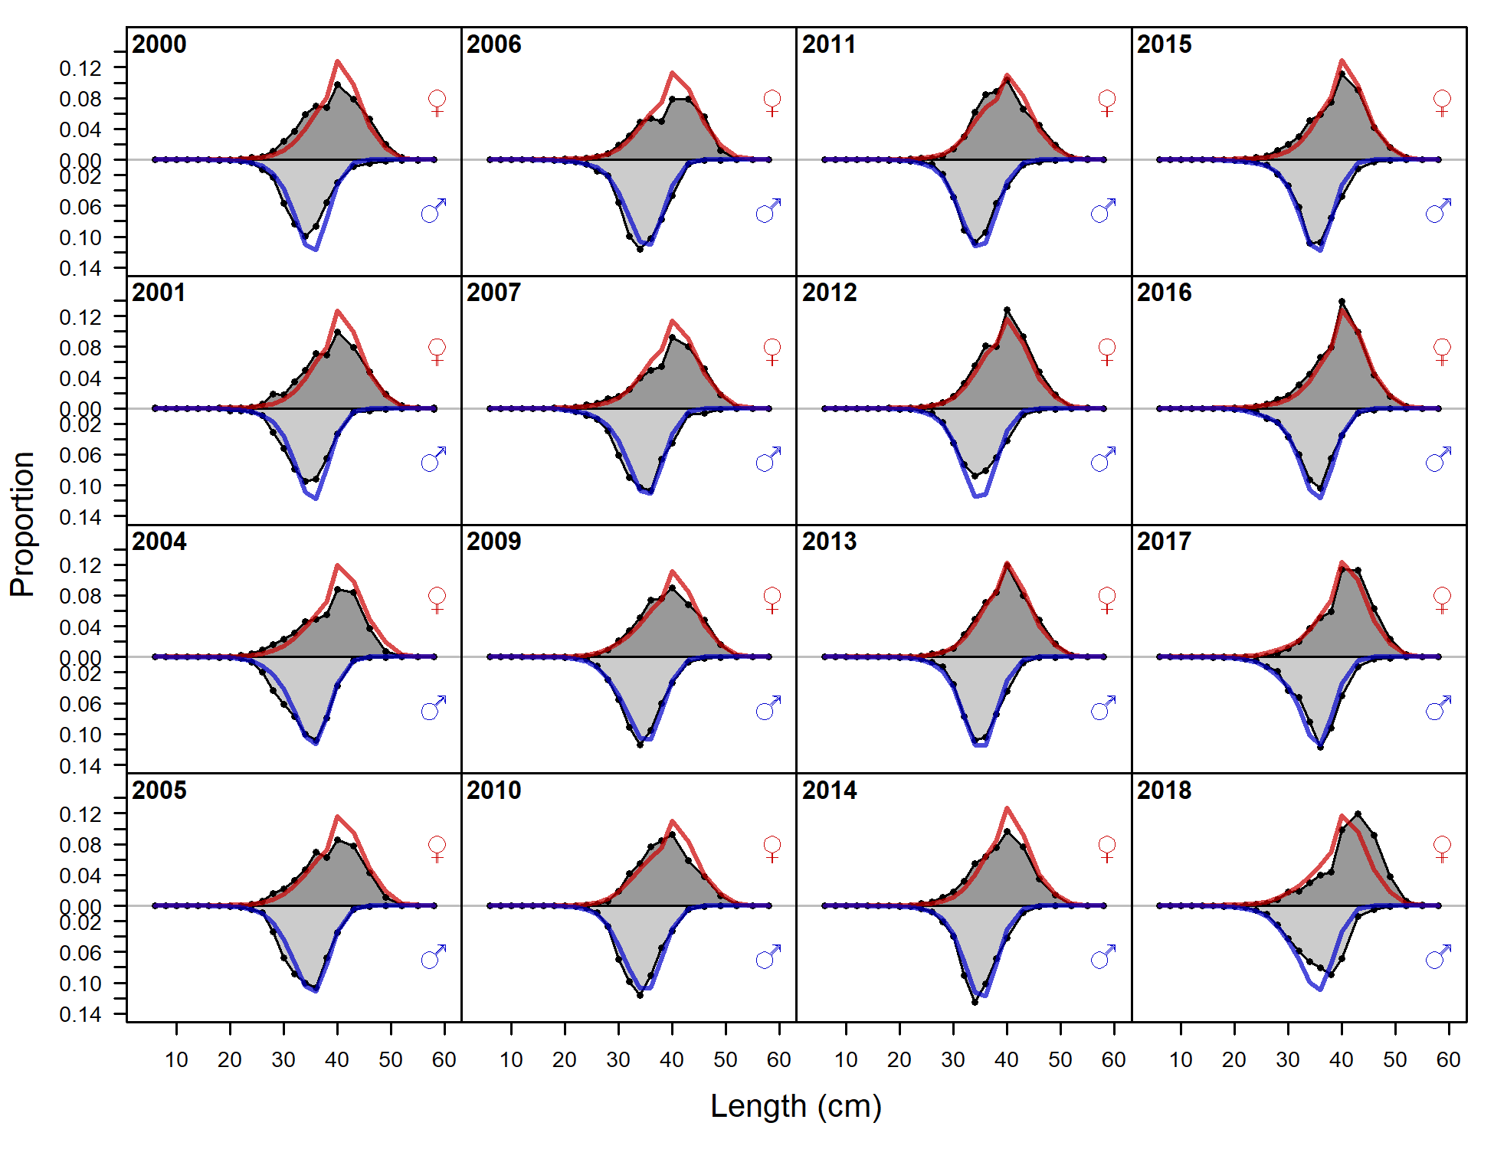

Figure 9.36. Observed (grey filled area and black line) and expected (red and blue lines) ghost fishery length compositions for males (blue lines) and females (red lines) for all years for Model 18.2c (2020). Fishery age composition data exist and the model fit to these data in the years represented in this figure, and therefore the objective function did not fit to length composition data in these years.

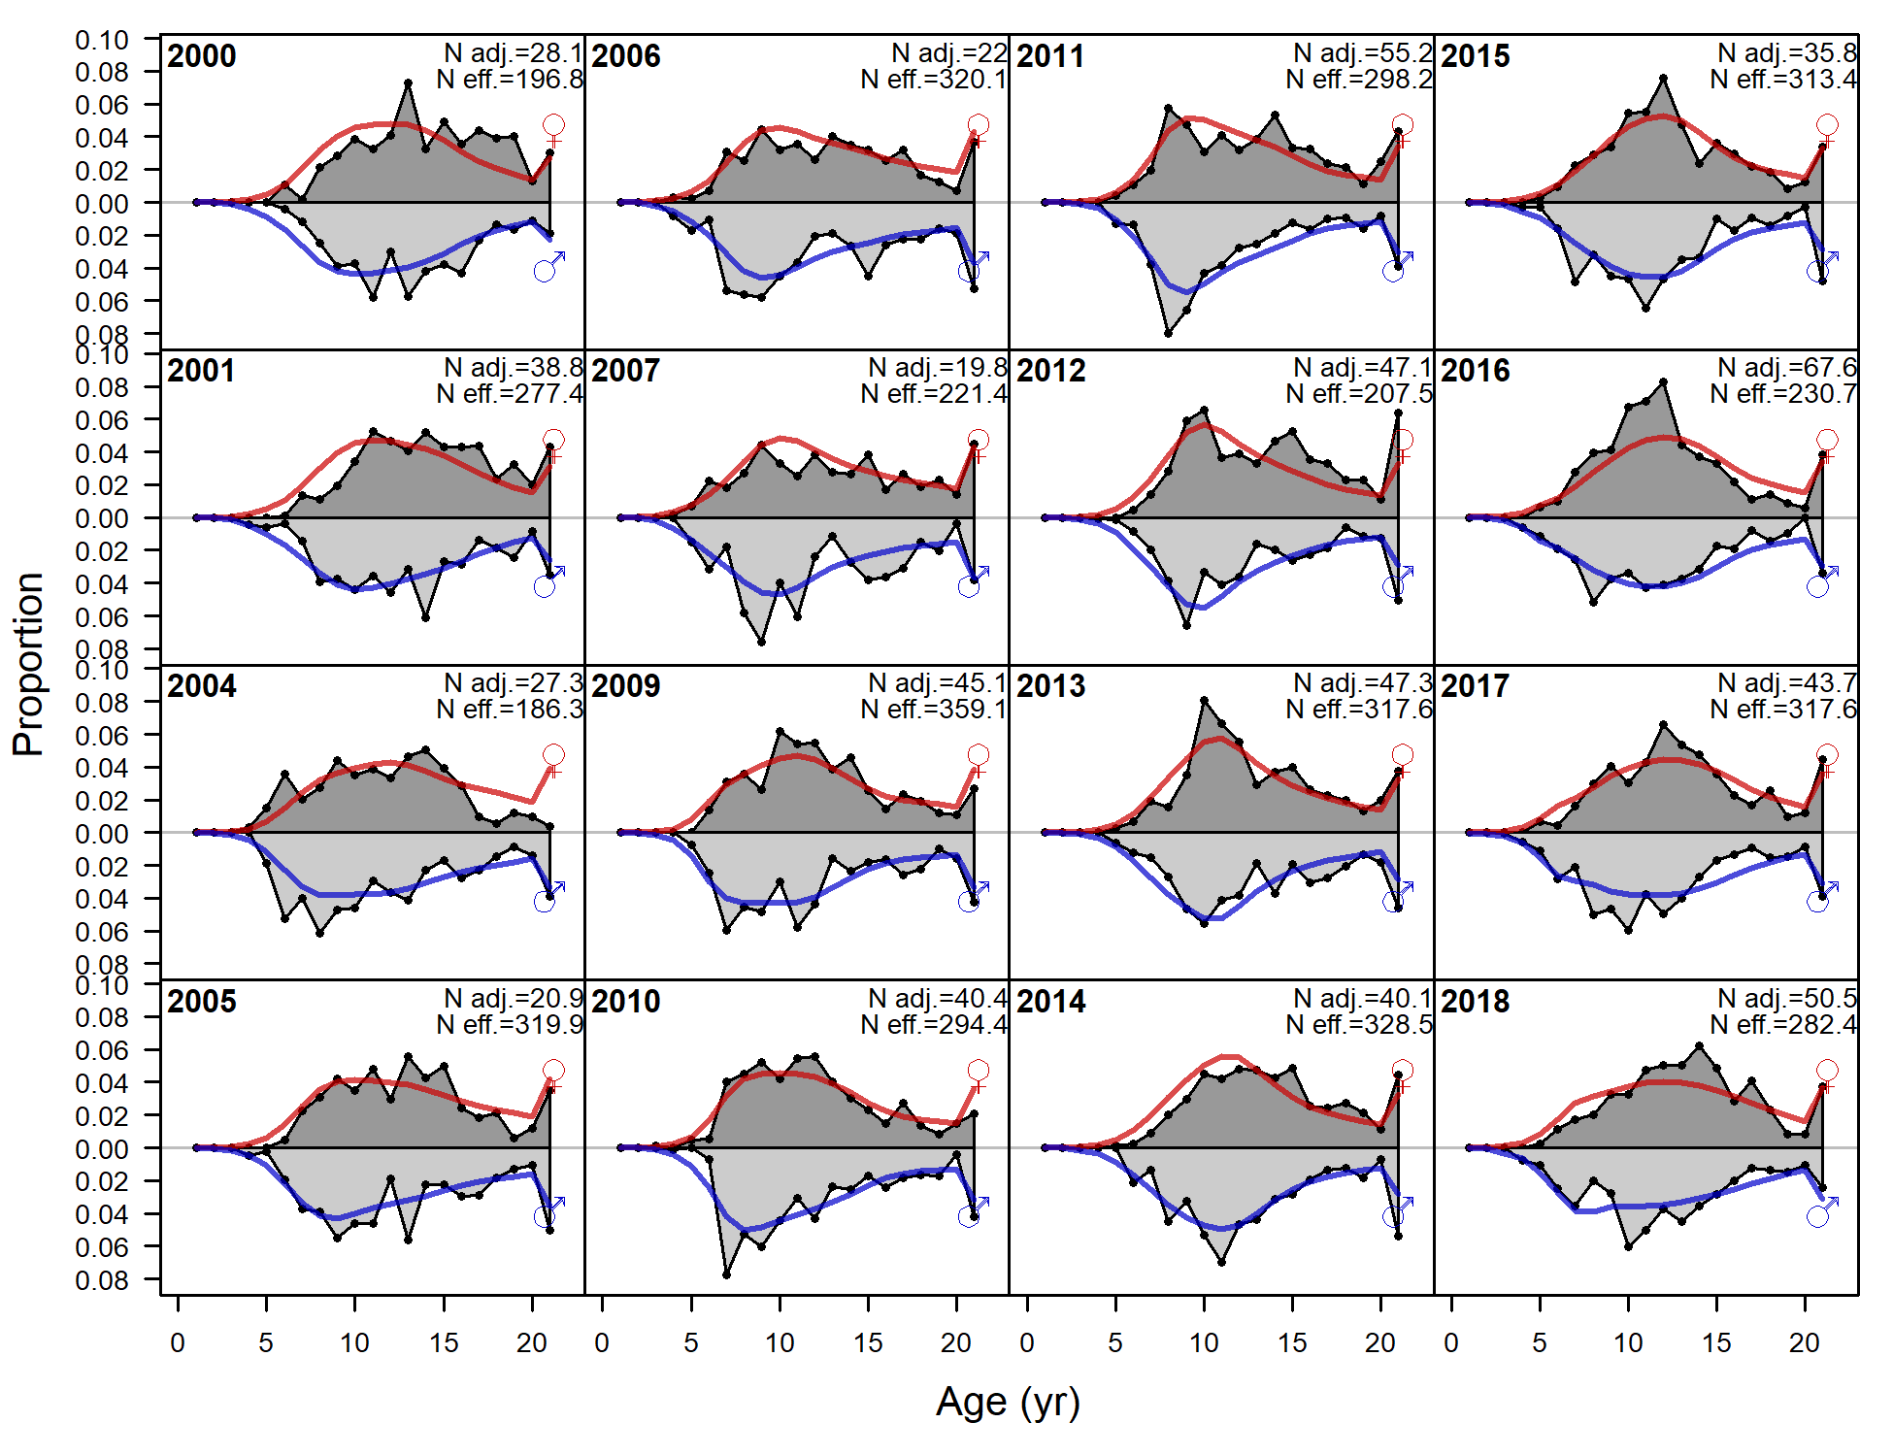

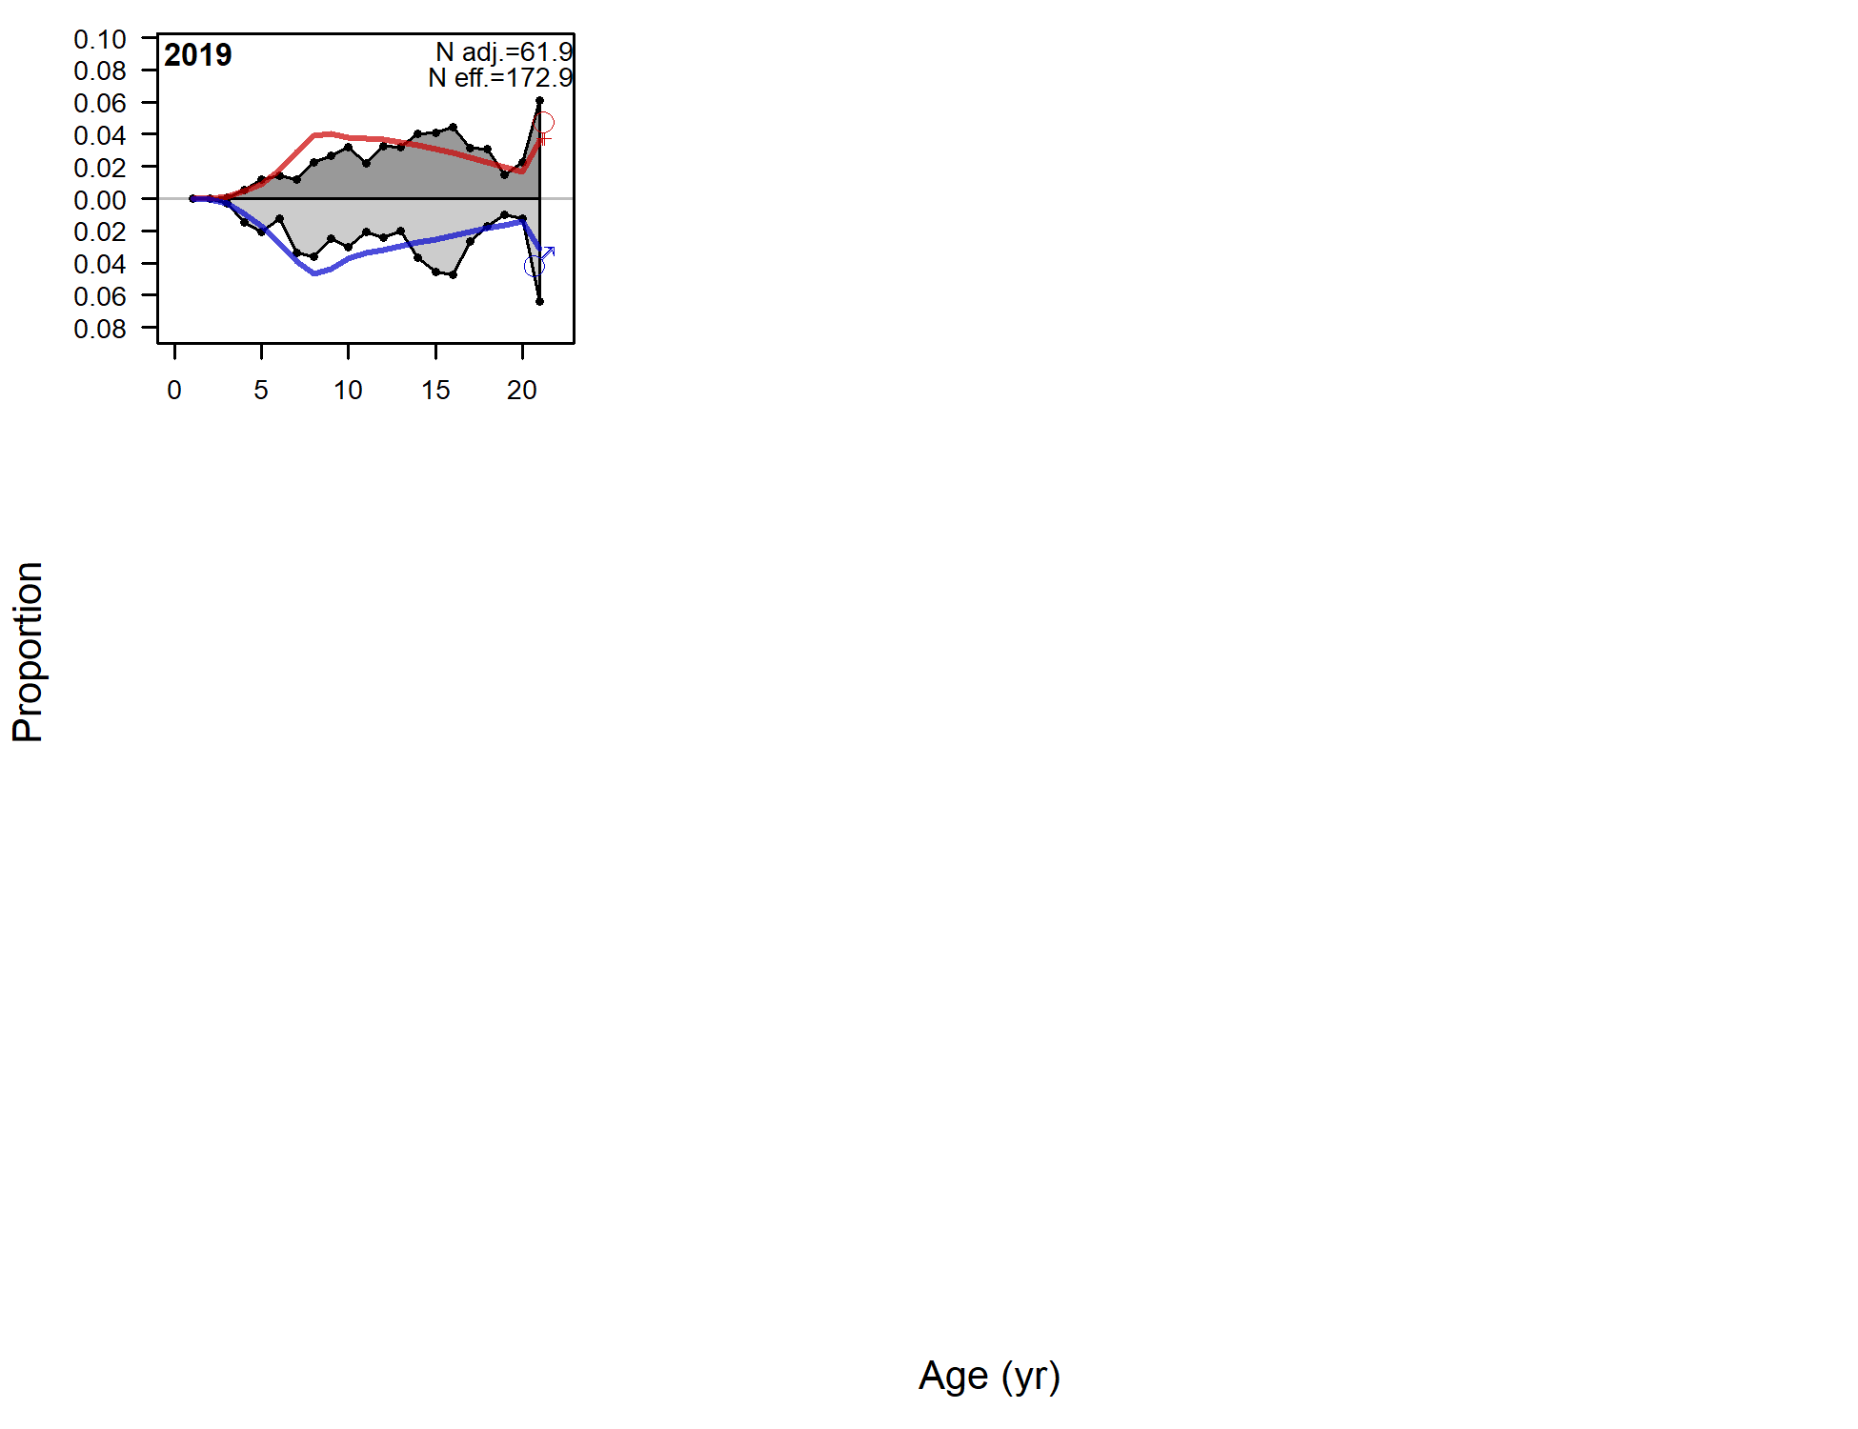

Figure 9.37. Observed (grey filled area and black line) and expected (red and blue lines) fishery age compositions for males (blue lines) and females (red lines) for Model 18.2c (2020).

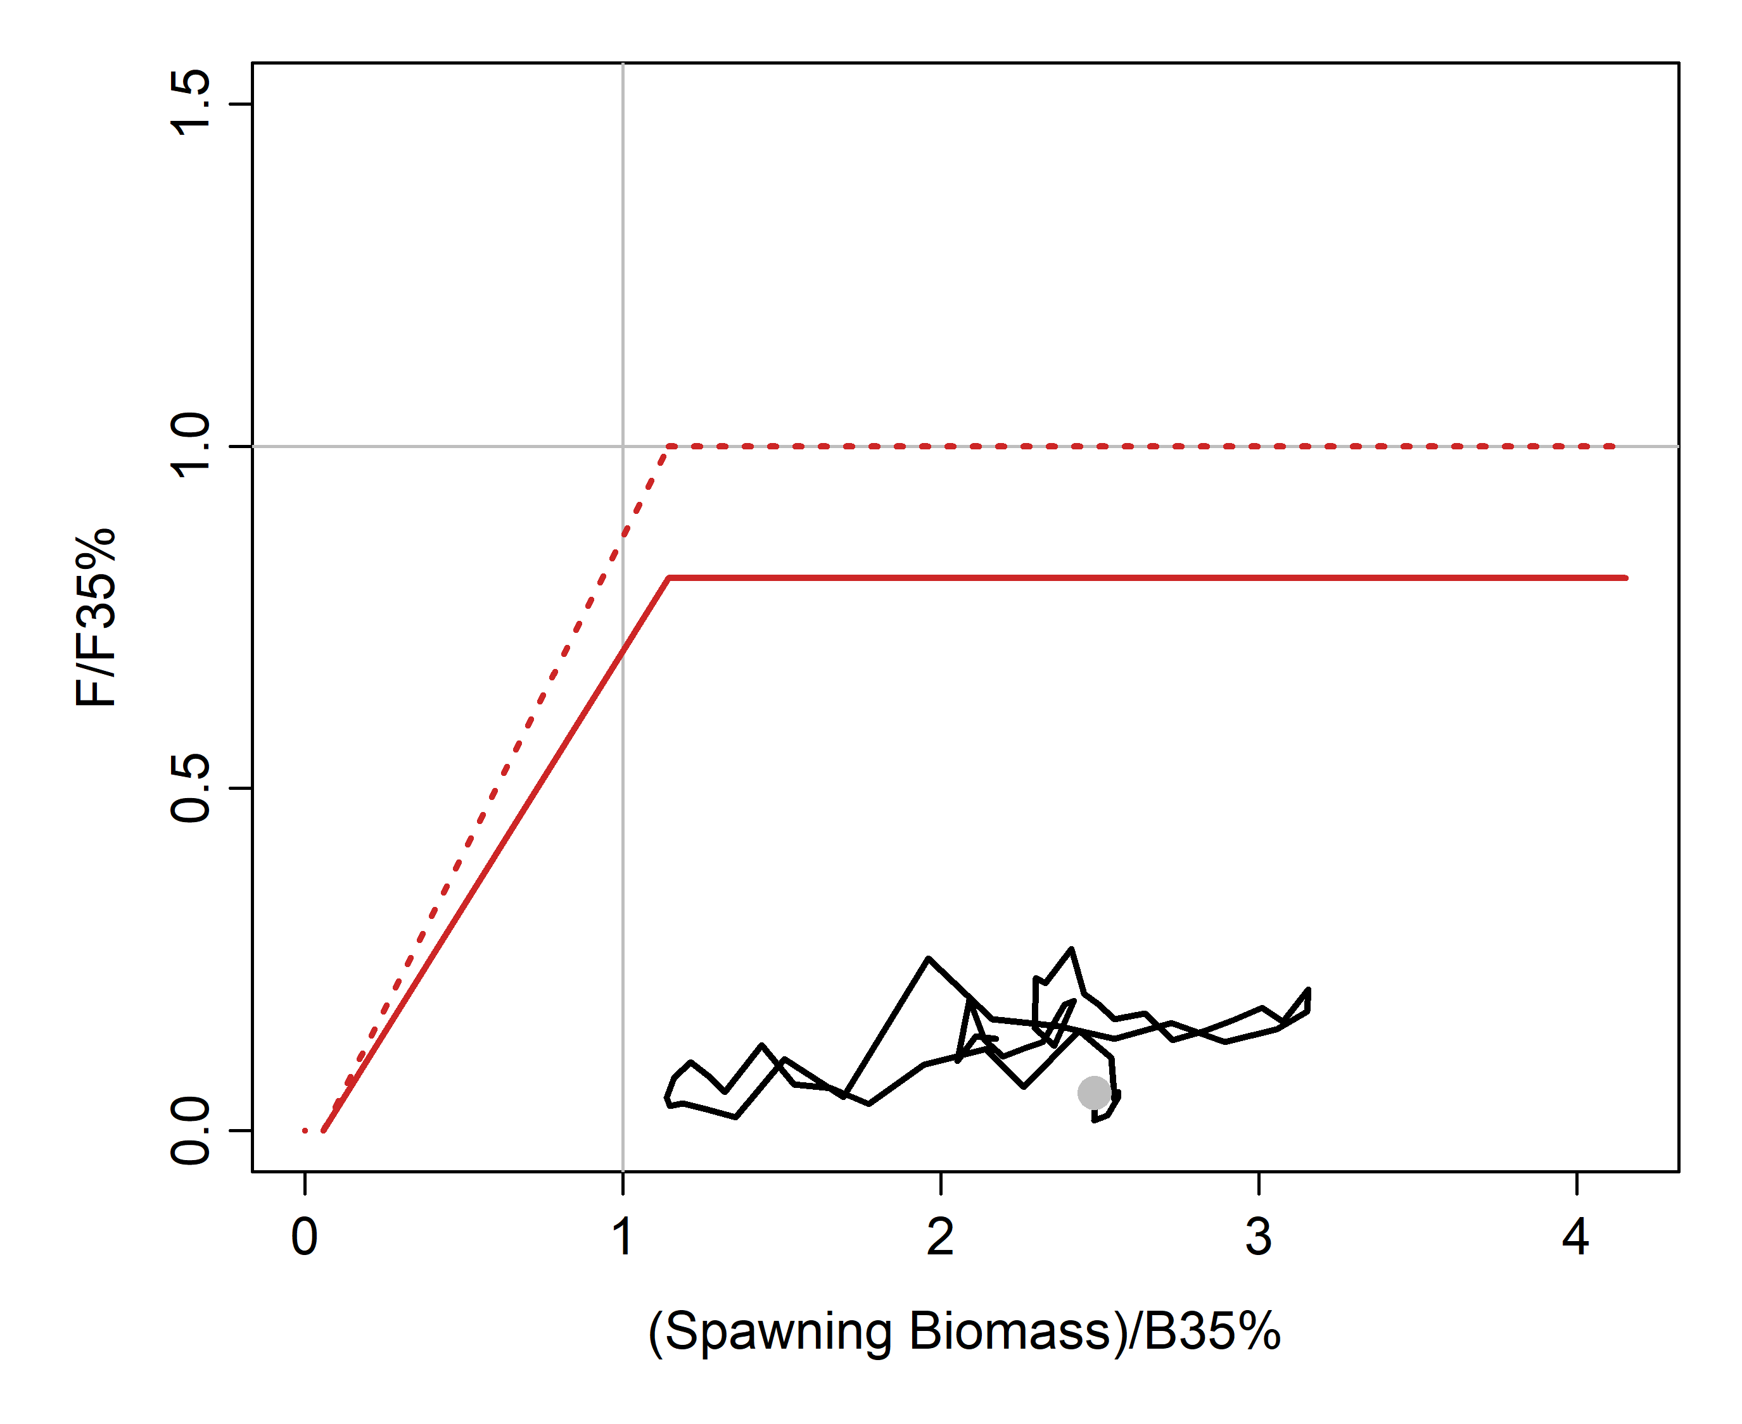

Figure 9.38. Phase plot showing spawning biomass and apical fishing mortality relative to B35% and F35%, respectively for each model year in addition to two projection years (black line). The grey dot shows the first year plotted (1964). The solid red line shows the ABC Tier 3 control rule and the dotted line shows the OFL Tier 3 control rule.

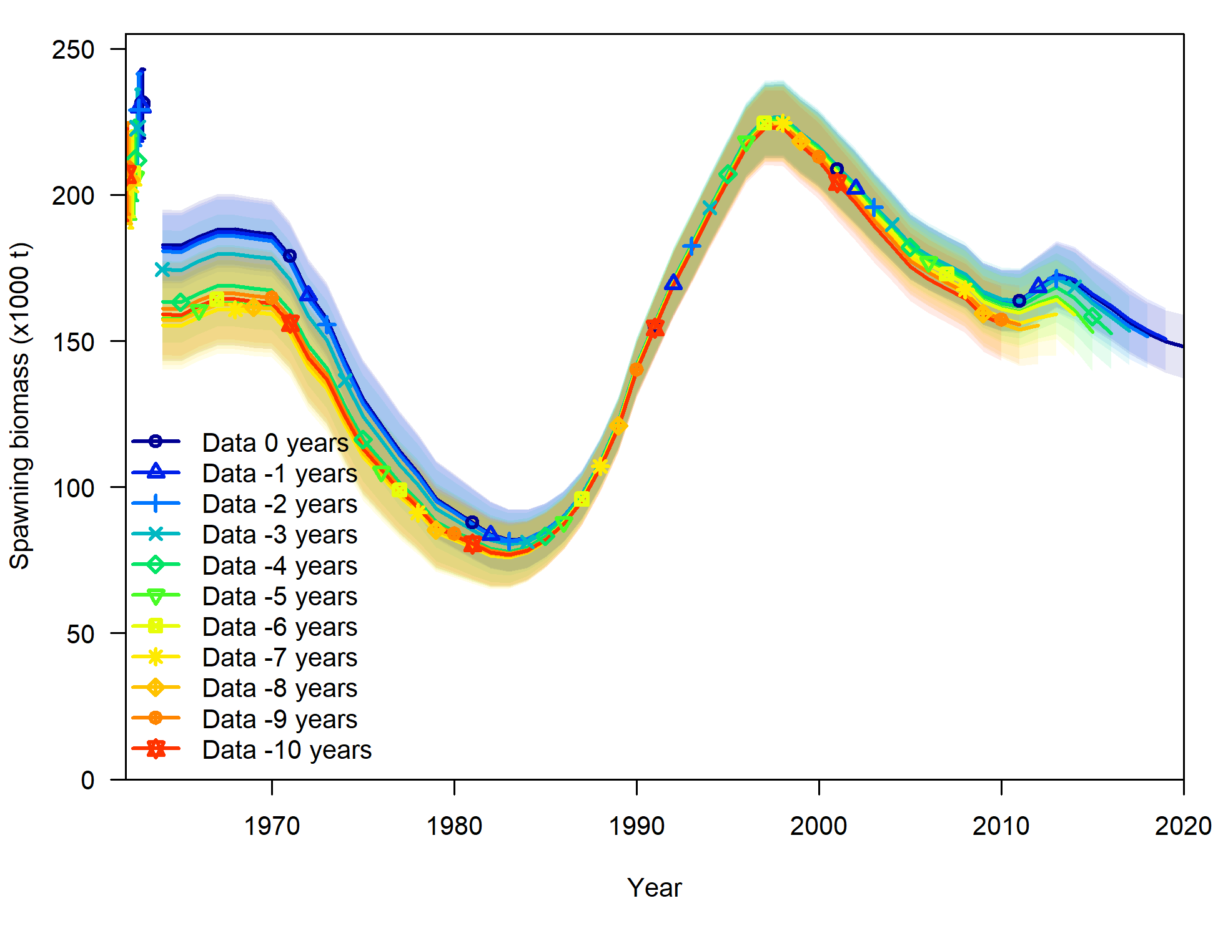

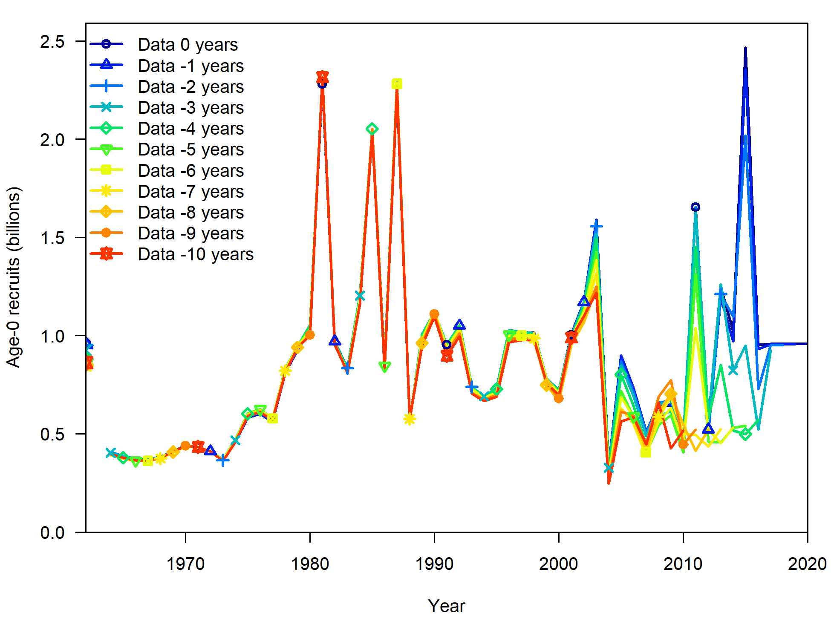

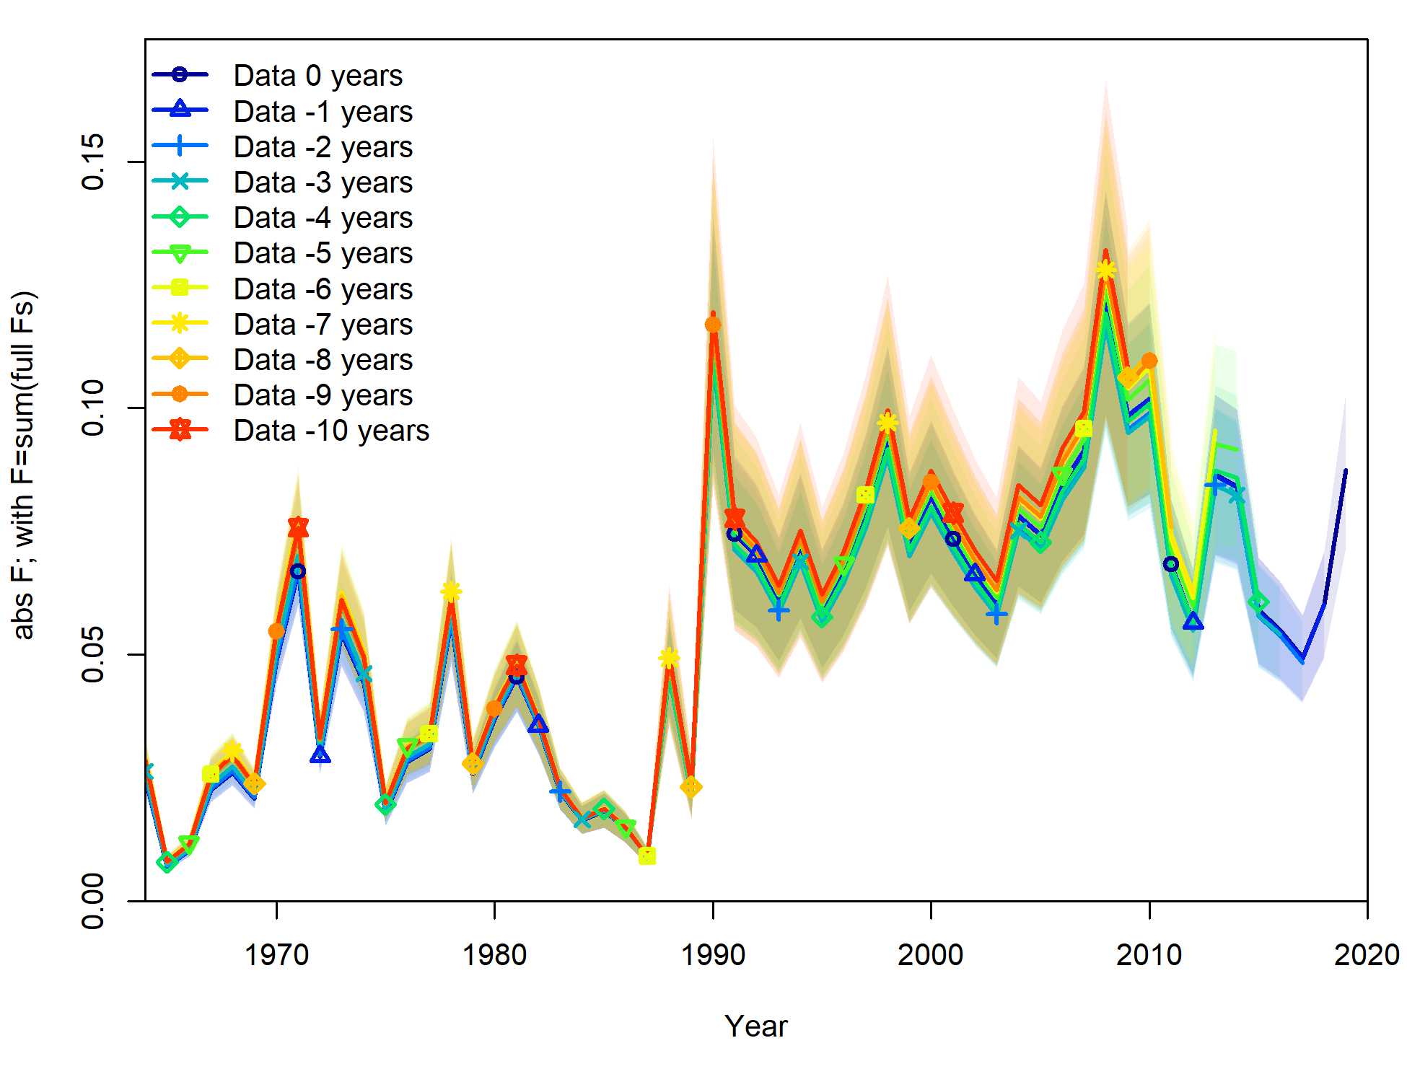

Figure 9.39. Spawning stock biomass (top), recruitment (middle), and fishing mortality (bottom) for retrospective model runs leaving out 0 to 10 years of the most recent data for Model 18.2c. Vertical lines show corresponding 95% asymptotic confidence intervals.

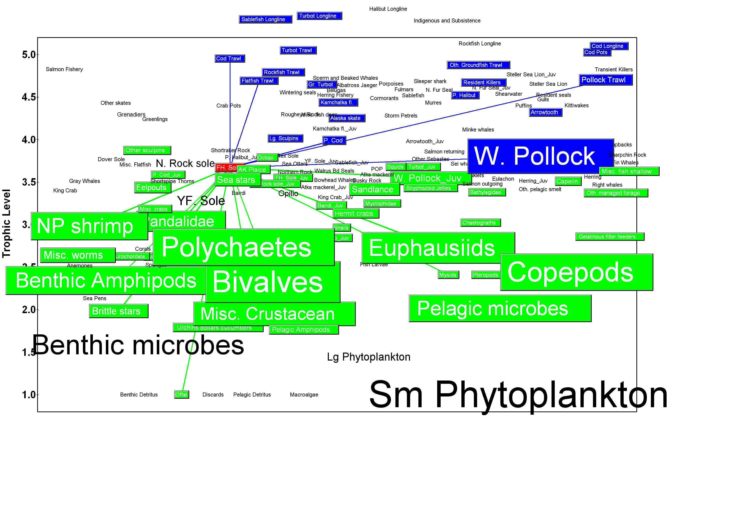

Figure 9.40. Ecosystem links to adult flathead sole in the eastern Bering Sea (based on a balanced ecosystem model for the eastern Bering Sea in the early 1990s; Aydin et al, 2007). Green boxes: prey groups; blue boxes: predator groups. Box size reflects group biomass. Lines indicate significant linkages.

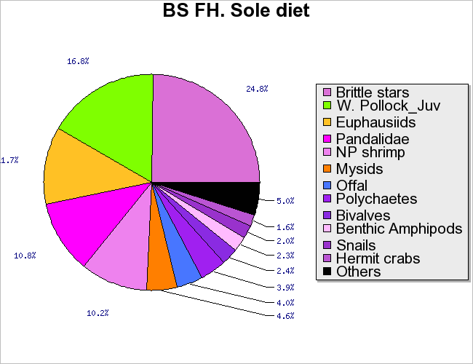

Figure 9.41. Diet composition of adult flathead sole in the eastern Bering Sea (based on a balanced ecosystem model for the eastern Bering Sea in the early 1990s; Aydin et al, 2007).

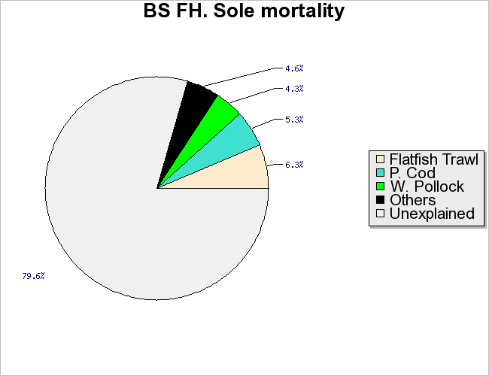

Figure 9.42. Mortality sources for flathead sole in the eastern Bering Sea (based on a balanced ecosystem model for the eastern Bering Sea in the early 1990s; Aydin et al, 2007).

# Appendix A

## Supplemental Catch Data

Table A.1-A3. Total non-commercial fishery catches not included in the AKFIN estimates of total catch. Units are not known (not identified on the AKFIN website), but may be kg. Top table is by agency, and bottom two tables are by type of collection and within agency.

|  |  |  |  |  |
| --- | --- | --- | --- | --- |
| **Year** | **ADFG** | **IPHC** | **NMFS** | **Total** |
| 2010 | 3,244 | 5 | 27,156 | 30,406 |
| 2011 | 2,592 | 13 | 32,555 | 35,160 |
| 2012 | 2,814 | 39 | 22,284 | 25,137 |
| 2013 | 2,426 |  | 19,647 | 22,072 |
| 2014 | 1,938 | 6 | 23,118 | 25,062 |
| 2015 | 2,432 | 13 | 15,920 | 18,366 |
| 2016 | 2,699 |  | 22,256 | 24,955 |
| 2017 | 2,584 | 14 | 22,548 | 25,145 |
| 2018 | 2,144 | 12 | 20,825 | 22,981 |
| 2019 | 2,679 | 2 | 23,998 | 26,680 |

|  |  |  |  |
| --- | --- | --- | --- |
|  | ADFG | | IPHC |
| Year | Large-Mesh Trawl Survey | St. Matthews Crab Survey | IPHC Annual Longline Survey |
| 2011 | 2,592 |  | 13 |
| 2012 | 2,814 |  | 39 |
| 2013 | 2,426 |  |  |
| 2014 | 1,938 |  | 6 |
| 2015 | 2,432 |  | 13 |
| 2016 | 2,699 |  |  |
| 2017 | 2,583 | 1 | 14 |
| 2018 | 2,144 |  | 12 |
| 2019 | 2,679 |  | 2 |

|  |  |  |  |  |  |  |  |  |  |  |
| --- | --- | --- | --- | --- | --- | --- | --- | --- | --- | --- |
|  | NMFS | | | | | | | | | |
| Year | AFSC Annual Longline Survey | Aleutian Island Bottom Trawl Survey | Bering Sea Acoustic Survey | Bering Sea Bottom Trawl Survey | Bering Sea Slope Survey | Eastern Bering Sea Bottom Trawl Survey | Eastern Bering Sea Walleye Pollock Acoustic-Trawl Survey | Northern Bering Sea Bottom Trawl Survey | Pollock EFP 11-01 | Summer EBS Survey with Russia |
| 2011 | 105 |  |  |  |  | 26,921 |  |  | 5,529 |  |
| 2012 | 5 | 1,082 |  |  | 4,479 | 16,122 |  |  | 552 | 45 |
| 2013 | 107 |  |  |  |  | 19,540 |  |  |  |  |
| 2014 | 22 | 2,518 |  |  |  | 20,578 |  |  |  |  |
| 2015 | 180 |  |  |  |  | 15,740 |  |  |  |  |
| 2016 | 6 | 1,444 |  |  | 3,182 | 17,624 |  |  |  |  |
| 2017 | 86 |  |  |  |  | 21,792 |  | 670 |  |  |
| 2018 | 9 | 1,566 |  |  |  | 18,781 | 18 | 451 |  |  |
| 2019 | 112 |  |  |  |  | 23,211 |  | 675 |  |  |